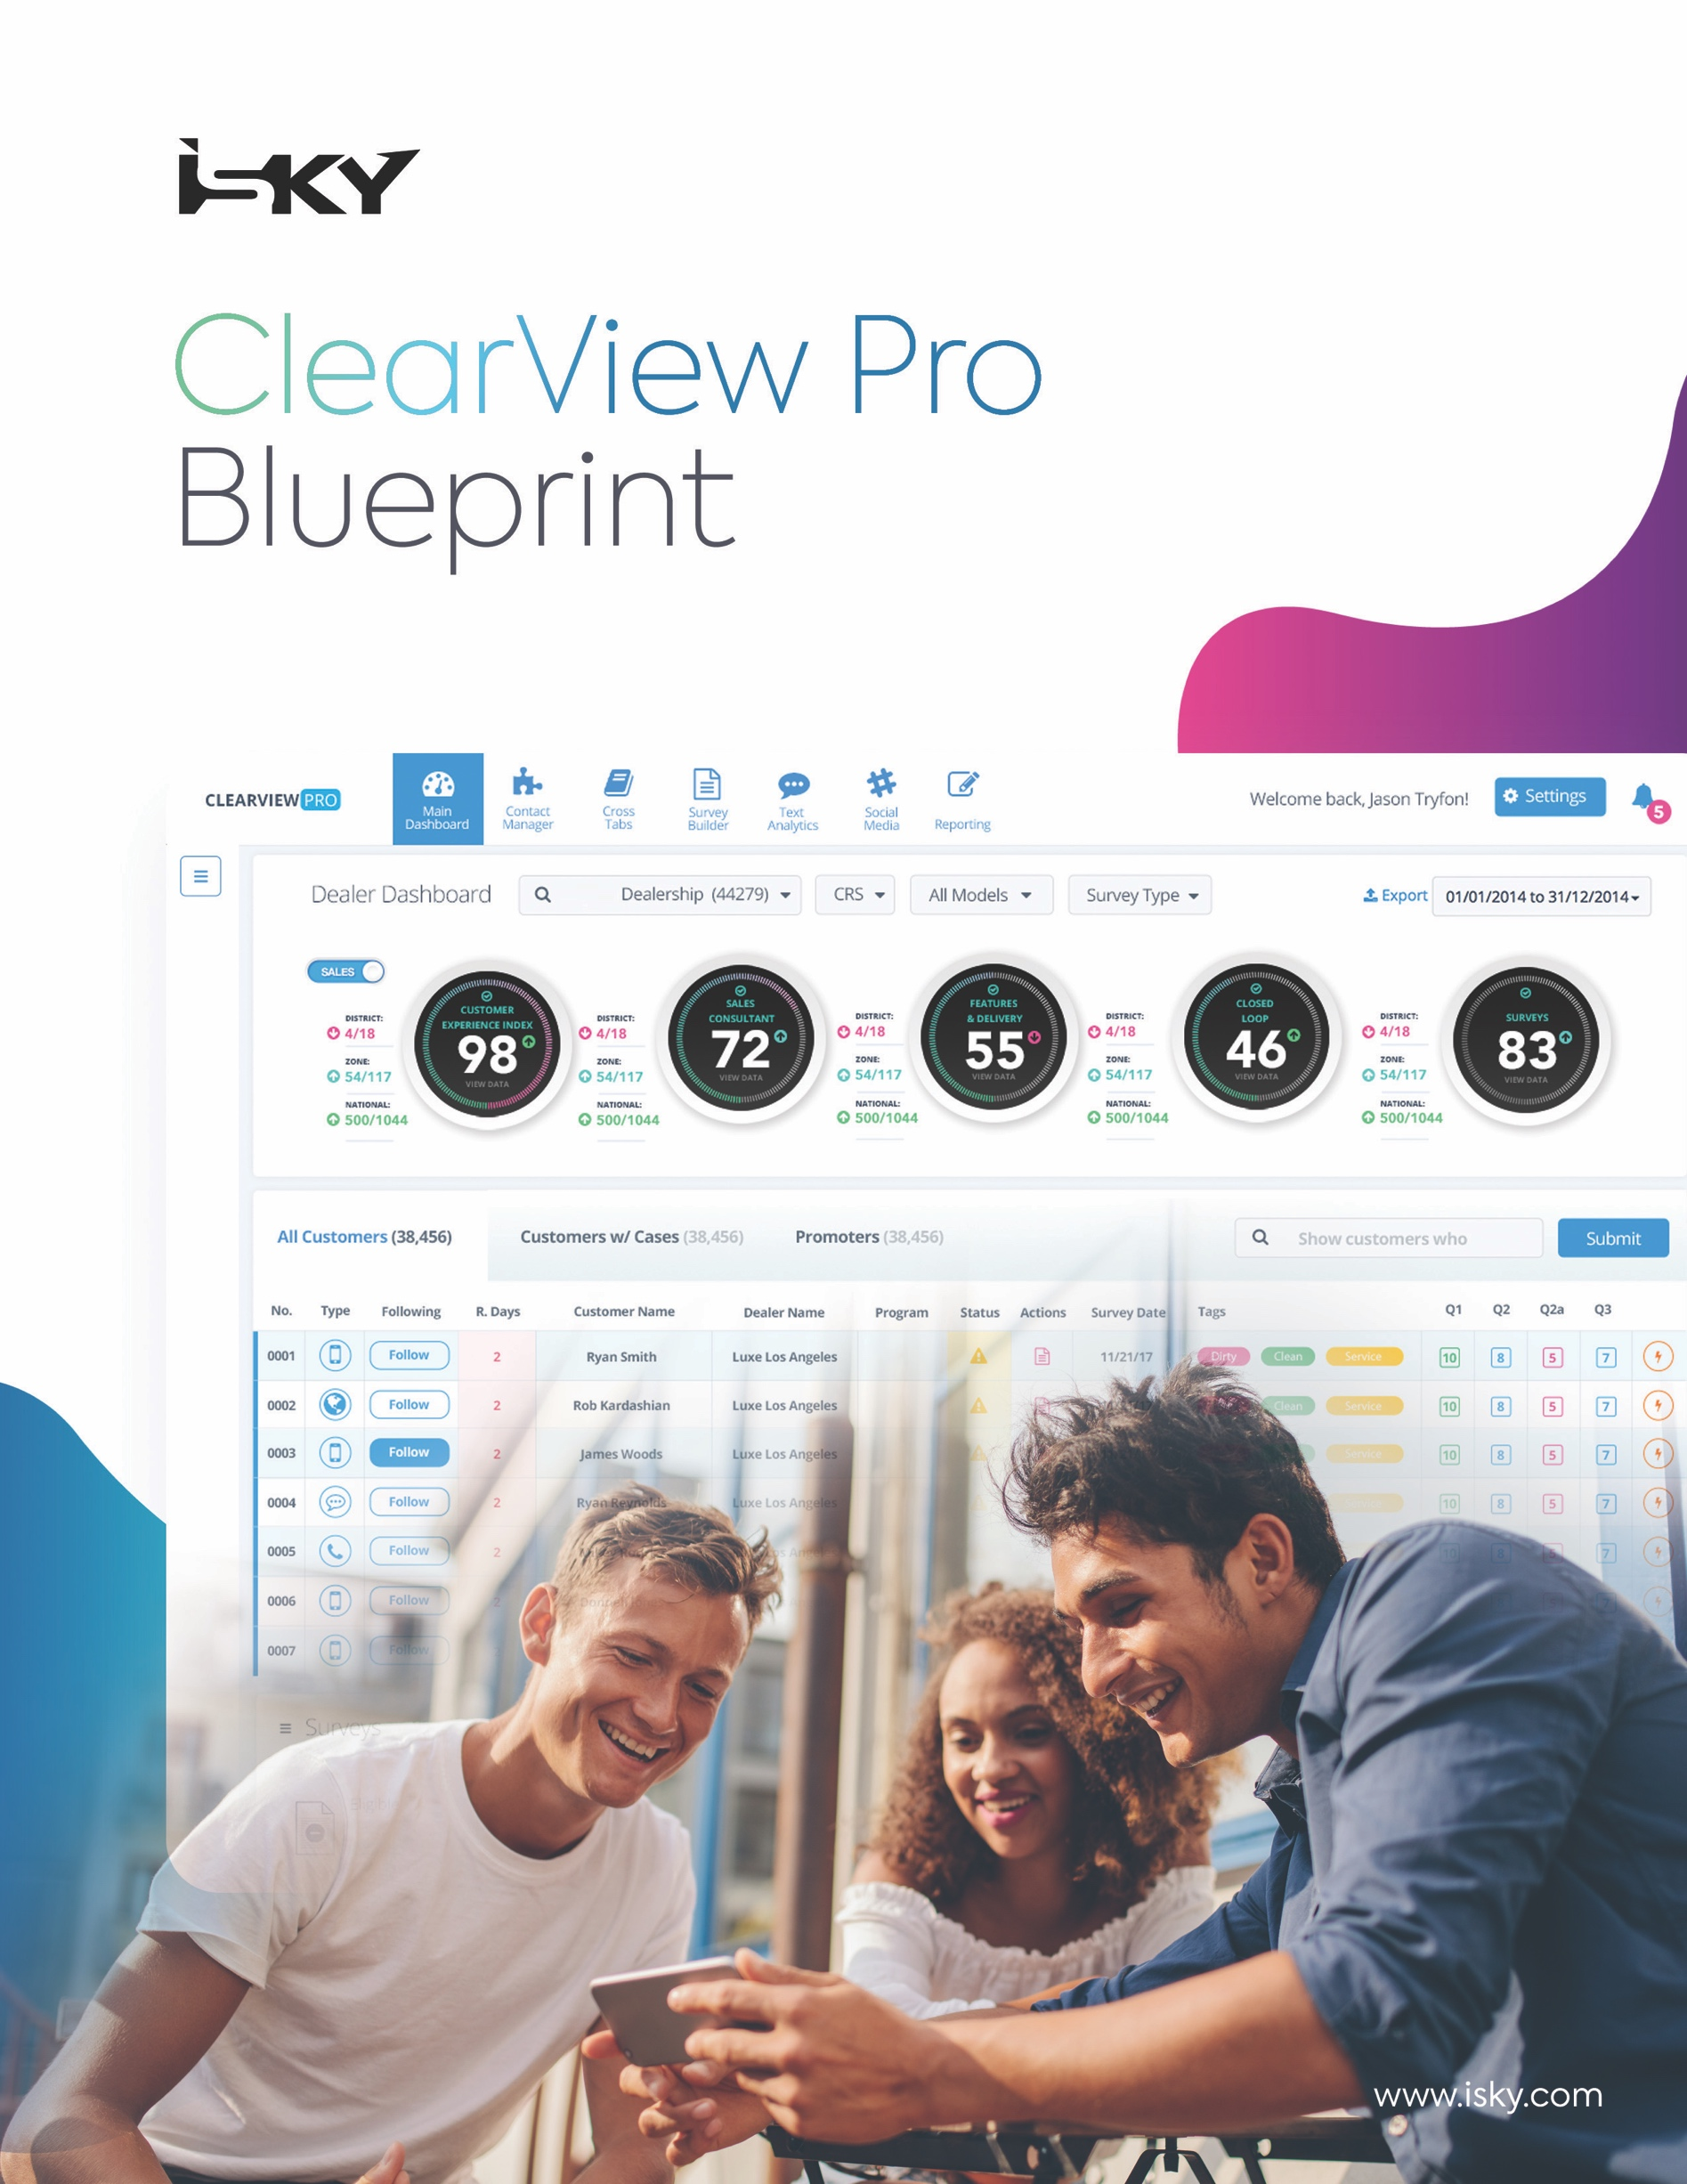

Toyota Canada Inc.

Version 1.9

Revision History

|  |  |  |  |  |
| --- | --- | --- | --- | --- |
| **Version** | **Date** | **Author** | **Description** | |
| 1.2 | 11/28/2017 | Ashley Omran | Document finalization | |
| 1.3 | 12/08/2017 | Ashley Omran | Updates Post Blueprint Q&A Meeting | |
| 1.4 | 12/15/2017 | Ashley Omran | Blueprint Meeting Notes | |
| 1.5 | 12/18/2017 | Ashley Omran | **Finalized:**  1. Contact Information  4.1 Site & Survey URL  4.2 Supported Browsers  6.1 Survey Process Times  6.2 Survey Methodology  6.4 Survey Link Validity  6.6 Survey Time Zones  6.10.2 Pinnacle Program  8.6 Sales Unwind Process  8.7 Dealer Buy/Sell/Termination Logic  **Added Sections:**  9.4.10 Closed Loop List  6.4.11 Closed Loop Summary  **Removed Sections:**  6.2.1 Multi Methodology Process  9.2.2 Dashboard Widgets – Pinnacle Program Widget | **Updates to:**  2.1 Program Launch Strategy  2.2 User Acceptance Testing  3.1 Authentication & Authorization  3.2 Program Hierarchy  4.3 “From” Name  6.3 Reminder Surveys  6.5 Survey Frequency  6.8 Email Edits  6.10.1 Quarterly Gas Card Draw  7.4 Results Collection & Sharing  9 ClearView  9.2.1 Key Performance Indicators (KPI)  10.8 Additional Inbound/Outbound Data Feeds  10.9 Custom Reporting  13 Deliverables Summary |
| 1.6 | 12/19/2017 | Ashley Omran | **Blueprint Meeting Continuation:**  **Finalized:**  9.4.4 Closed Loop Target (KPI)  9.4.5 Closed Loop Status  9.4.6 Follow up Email  9.4.7 Follow Up Email Alert Assignment  9.4.8 Reopen/Close Closed Loop Option | **Added Sections:**  9.1.4 Customer Search  9.3.1.1 Customer Search  **Removed Sections:**  9.1.2.1 Customer Search  **Updates to:**  9.4.10 Closed Loop List  13 Deliverables Summary |
| 1.7 | 1/9/2018 | Tara Davis & Ashley Omran | Updates based on TCI Project Deliverables | |
| 1.8 | 1/16/2018 | Tara Davis & Ashley Omran | **Updates to:**  6.10.1 Quarterly Gas Card Draw  10.9 - Custom Reporting  11.2 – Survey Removal  Appendix B – Survey Communication (Thank you pages) | Appendix C – Survey Content  Appendix D – Data Requirements  **Added section:**  14 - Budget and Payment Terms  Appendix I – SSO role Mapping |
| 1.9 | 1/24/2018 | Ashley Omran | **Updates to:**  2.1 – Program Launch Strategy  3.2 – Program Hierarchy  6.9 – Survey Resends  6.10.2 – Pinnacle Program  8.7 – Dealer Buy/Sell/Termination  9.4.2 – Escalation Alert Assignment  11.2.1 - | |

Table of Contents

1 Contact Information 8

2 Launch Details 10

2.1 Program Launch Strategy 10

2.2 User Acceptance Testing 10

3 System Access 12

3.1 Authentication and Authorization 12

3.2 Program Hierarchy 12

3.3 User Admin Module 13

4 Technical Details 16

4.1 Site and Survey URL 16

4.2 Supported Browsers 16

4.3 ‘From’ Email 16

4.4 ‘From’ Name 16

4.5 Privacy Policy Link 17

5 Survey Details 19

5.1 Survey Question Content 19

5.1.1 Survey Event Types 19

5.2 Survey Language Preference 19

5.3 Survey Communication Content 19

5.4 Survey Invitation Signature 19

5.5 Unsubscribe Requirements 20

6 Survey Contact Lifecycle 22

6.1 Survey Process Times 22

6.2 Survey Methodology 22

6.3 Reminder Surveys 22

6.4 Survey Link Validity 22

6.5 Survey Frequency 23

6.6 Survey Time Zones 23

6.7 Business Days & National Holidays 23

6.8 Email Edits 24

6.9 Survey Resends 25

6.10 Incentives 26

6.10.1 Quarterly Gas Card Draw 26

6.10.2 Pinnacle Program 27

6.11 Survey Process Maps 28

6.11.1 Email Process 28

6.11.2 SMS Process 29

7 ePanel Program 31

7.1 Enrollment 31

7.2 Survey Group Selection 31

7.3 Deployment 31

7.4 Results Collection & Sharing 31

8 Data Requirements 35

8.1 sFTP Location 35

8.2 Import Data Feed 35

8.3 Import Data Feed Filters 35

8.4 Launch Data Requirements 35

8.5 Data Delivery Alerts 36

8.6 Sales Unwind Process 36

8.7 Dealer Buy/Sell/Termination Logic 36

8.8 VIN Decoder 36

8.9 Data Center 37

8.9.1 Data Process Map 37

9 ClearView 39

9.1 Functionality 41

9.1.1 Date Range Selection 41

9.1.2 Search Criteria 41

9.1.3 Export Formats 43

9.1.4 Customer Search 43

9.2 Dashboard 44

9.2.1 Key Performance Indicators (KPI) 44

9.2.2 Dashboard Widgets 45

9.2.3 Customized Dashboard 48

9.3 Survey Results 51

9.3.1 Survey List 51

9.3.2 Customer History 52

9.4 Closed Loop, Thresholds and Key Performance Indicators 54

9.4.1 Closed Loop Triggers 54

9.4.2 Escalation Alert Assignment Hierarchy 54

9.4.3 Alert Content 55

9.4.4 Follow-up Email Alert Assignment 55

9.4.5 Closed Loop Target (KPI) 55

9.4.6 Closed Loop Status 56

9.4.7 Follow-up email 56

9.4.8 Reopen/Close Closed Loop Option 57

9.4.9 Closed Loop Summary 57

9.4.10 Closed Loop List 58

9.4.11 Closed Loop Process Map 59

9.5 Voice of Customer (VoC) - Textual and Sentiment Analysis 59

9.5.1 VoC Dashboard 60

9.5.2 VoC Tree Report 61

9.5.3 VoC Comment List 61

9.5.4 VoC Interface 62

9.5.5 VoC Process Map 64

10 Reporting 66

10.1 Contact Statistics 66

10.2 Portal Traffic 68

10.2.1 Login Summary 68

10.2.2 Login and Traffic Stats Details 69

10.2.3 Login and Site Traffic Summary 70

10.3 Organization Summary 70

10.4 Performance Trend 71

10.5 Manipulation Reports 72

10.6 Crosstabs 73

10.6.1 Fields and Descriptions 74

10.6.2 Measure/Dimension Structure & Fields Available 75

10.7 Report Generator 76

10.7.1 Attributes List 77

10.7.2 Fields and Descriptions 78

10.8 Additional Inbound/Outbound Data Feeds 80

10.9 Custom Reporting 80

11 ClearView Self Administration 82

11.1 Survey Administration 82

11.2 Survey Removal 83

11.2.1 Appeals 83

11.2.2 Survey List – Deleted Surveys Tab 86

11.3 Translation Module 86

11.3.1 Translation Update Tool for Email Notification 87

12 Branding and imagery 89

12.1 Corporate Image Library Access 89

12.2 Survey imagery 89

13 Deliverables Summary 91

14 Budget and Payment Terms 94

15 Client sign-off 95

Appendix A: Creative Package 96

Survey Imagery 96

Survey Email Invitation 96

Survey 97

Thank You Page 98

Appendix B: Survey Communication Template 99

Sales Survey Communication 99

Service Survey Communication 103

Standard (Shared) Communication 107

Closed Loop Alert Content 108

Data Tracking Alerts 112

Gas Card Contest – Contest Rules 113

Appendix C – Survey Content 115

Sales Survey 115

Sales Survey – Extended 115

Service Survey 118

Extended Service Survey 118

Appendix D: Data Requirements 122

Sales Import Data Feed 122

Service Import Data Feed 124

Lexus 126

Event Data Filters 126

Appendix E: VoC Tree Report Categories 129

Sales 129

Service 138

Appendix F – Dealer List 146

Toyota 146

Appendix G – ePanel Summary Report Example 151

By Region 151

By Vehicle Age 151

By Generation 151

Verbatim 151

Appendix H – Additional Inbound/Outbound Data Feed Layouts 152

Dealer Buy/Sell/Termination Feed 152

Customer Information Update 152

Appendix I – SSO Role Mapping 153

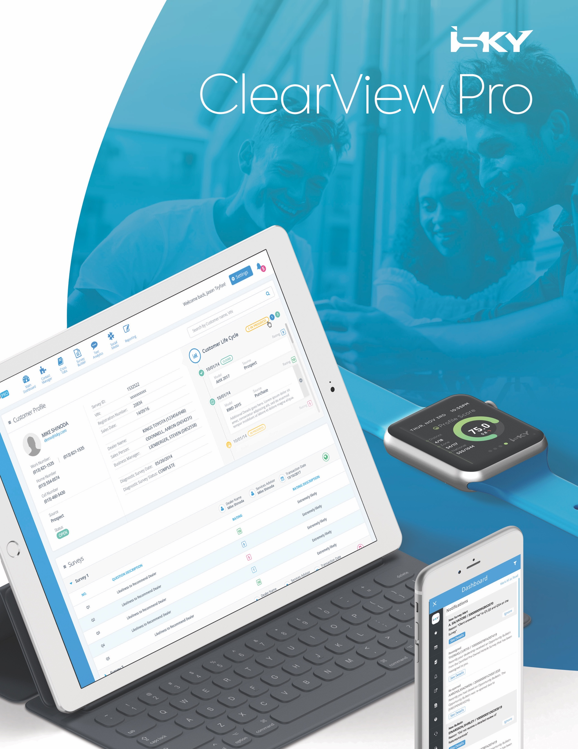

Section 1: Contact Information

# Contact Information

A successful ClearView system deployment requires the input of multiple project stakeholders, both at Toyota Canada, and at iSKY.

Please identify the main project stakeholders that will be involved in the ClearView product deployment. These stakeholders will be responsible for attending project status meetings, and will be the main day to day contacts for the iSKY project team.

**TCI Final:** Please see the main project stakeholders below:

|  |  |  |  |
| --- | --- | --- | --- |
| Contact Department | Title | Name | Email/Phone |
| Toyota Canada Stakeholder 1 | National Manager Service Retention | Patrice Dupuis | Cell: 647-920-0651  Office: 416-431-8304  [pdupuis@toyota.ca](mailto:pdupuis@toyota.ca) |
| Toyota Canada Stakeholder 2 | Manager, VOC Strategy & Planning | Stacey Metcalfe | Cell: 289-200-3980  Office: 416-438-6320 X8468  [stacey_metcalfe@toyota.ca](mailto:stacey_metcalfe@toyota.ca) |
| Toyota Canada Stakeholder 3 | PM, ePMO, Information Services | Anita Telford | Office: 416-438-6320 Ext. 2443  [anita_telford@toyota.ca](mailto:anita_telford@toyota.ca) |
| Toyota Canada IT Contact | Business Analyst  Information Services | Steven Taylor | Cell: 416-617-3416  Office: 416-438-6320 X2416  [steven_taylor@toyota.ca](mailto:steven_taylor@toyota.ca) |
| iSKY Launch Executive | VP, Client Operations | Ashley Vukusic | [Ashley@isky.com](mailto:Ashley@isky.com) |
| iSKY Launch Leader | Manager, Client Services | Tara Davis | [Tara@isky.com](mailto:Tara@isky.com) |
| iSKY Launch Account Manager | Account Manager | Ashley Omran | [aomran@isky.com](mailto:aomran@isky.com) |
| iSKY Project Manager | Director, Project Mgmt. | Adya Shukla | [Adya@isky.com](mailto:Adya@isky.com) |
| iSKY IT 1 | IT Manager | Tashfeen Khalid | [tashfeen@isky.com](mailto:tashfeen@isky.com) |
| iSKY IT 2 | IT Launch Lead | Abdullah Tayyab | [abdullah@isky.com](mailto:abdullah@isky.com) |



Section 2: Launch Details

# Launch Details

## Program Launch Strategy

ClearView can be rolled out on a single date or on a staggered release that spreads ‘launch’ dates over a set period of time.

**TCI Final:** Toyota Canada will run a two (2) week pilot program starting July 1, 2018 including approximately twenty (20) Dealers. The Toyota Canada ClearView portal full launch tentative release date, with surveys and the ClearView portal going live simultaneously for the remainder of Dealers is July 16, 2018.

## User Acceptance Testing

iSKY strongly recommends implementing a User Acceptance Testing (UAT) period to test the system workflow, processes and business rules.

Through our experience with various program launches, we have adopted a formal UAT review meeting as a recommended best practice. During this meeting, which is led by the Account Manager, the launch team along with key Toyota Canada stakeholders will meet to review the UAT environment as a group. The Project Manager will walk everyone through the system functions and features driven from the finalized Blueprint document and provide direction on the recommended steps to conduct a successful UAT independently. Post meeting, key stakeholders will be provided UAT links to the production system and survey to execute user testing. All feedback will be consolidated and provided to the Project Manager for evaluation and implementation.

**TCI Final:** The User Acceptance Testing will be released in a staggered release (UAT Dates TBD post Blueprint sign off) including (3) separate UAT releases.

Please see the below the user profiles that will be created for User Acceptance Testing:

|  |  |  |  |
| --- | --- | --- | --- |
| **Title** | **Name** | **Role Type** | **Email/Phone** |
| Manager, VOC Strategy & Planning | Stacey Metcalfe | VoC Team | Cell: 289-200-3980  Office: 416-438-6320 X8468  [stacey_metcalfe@toyota.ca](mailto:stacey_metcalfe@toyota.ca) |
| Consultant, Customer Survey Program | Daniela Erse | VoC Team | Office: 416-438-6320 X2134  [daniela_erse@toyota.ca](mailto:daniela_erse@toyota.ca) |
| Consultant, Customer Survey Program | Marzena Musielak | VoC Team | Office: 416-438-6320 X2189  [marzena_musielak@toyota.ca](mailto:marzena_musielak@toyota.ca) |
| N/A | TBD | National User | TBD full list |
| N/A | TBD | Zone User | TBD |
| N/A | TBD | Dealer Group User | TBD |
| N/A | TBD | Dealer Administrator | TBD |
| N/A | TBD | Dealer User | TBD |
| N/A | TBD | Employee User | TBD |



Section 3: System Access

# System Access

When a user accesses ClearView it displays relevant information for each user group within the defined hierarchy ensuring that action can be taken from every level.

## Authentication and Authorization

Access to ClearView can be set up in the following methods:

**1. Single Sign On** - enabling iSKY to determine access rights based on user credentials within Toyota Canada’s internal information portal – Infostream.

**2. ClearView User Admin Module** - iSKY can manage and control access directly through the ClearView portal by issuing a user login and password during the program launch through an automated email distribution.

**TCI Final:**  ClearView will be integrated with Toyota Canada’s internal information portal – Infostream. The Toyota and Lexus single sign on (SSO) platforms will both be integrated with the same Toyota/Lexus ClearView platform, with Toyota SSO users accessing the Toyota branded ClearView, and Lexus SSO users accessing the Lexus branded ClearView.

Through the SSO login, iSKY is able to determine the users access rights based on user credentials passed from the SSO system; dealers can access only their own dealership’s information, while corporate, regional and field users have the ability to see all data for their entire network.

Please refer to Appendix I to review the SSO role mapping. Toyota’s VOC Team members will be granted direct access to ClearView through a login URL. Toyota to investigate addition of new VOC role within SSO platform post Blueprint sign off.

**Action Item:** iSKY to add SSO testing schedule to project UAT schedule.

## Program Hierarchy

The following access matrix defines the hierarchy levels for data access. The below depicts what data each user can view when they log into ClearView. For example, Toyota Canada National Users have access to view data at all hierarchy levels, whereas a District User is limited to viewing data belonging to their local district only, and below.

**TCI Final:** Please refer to the below matrix detailing the ClearView system roles and their access level. Toyota and Lexus will maintain separate hierarchies, and Lexus does not utilize “Zone” or “Zone Category”. In addition, please refer to the Toyota and Lexus Dealer details documented in Appendix F.

**Toyota:**

| **User Role** | **National** | **Category** | **Zone** | **Zone Category** | **Dealer Group** | **Dealer** | **Employee** |
| --- | --- | --- | --- | --- | --- | --- | --- |
| *Example* | *Toyota* | *1* | *Pacific* | *1* | *TBD* | *42338 Toyota of Richmond Hill* | *TBD* |
| VoC Team | **RWD** | **RWD** | RWD | RWD | RWD | RWD | RWD |
| National User | **RW** | **RW** | RW | RW | RW | RW | RW |
| Zone User |  |  | RW | RW | RW | RW | RW |
| Dealer Group User |  |  |  |  | ODO | ODO | ODO |
| Dealer Administrator |  |  |  |  |  | ODO | ODO |
| Dealer User |  |  |  |  |  | ODO | ODO |

**Lexus:**

| **User Role** | **National** | **Category** | **Dealer Group** | **Dealer** | **Employee** |
| --- | --- | --- | --- | --- | --- |
| *Example* | *Lexus* | *1* | *TBD* | *42338 Lexus of Richmond Hill* | *TBD* |
| VoC Team | RWD | RWD | RWD | RWD | RWD |
| National User | RW | RW | RW | RW | RW |
| Zone User |  |  | RW | RW | RW |
| Dealer Group User |  |  | ODO | ODO | ODO |
| Dealer Administrator |  |  |  | ODO | ODO |
| Dealer User |  |  |  | ODO | ODO |

**Legend:**

|  |
| --- |
| RWD – Read/Write/Delete |
| RW - Read /Write |
| Blank = None |
| ODO - Own Dealer Only |

## User Admin Module

The User Admin module within ClearView allows Toyota and Lexus Dealer Administrative Users as well as Corporate Users to self-manage ClearView User Administrative functions. This module provides the ability to link the User Profile (ClearView login) with the employee information received through the inbound event data feeds (Employee level survey results). Within the ClearView User Admin module, users can be allocated as an alert recipient either at the Dealer level, or as the corporate escalation contact.

**Alert Notifications**

* Notification Email – Initial Assignee
* Dealer Escalation - 1st Escalation Contact
* Corporate Escalation - 2nd Escalation Contact
* Corporate – Appeals Notifications

**Appeal Approval**

* National or VoC Team Appeal Approve + Deny Rights

**Module Access**

* User Admin Module (Section 3.3 - User Admin Module)
* Survey Administration (Section 11.1 - Survey Administration)
* Portal Translation (Section 11.3 - Translation Module)
* Cross Tabs (Section 10.6 - Crosstabs)
* VoC Interface (Section 9.5.4 - VoC Interface)
* ePanel Survey Results (Section 7 – ePanel Program)
* Email Edits (Section 6.8 – Email Edits)
* Appeals (Section 11.2 – Survey Removal)

**TCI Final**: The following modules will be available for the following role types:

|  |  |  |  |  |  |  |  |  |  |  |
| --- | --- | --- | --- | --- | --- | --- | --- | --- | --- | --- |
|  | **User Admin Module** | **Survey Admin.** | **Portal Translation** | **Cross Tabs** | **VoC Interface** | **ePanel Survey Results** | **Email Edits** | **Survey Resend** | **Manipulation Reports** | **Appeals** |
| VoC Team | ✓ | ✓ | ✓ | ✓ | ✓ | ✓ | ✓ | ✓ | ✓ | ✓ |
| National User | ✓ | 🗶 | 🗶 | ✓ | 🗶 | 🗶 | ✓ | 🗶 | ✓ | ✓ |
| Zone User | ✓ | 🗶 | 🗶 | ✓ | 🗶 | 🗶 | ✓ | 🗶 | ✓ | ✓ |
| Dealer Group User | ✓ | 🗶 | 🗶 | 🗶 | 🗶 | 🗶 | ✓ | 🗶 | ✓ | 🗶 |
| Dealer Admin. | ✓ | 🗶 | 🗶 | 🗶 | 🗶 | 🗶 | ✓ | 🗶 | ✓ | ✓ |
| Dealer User | 🗶 | 🗶 | 🗶 | 🗶 | 🗶 | 🗶 | ✓ | 🗶 | 🗶 | 🗶 |

**Legend:**

|  |
| --- |
| ✓ = Full Access |
| 🗶 = No Access |



Section 4: Technical Details

# Technical Details

## Site and Survey URL

The following is the URL for ClearView portal and survey hosting

**TCI Final:** The following URL’s will be reserved for the Toyota/Lexus ClearView platform:

**Portal:** <https://toyotaexperience.ca/clearview/>

<https://lexusexperience.ca/clearview/>

**Surveys:**

Toyota Canada Sales Survey: [[https://toyotaexperience.ca/](https://toyotaexperience.ca/clearview/)survey/sales](https://toyotaclientexperience.com/survey/sales)

Toyota Canada Service Survey : [[https://toyotaexperience.ca/](https://toyotaexperience.ca/clearview/)survey/service](https://toyotaclientexperience.com/survey/service)

Toyota Canada Certified Used Survey: [[https://toyotaexperience.ca/](https://toyotaexperience.ca/clearview/)survey/certifiedused](https://toyotaexperience.ca/clearview/survey/certifiedused)

Toyota Canada ePanel Survey: [[https://toyotaexperience.ca/](https://toyotaexperience.ca/clearview/)survey/epanel](https://toyotaclientexperience.com/survey/epanel)

Lexus Canada Sales Survey: <https://lexusexperience.ca/survey/sales>

Lexus Canada Service Survey: <https://lexusexperience.ca/survey/service>

Lexus Canada Certified Pre-Owned Survey: <https://lexusexperience.ca/survey/certifiedpreowned>

Lexus Canada ePanel Survey: <https://lexusexperience.ca/survey/epanel>

## Supported Browsers

Users will have the capability to access and view ClearView on a desktop and/or mobile device using iOS and Android platforms.

**TCI Final:** ClearView supports the current version of each browser type listed below, as well as the previous two (2) versions. Twice a year the list of supported browsers will be reviewed with Toyota Canada and updated accordingly.

* Chrome
* Internet Explorer
* Firefox
* Safari

## ‘From’ Email

Each survey type requires a valid ‘From’ email address in order for surveys to be sent to customers. iSKY has reserved the following email address for survey deployment:

**TCI Final:** The following ‘from’ email address can be reserved to deploy customer satisfaction surveys.

**Toyota**: [surveys@toyotaexperience.ca](mailto:surveys@toyotaexperience.ca) **Lexus**: [surveys@lexusexperience.ca](mailto:surveys@lexusexperience.ca)

*Note: Any Customer response received in the above inboxes will be auto-forwarded to the Toyota general inbox for TCI response:* [*surveys@toyota.ca*](mailto:surveys@toyota.ca)*.*

## ‘From’ Name

Each survey type has a From Name in order for surveys to be recognized by the customer. This is the name that the customers will see the survey has been delivered from.

**TCI Final:** The following names will be utilized in the name field of the from email addresses.

**Toyota:** Toyota Canada **Lexus:** Lexus Canada

## Privacy Policy Link

In the survey communications, Customers have the ability to review Toyota’s privacy policy. The privacy policy link will re-direct customers to Toyota’s corporate privacy policy website.

**TCI Final:** Toyota to approve the below proposed privacy policy URL’s:

|  |  |  |
| --- | --- | --- |
| **Brand** | **English** | **French** |
| **Toyota** | <https://www.toyota.ca/toyota/en/privacy#/al/toyota-privacy-content> | <https://www.toyota.ca/toyota/fr/privacy> |
| **Lexus** | <https://www.toyota.ca/toyota/en/privacy#/al/toyota-privacy-content> | <https://www.toyota.ca/toyota/fr/privacy> |



Section 5: Survey Details

# Survey Details

To remain aligned with the Toyota Canada’s objective to measure customer satisfaction at critical points in the ownership process for Toyota and Lexus customers, within 3-5 days of vehicle delivery and whenever service or repairs have been performed, iSKY will deploy surveys to required customers based on the parameters outlined below.

## Survey Question Content

iSKY provides a set of recommended survey questions based on our best practices and analytical insights.

**TCI Final:** Please refer to Appendix C to review the Sales and Service survey content.

### Survey Event Types

iSKY has the capability to create and deploy custom surveys for a variety of event types.

**Survey Types:**

1. Sales
2. Service
3. Certified Pre-Owned:
4. E-Panel (Ad-hoc Surveys)

**TCI Final:** The ClearView platform will provide surveys for Sales and Service event types, with the certified pre-owned events utilizing the Sales survey.In addition, the Survey Administration tool will be made available for Toyota users to create and deploy ad-hoc e-Panel surveys (please refer to Section 7 – ePanel Program for details).

## Survey Language Preference

Surveys can be deployed in several languages based on the customer preference. Customers can select the available language options based on their preference, detailed in this section.

**TCI Final:** Customers will be sent in English or French surveys depending on the language preference detailed in the inbound data feed. Upon receiving the survey, toggle options will be available for customers which will allow them to complete the survey in the following languages: Cantonese, Punjabi, Chinese, Urdu, Tamil, Arabic, Spanish, Tagalog and Japanese. iSKY will be responsible for all survey content translations; Toyota Canada will be responsible for final review and approval of all translated surveys.

## Survey Communication Content

Each survey invitation and greeting will be personalized with the respondent’s name; Vehicle picture derived from a VIN decoder and will be customized to comply with Toyota Canada’s Corporate Identity Guidelines. It is important to individualize the survey and show that we know which vehicle the client has purchased, and from which retailer. Customers are more apt to complete the survey if you acknowledge them by name, show their vehicle, and establish a rapport.

**TCI Final:** Please refer to Appendix B to review the finalized communication package.

## Survey Invitation Signature

Surveys can be personalized to the where the event took place, as if the surveys have come straight from the OEM or in a combined approach.

**TCI Final:** Please refer to the below email survey invitation signatures.

|  |  |  |  |  |
| --- | --- | --- | --- | --- |
|  | **Toyota** | | **Lexus** | |
| **Event Type** | **Sales** | **Service** | **Sales** | **Service** |
| **Name** | Toyota Canada | Toyota Canada | Lexus Canada | Lexus Canada |

## Unsubscribe Requirements

Every customer has the ability to select the ‘Unsubscribe’ option within the survey invitation. This information will automatically update the ClearView Unsubscribe (Do Not Contact) list and prevents further email surveys from being sent to that customer. Prior to the program implementation, iSKY recommends loading a historical unsubscribe listing and requires the unsubscribe filters to be determined.

Reporting will be available to retailers to ensure they update their own DMS/CRM with customers who have selected to unsubscribe from the surveys.

**Action item**: iSKY to add “Unsubscribe Historical Details” to the project UAT schedule including final required dates.

A historical list of unsubscribed customers will be collected and provided to iSKY prior to surveys being deployed in the below format:

|  |  |
| --- | --- |
| **Customer Name** | **Contact Method Unsubscribed** |
| Ashley Omran | 416-302-1371 |
| Tara Davis | [tara@isky.com](mailto:tara@isky.com) |

*Note: Any customer who has non-solicit flags selected should be removed from the data feed prior to sending to iSKY.*



Section 6: Survey Contact Lifecycle

# Survey Contact Lifecycle

ClearView allows you to easily build and customize shorter and smarter surveys sent at a pace that won’t fatigue your customers, but instead identify and correct customer issues in an expedited manner.

## Survey Process Times

To ensure that customers do not receive a survey before they have taken delivery of their vehicle, ClearView provides a delay feature that allows survey delays by event type.

Sales Surveys are typically delayed five (5) calendar days from the event finalization date to ensure that the customer has taken delivery of their vehicle.

Service surveys are typically sent out without a delay the day after the data is received, as best practices show that a majority of Repair Orders are closed immediately after the service work has been paid and completed.

**TCI Final:** Sales surveys are delayed for three (3) calendar days from the date the event data feed is received.

Service surveys are sent immediately upon event data feed receipt.

## Survey Methodology

Customer service is not a one size fits all and people expect a variety of channels to be used when and how they want them. iSKY supports the contact methodologies required by Toyota Canada and can administer surveys by email, SMS and phone across the country.

**TCI Final:** Surveys are to be initially deployed by email only. Once a customer receives their first email survey, they will be asked if they would prefer the ability to complete the survey via SMS in the future. Should they indicate yes the survey methodology preference will be updated to SMS.

Users will have the ability to complete an extended survey. User will be sent the short survey and within the Thank you page have the ability to complete an extended version of the survey. Please see Appendix B Survey communication for Thank you page verbiage.

*Note: If a customer has selected SMS as the preferred method of contact, the follow up survey invitation will be deployed by SMS.*

## Reminder Surveys

ClearView has the ability to send a reminder to the customer if a survey response is not received within a defined period of time.

The reminder will follow the same copy as the initial survey invitation with the inclusion of ‘Reminder’ in the email subject line.

**TCI Final:** One (1) reminder email will be sent eight (8) calendar days from the initial survey sent date for both sales and service surveys. A reminder SMS will not be sent.

For a detailed workflow please refer to the Process maps in Section 6.9.

## Survey Link Validity

Once an Email is successfully sent to a customer, the survey link has a defined validity period. After the validity period expires, the survey link is deactivated and the customer will no longer be able to complete the survey. The deactivation date is applicable for all survey types in one convenient setting.

**TCI Final:** Survey links are valid for twenty (20) calendar days from the initial survey sent date.

## Survey Frequency

To ensure that customers are not over surveyed, iSKY has a survey frequency filter that is determined by the customer ID, VIN and event type.

**TCI Final:** Customers are eligible to be surveyed once every 60 calendar days. The survey frequency, by event type, filter is determined by: Dealer ID + Event date + customerCode.

## Survey Time Zones

In order to ensure that survey deployment is conducted during a time that is not intrusive to customers, all survey invitations are deployed between 11:00am – 6:00pm. The default time zone for survey deployment is Eastern Standard Time (UTC−05:00) but can be adjusted to accommodate any time zone preference.

**TCI Final**: Survey deployment will commence at 11:00 am and cease at 6:00 pm Eastern Standard time.

Survey results feed into the ClearView system in Eastern Standard Time, for month end cut-offs, for example a survey submitted on July 31, 2017 at 11:30 pm PST counts towards the August, 2017 survey results.

## Business Days & National Holidays

The ClearView system sends Customer survey invitation emails five (5) days a week, and Closed Loop email notifications seven (7) days a week, however can be limited to sending during business days only. ClearView can prevent email survey invitations, as well as Closed Loop email notifications from being deployed during National holidays, when Customers or Retailers may not be available to respond. Additionally, National holidays will not be counted as “business days” for some KPI Calculations (if based on business days).

**TCI Final:** Please refer to the proposed National Holidays below. Surveys and Closed Loop deployment will not occur on holidays.

|  |  |  |  |  |  |
| --- | --- | --- | --- | --- | --- |
| **Holidays** | **AB** | **BC** | **NS** | **ON** | **QC** |
| **New Year’s Day** – January 1 | ✓ | ✓ | ✓ | ✓ | ✓ |
| **Family Day** – Monday February 12, 2018 |  | ✓ |  |  |  |
| **Family Day / Heritage Day** (NS) – Monday February 19, 2018 | ✓ |  | ✓ | ✓ |  |
| **Good Friday** – Friday March 30 | ✓ | ✓ | ✓ | ✓ | ✓ |
| **Victoria Day / National Patriots Day** (QC) – Monday May 21, 2018 | ✓ | ✓ | ✓ | ✓ | ✓ |
| **St. Jean-Baptiste Day** – Monday June 25, 2018 (in lieu of Sunday, July 1) |  |  |  |  | ✓ |
| **Civic Day/BC Day** – Monday, August 6, 2018 |  | ✓ |  | ✓ |  |
| **Labour Day** – Monday September 3, 2018 | ✓ | ✓ | ✓ | ✓ | ✓ |
| **Thanksgiving Day** – Monday October 8, 2018 | ✓ | ✓ | ✓ | ✓ | ✓ |
| **Remembrance Day** – Monday November 12, 2018 (in lieu of Sunday, November 11, 2018) | ✓ | ✓ | ✓ |  |  |
| **Assigned Floating** **Day** – Monday December 24, 2018 | ✓ |  | ✓ | ✓ | ✓ |
| **Christmas Day** – Tuesday December 25, 2018 | ✓ | ✓ | ✓ | ✓ | ✓ |
| **Boxing Day** – Wednesday December 26, 2018 | ✓ | ✓ | ✓ | ✓ | ✓ |
| **Donated Day** – Thursday December 27, 2018 | ✓ | ✓ | ✓ | ✓ | ✓ |
| **Donated Day** – Friday December 28, 2018 | ✓ | ✓ | ✓ | ✓ | ✓ |
| **Donated Day** – Monday December 31, 2018 | ✓ | ✓ | ✓ | ✓ | ✓ |

|  |  |
| --- | --- |
| **Business Days** | |
| **Day** | **Business Day** |
| Monday | ✓ |
| Tuesday | ✓ |
| Wednesday | ✓ |
| Thursday | ✓ |
| Friday | ✓ |
| Saturday | ✓ |
| Sunday |  |

## Email Edits

In the event that an email address or mobile phone number is not collected from a Customer at the time of the event, the ClearView platform contains a module, called Email Edits that allows Dealerships a second chance at collecting customer information, to send a Sales or Service survey to.

Within the Email Edits module, users will review a listing of Customers that were not sent a survey, due to incorrect or missing contact information. Upon clicking the Customer name, a pop-up appears that asks the user to select the methodology (Email or SMS) and enter or correct the contact information captured at the time of the event.

The Email Edits main page will display a screen that lists all survey events that were not deployed to customers, due to missing or incorrect information.

At the top of the Email Edits screen, users will have the ability to filter down on the data that is being displayed on the page. Please review the filters and their descriptions below:

|  |  |
| --- | --- |
| **Filter Criteria** | **Description** |
| Event Type | All (default selection)  Sales  Service  Certified Pre-Owned |
| Date Range | Displays the pre-determined ClearView date ranges  *Note: Custom date range not available in Email Edits* |
| Hierarchy | Displays the pre-determined ClearView hierarchy levels |
| Status | Pending (default selection)  Delivered – by Email  Delivered – by SMS  Manual Drop  Expired |

The statuses within the filter criteria allow users to review the actions that have been taken within the module. Please review the statuses and their descriptions below:

|  |  |
| --- | --- |
| **Status** | **Description** |
| Pending | Records that are available for correction |
| Delivered – by Email | Records that have been actioned (contact information updated) via email and sent |
| Delivered – by SMS | Records that have been actioned (contact information updated) via SMS and sent |
| Manual Drop | Records that have not been modified, however the Customer does not want to provide the contact information. Selecting ‘Manual Drop’ will remove the Customer from the pending list, to ensure they are not re-contacted.  *Note: Opt outs do not automatically unsubscribe the Customer from the survey process.* |
| Expired | Records that have expired from the Email Edits module, and are no longer available to action |

Within the Email Edits screen, users will see the following information, within a table format. Please review the table column headers and their descriptions below:

|  |  |
| --- | --- |
| **Column Header** | **Description** |
| Number | Number of event on the page (oldest/soonest to expire shown on top) |
| Customer Name | Displays the Customer name received within the Inbound Event Data Feed |
| Bounce back Type | Email / SMS |
| Bounce Back Reason | Displays 1 of 2 reasons:  Contact Information not provided  Survey undeliverable |
| Event Date | Date of the Customer event at the Dealership |
| Email Edits Expire Date | Date the Customer record will no longer be available for contact information correction  Note: Records will drop at 11:59 pm local time on the day of expiry. I.e. a record expiring on July 20th will be available on July 20th until 11:59 pm local time. |
|  |  |
| Update Customer Information | Clickable icon – upon clicking icon a pop-up displays asking the user to and enter the email address information. |

Records will only remain within the Email Edits module for twenty (20) calendar days following the initial sent date (the day following the event received date). Surveys sent from the Email Edits module keep the existing survey expiry date, based on the *initial* survey sent date. Please refer to the process maps within section 6.10 – Survey Process Maps for details.

**TCI Final:** The Email Edits module will be available for all role types to resend undeliverable records, or records that contained no contact details, for both email and SMS methodologies. Records will remain in the Email Edits module for twenty (20) calendar days from the initial survey sent date. Send by SMS to only be available for Customers who have previously opted in to SMS.

**Action Item:** TCI to provide proposed talk track for Dealers calling customers to obtain contact details

## Survey Resends

In the event that a Customer accidentally deletes or misplaces a survey invitation, users will be able to resend surveys by email within the ClearView platform.

The Resend Survey functionality is to be made available to VOC ClearView Roles only. Please refer to section 3.3 – User Admin Module for details.

At the top of the Resend Survey screen, users will have the ability to filter down on the data that is being displayed on the page. Please review the filters and their descriptions below:

|  |  |
| --- | --- |
| **Filter Criteria** | **Description** |
| Event Type | All (default selection)  Sales  CPO  Service |
| Date Range | Displays the pre-determined ClearView date ranges  *Note: Custom date range not available in Email Edits* |
| Hierarchy | Displays the pre-determined ClearView hierarchy levels |

The Survey Resend page will contain a search function that allows users to search for surveys to resend. The search criteria are:

* iSKY Rec ID /CustomerCode
* Customer Name
* RO Number / Deal Number
* VIN
* Phone No.
* Email Address

Surveys are only eligible to be resend within the survey validity period, and if the survey has not been completed.

The results will display in a table format with the following column headers users:

* iSKY Rec ID
* Dealer Code
* Customer Name
* RO Number / Deal Number
* VIN
* Phone No.
* Email Address
* Resend Survey

Within the Resend Survey column, a button icon will display for each search result that is eligible to resend. Once clicked a popup will appear that asks the user to confirm the email address to send the survey to. The email address will be pre-populated with the email address the survey was initially delivered to, but with the option for the user to modify the email.

If a record is not eligible to be resent (over the validity period or already completed) in place of the Resend Survey button there will be text displayed “Ineligible”.

*Note: Survey resend functionality was not included in the RFP.*

*Add a note to the resend survey popup that identifies when the survey will expire*

## Incentives

In an effort to motivate customers to complete their satisfaction surveys (sales and service), quarterly gas card draws will be held. Esso gas cards and Lexus gift certificates will be advertised to customers in their email invitations.

### Quarterly Gas Card Draw

Four times per year at the end of each quarter (ex. March 31st, June 30th, September 30th and December 31st) iSKY will randomly select three (3) Toyota winners (for a total of twelve (12) winners annually) and one (1) Lexus Winner (for a total of four (4) winners annually).

The Toyota draw winners will be selected out of all Toyota Sales and Service completed surveys and any mail-in entries iSKY received during the draw timeframe.

The Lexus draw winners will be selected out of all Lexus Sales and Service completed surveys and any mail-in entries iSKY received during the draw timeframe.

There will be four (4) draws total each quarter:

|  |  |
| --- | --- |
| **Toyota** | **Lexus** |
| 1. $1000 Esso 2. $500 Esso 3. $500 Esso | 1. $1000 Lexus Boutique |

Once winners are selected, iSKY will provide Toyota Canada with the customers’ first names, last names, survey completion date and gas card numbers for activation.

iSKY will then reach out to the winners of each quarterly draw to inform them of the process for receiving their prize. iSKY will send applicable legal sign off to customers via email, and once signature is received iSKY will mail via express post (signature required) the gas card along with a congratulatory letter to the address confirmed by the winners.

**TCI Final:** Four times per year at the end of each quarter (ex. March 31st, June 30th, September 30th and December 31st) iSKY will randomly select three Toyota winners (for a total of 12 winners annually) and one Lexus Winner (for a total of 4 winners annually).

The Toyota draw winners will be selected out of all Toyota Sales and Service completed surveys and any mail-in entries iSKY received during the draw timeframe.

The Lexus draw winners will be selected out of all Lexus Sales and Service completed surveys and any mail-in entries iSKY received during the draw timeframe.

There will be four (4) draws total each quarter:

Toyota - $1000.00 ESSO Gas Gift Card

Toyota - $500.00 ESSO Gas Gift Card (2 draws)

Lexus - $1000.00 Lexus Boutique Collection

Toyota Canada will be responsible for the purchase and activation of the ESSO gas cards. Toyota Canada will provide iSKY with 4 x $1000 and 8 x $500 un-activated gas cards per year, which iSKY will reserve until quarterly draws are completed.

The draw will take place quarterly within the first two weeks of the new quarter.

On the draw date, iSKY will select three (3) Toyota winners (1 x $1,000 – 2 x $500) and one (1) Lexus winner, and will then prepare the declaration forms for potential winners.

Within fifteen (15) days of the draw date, iSKY contacts potential winners by e-mail to notify of prize, and to distribute declaration forms. Prize winners have five (5) business days to respond.

Once iSKY receives signed declarations from the selected winners, their names, e-mails (for Lexus only), dealerships and Esso card numbers are provided to Toyota via ‘JIRA’. Toyota activates the gift cards, and notifies iSKY upon activation. Lexus winner will be notified by dealership directly. Once the gift card is activated, iSKY emails a congratulatory message to the winner to confirm receipt of signed declaration forms. iSKY mails the activated gift cards to the winners via mail, within five (5) business days of deployment of the congratulatory email message.

*Note: Toyota to provide iSKY with physical cards in advance and provides additional cards when required.*

Legal sign off documentation and congratulatory letter to be drafted, reviewed and approved by Toyota Canada post Blueprint sign-off.

|  |  |  |
| --- | --- | --- |
| **Gas Card Draw** | **Draw Date Deadline** | **Draw from Survey Results Date Range** |
| Draw 1 | January 15 | October 1 – December 31 |
| Draw 2 | April 14 | January 1 – March 31 |
| Draw 3 | July 15 | April 1 – June 30 |
| Draw 4 | October 14 | July 1 – September 30 |

*Note: Draw dates will be adjusted to occur on a business day of the calendar year.*

### Pinnacle Program

The Pinnacle Program is an annual Toyota only Dealer award program currently based on customer satisfaction scores from the Purchase and Service surveys. Standings are calculated by accumulating points for monthly satisfaction scores.

**TCI Final:** There will be no Pinnacle Program for 2018. Requirements for the Pinnacle Program will be collected in fall of 2018, with a target release of Q1 2019.

Requirements for the Pinnacle program will be documented through a separate no charge Statement of Work.

## Survey Process Maps

### Email Process

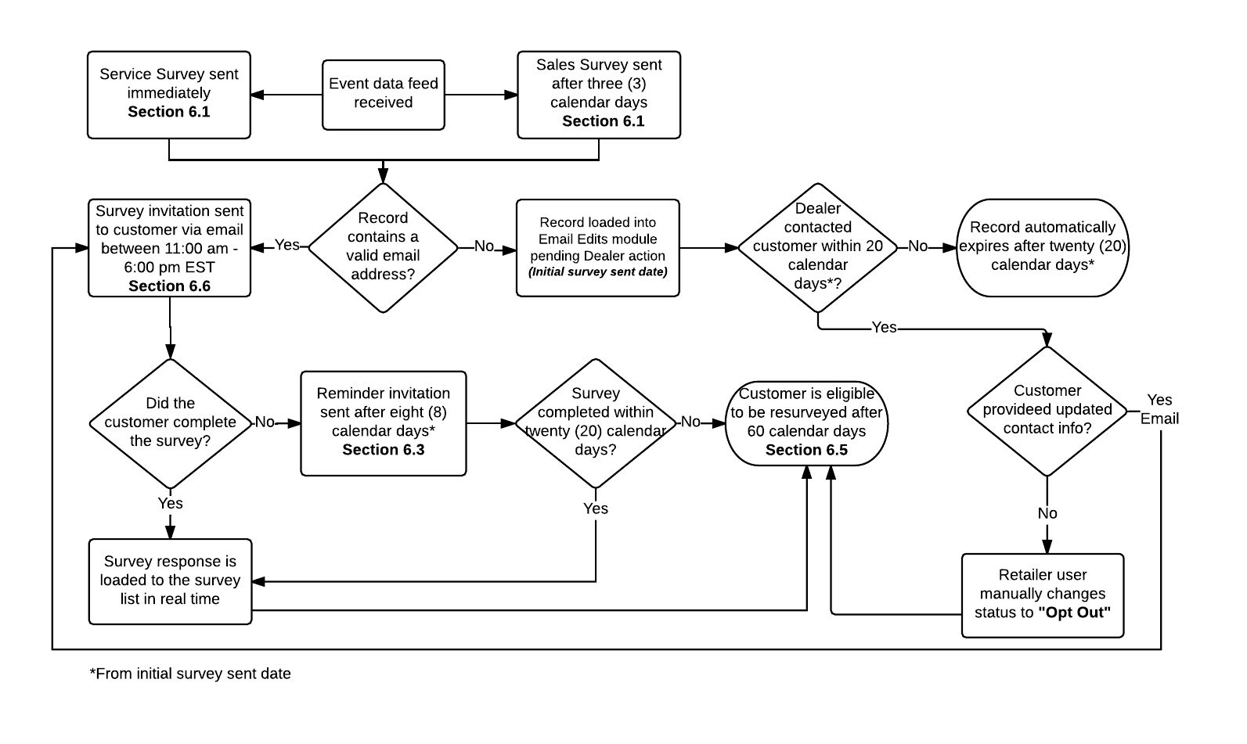

### SMS Process

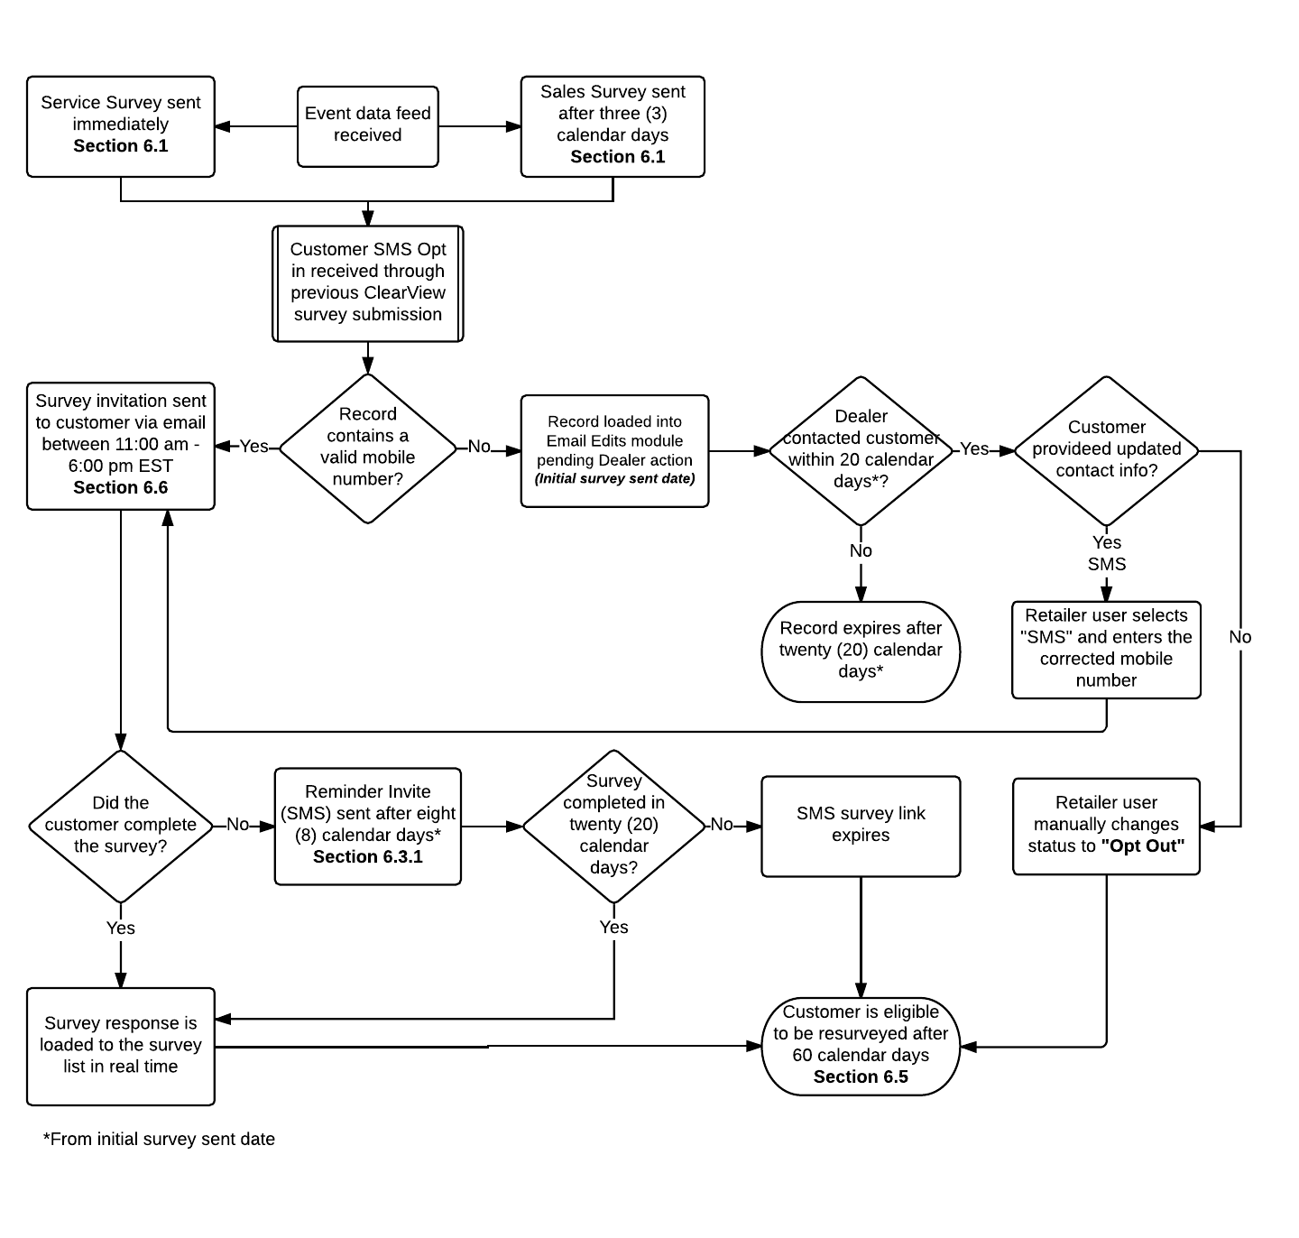



Section 7: e-Panel Program

ePanel Program

ePanel is a research tool to gather Toyota and Lexus customer insights through online surveys (sent via email only), to assist in making decisions, understanding product/quality concerns and product planning.

**TCI Final:** Only the following users will have access to ePanel survey results:

Stacey Metcalfe: [stacey_metcalfe@toyota.ca](mailto:stacey_metcalfe@toyota.ca)

Marzena Musielak: [marzena_musielak@toyota.ca](mailto:marzena_musielak@toyota.ca)

Daniela Erse: [daniela_erse@toyota.ca](mailto:daniela_erse@toyota.ca)

## Enrollment

When customers complete a sales or service survey for either Toyota or Lexus, they will be asked if they would like to become a member of ePanel.

In addition, Toyota Canada may also send a list of contacts to participate in ePanel surveys on an ad-hoc basis. These contacts, do not need to be added to the ePanel database and should be managed separately. For example, Toyota Canada currently conducts quarterly ePanels for the Customer Assistance Centre to understand customer satisfaction when dealing with CAC agents. The CAC provides a customer list to send the ePanel to, but the customers do not become part of the ePanel database.

## Survey Group Selection

At an anticipated volume of two to three surveys a month, Toyota Canada will identify an opportunity to solicit customer feedback to meet a business need, and will provide iSKY with survey questions to be deployed to a specific customer group, which can be determined based on the filter criteria below:

* last ePanel survey completion date
* demographic information
* vehicle information – hybrid/non-hybrid, *Require trim level here*
* customer opt-in based on sales or service survey
* historical ePanel survey completions

## Deployment

iSKY will deploy ePanel surveys to the customers identified via the survey group selection process. We will send these emails from the iSKY managed Toyota or Lexus inbox’s.

*Note: Should customers respond via email to this inbox, responses will be consolidated and sent to Toyota Canada for further action.*

In an effort to deploy the ePanel surveys to market as quickly as possible, ePanel surveys will also be integrated with our Survey Administration tool, allowing Toyota Canada the ability to modify and deploy surveys as required on their own. See section 11.1 – Survey Administration for more details.

Surveys will have variable validity periods and will be specified during the initiation of the request by Toyota Canada.

## Results Collection & Sharing

Results collected from these surveys will only be made available to the VOC team at Toyota Canada via the ClearView site. This will be managed via creation of a VoC Team role type.

**TCI Final:** Upon selecting the ePanel Survey results from the ClearView menu, the user will be navigated to a page where they will be able to review the results of in progress and completed ePanel Surveys.Each survey will be listed by date, with the newest ePanel surveys displaying on top.

* A raw-data export containing the Customer level survey details
* A summary report of the ePanel Survey campaign

The raw-data export will be available in excel, and .csv. If the data rows exceed 10,000 the download is defaulted to .csv. Please see the column headers for the raw data report below:

|  |  |
| --- | --- |
| Field | Description |
| ResponseID | Displays the unique survey response identifier |
| Q_Language | Displays the language the survey was completed under |
| STYPE | Displays the sales type of the customer: Purchase / Lease |
| CATEG | Displays the category (number i.e. 1) of the Dealer the vehicle was purchased from |
| CATNAME | Displays the category (name i.e. Category 1) of the Dealer the vehicle was purchased from |
| ZONE | Displays the Zone (number i.e. 1) of the Dealer the vehicle was purchased from |
| ZONENAME | Displays the Zone Name (name i.e. Central) of the Dealer the vehicle was purchased from |
| DCODE | Displays the Dealer code of the Dealer the vehicle was purchased from |
| DNAME | Displays the Dealer Name of the Dealer the vehicle was purchased from |
| MYEAR | Displays the vehicle model year |
| FULLMODEL | Displays the full model name (i.e. RX 350 SPORTDESIGN) |
| MODEL | Displays the model name (i.e. RX 350) |
| CITY | Displays the customer city |
| PROV | Displays the customer province |
| BUYER | Displays the customers stored response to demographics question (first time buyer) |
| ODATE | Displays the date the survey was opened |
| GENDER | Displays the customers stored response to demographics question (gender) |
| YOB | Displays the customers stored response to demographics question (year of birth) |
| AGE | Displays the customers stored response to demographics question (age) |
| HOUSEHOLD_INCOME | Displays the customers stored response to demographics question (household income) |
| Q1 | Include columns to displays all questions included on the ePanel survey |
| Etc. |
| QX |

A Summary excel report will also be created for each ePanel Survey Campaign and made available updating in real time, based on ePanel survey results. Each summary report will contain four (4) separate tabs:

1. Total by Region
2. Total by Vehicle Age
3. Total by Generation
4. Verbatim

The first three (3) will contain summary results for the ad-hoc survey results, broken out by group type. The first columns will display the questions from within the ad-hoc survey and the available responses, with the remainder of the columns displaying the count and percent of responses to each question result. Please refer to the example within Appendix G.

The last tab, Verbatim, will contain all verbatim comments received, grouped by survey question.

Both reports will be updated in real time, allowing users to view survey results and summaries before the ePanel survey campaign has ended.



Section 8: Data Requirements

# Data Requirements

## sFTP Location

sFTP (Secure File Transfer Protocol) provides file access, file transfer and file management functionalities over a reliable stream. This file transfer location will be the location where incoming data feeds are sent and will also be utilized for outbound data feed distribution by Toyota Canada and iSKY stakeholders.

At iSKY the protection of all customer data is very important to us. As such, any reporting required by Toyota Canada which contains sensitive customer data, will only be transferred via the sFTP detailed above.

**iSKY Proposed:** For communication between iSKY and Toyota Canada stakeholders. WinScP or FileZilla will be required to access the sFTP account. Folders have been created for iSKY and for Toyota Canada.

**Server**: ftp.isky.com **Port**: 22

**User**: toyotacanada

**Pass**: Toy0taC@nADa

*Toyota has a hub that they would use to push the file to us. Confirmed that if Toyota prefers to use their own SFTP site. Add PGP encryption testing to UAT schedule. Cannot email customer details even in reports. Wants to use the TCI sFTP site for sending inbound/outbound data feeds as well.*

## Import Data Feed

Customer event data is a critical component of a successful implementation. In order to ensure that the data collection process is streamlined, the data format and delivery method needs to be uniform.

**iSKY Proposed:** Customer event data will be loaded to the iSKY SFTP by Toyota Canada. The file will contain customer and event data for all retailers using the system. It is recommended that this be loaded daily (Monday – Friday) with the Monday file containing events that occurred Friday - Sunday.

The required file format is .XML, please review required data schema in Appendix D.

**Action Item**: iSKY to investigate importing data feed via API rather than sFTP.

## Import Data Feed Filters

iSKY requires a definitive method of excluding customer event types such as Labour operation codes. Any event where only a portion of the record meets the filter criteria is eligible to be surveyed.

There are 4 types of data filters:

1. Fraud Detection - The customer’s name/email address/phone number is the same as the Retailer’s address
2. Duplicate within file - Duplicate VIN, email address, customer name etc.
3. Data Sanity - Invalid/missing customer details
4. Business Rules -Survey frequency, unsubscribe, vehicle age etc.

**TCI Final:** iSKY will perform data feed filtering/scrubbing on Toyota Canada’s behalf. Please refer to the filter criteria within Appendix D.

## Launch Data Requirements

Best practices have proven that one of the key drivers of user engagement during implementation is a larger than usual sample size of survey returns. iSKY recommends providing two (2) weeks of event data in order to ensure that the initial survey blast will release greater survey responses allowing retailers to quickly practice and adapt to the new system.

**TCI Final:** No historic data will be provided for an initial survey blast.

## Data Delivery Alerts

iSKY has an automated monitoring system to ensure the successful delivery of data flow. This allows for increased corporate oversight. Email notifications will be sent should the following occur:

* File submission failure for two (2) consecutive occurrences
* A record deviation count is detected e.g. 100 records today and only 2 tomorrow.

**TCI Final:** Please provide a minimum of two (2) recipients for data delivery alerts:

|  |  |
| --- | --- |
| **Name** | **Email Address** |
| Stacey Metcalfe | stacey_metcalfe@toyota.ca |
| Marzena Musielak | marzena_musielak@toyota.ca |
| Daniela Erse | daniela_erse@toyota.ca |

*Note: Please reference Appendix B - Communication Template for alert verbiage.*

## Sales Unwind Process

In the event of a cancelled/returned Sales event, ClearView contains a process for managing the survey results, and ensuring the true customer experience is captured.

**TCI Final:** Cancelled Sales events are communicated through the Sales inbound event data feed. Please refer to Appendix D –Sales Import Data Feed for more details.

If a sales unwind is received the survey record is removed, and displayed in the Deleted Surveys tab. If a new Sales event is received for the same customer (based on Customer Name + Customer ID) a new survey is not sent. The initial survey is not reinstated.

If a new Sales event is received for a different customer then the event is surveyed as normal.

## Dealer Buy/Sell/Termination Logic

In the event of a Dealer Buy/Sell or termination, the terminated (or sold) retailers data remains in the data rollups, they marked as inactive, however is no longer available in the hierarchy selections or reports when there is no longer data for them. For example, if a Dealer had surveys for January, and was terminated Jan 21:

Reviewing a January MTD report – Dealer would be displayed (as they were active in January)

Reviewing a February MTD report – Dealer would not be displayed (as they were not active in February)

Reviewing a March QTD report – Dealer would be displayed (as they were active within the quarter)

Reviewing a June QTD report – Dealer would not be displayed (as they were not active within the quarter).

**TCI Final:** Toyota Canada will provide a daily “Dealer Update File” that will communicate Dealer buy/sells, terminations, new dealer openings, and territory alignments. For Buy/Sells – New Dealer code is overwritten on the ClearView platform, and the new dealer *will inherit* the previous Dealers data.

Please refer to the data feed template within Appendix F.

## VIN Decoder

ClearView has the ability to send survey invites containing model specific images. This is done through mapping the model type to the image using the vehicle identification number (VIN). In order to ensure that we are including model specific images for newly released models, iSKY requires updated VIN Decoder details in the event of a new model release.

**TCI Final:** Toyota Canada provided the existing VIN Decoder.

*Note: Toyota Canada to provide updated VIN Decoder details in the event of updates.*

## Data Center

Data integrity and security is crucial for your customers’ personal information confidentiality. iSKY ensures continuous data backups and the use of secure channels for data communication to and from its customers. The ClearView solution would be installed in the data centers around the world, to cater for individual regions, including their customer data needs.

**TCI Final:** Data centre is located in Dallas, TX, USA.

### Data Process Map

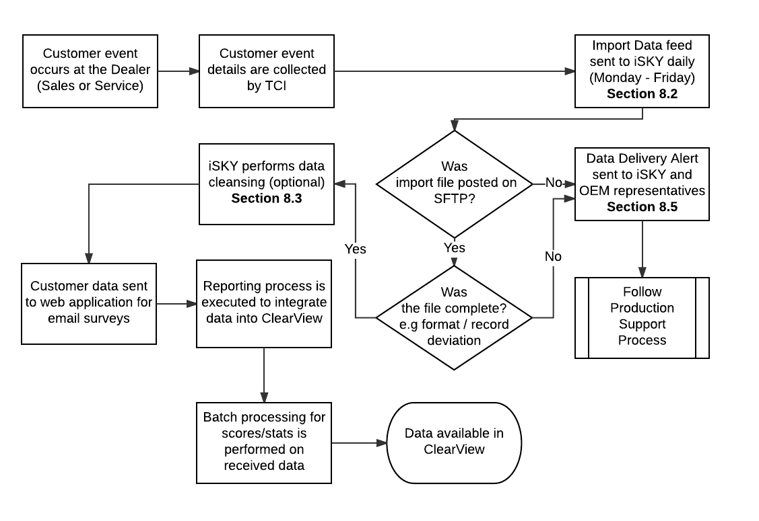





Section 9: ClearView

# ClearView

ClearView provides survey results in a way that is engaging and easy to understand. When a user logs on, they land on the dashboard designed specifically for that users’ hierarchy level. In order to drive user adoption, ClearView displays relevant information for each user group within the defined hierarchy ensuring that actions can be taken from every level.

**Menu Navigation:**

|  |  |  |
| --- | --- | --- |
| **USER: National (And below)** | | |
| **Menu Selection** | **Sub Heading** | **Drill Down** |
| Dashboard | Dashboard |  |
|  | Survey List |  |
|  | Email Edits |  |
|  |  |  |
| Closed-Loop | Closed Loop | Closed Loop Summary |
|  |  | Closed Loop List |
|  |  |  |
| Reports | Contact Statistics |  |
|  | Organization Summary |  |
|  | Performance Trend |  |
|  | Cross Tabs |  |
|  | Report Generator |  |
|  | Manipulation Reports |  |
|  | National Sales Results Report |  |
|  | National Service Results report |  |
|  | Consultation Dealer report |  |
|  | Portal Traffic | Login Summary |
|  |  | Login & Traffic Stats Details |
|  |  | Login & Site Traffic Summary |
|  |  |  |
| VoC | VOC | Tree Report |
|  |  | Comment List |
|  |  |  |
| Social Media | Social Media |  |

|  |  |  |
| --- | --- | --- |
| **USER: VoC User** | | |
| **Menu Selection** | **Sub Heading** | **Drill Down** |
| Dashboard | Dashboard |  |
|  | Survey List |  |
|  | Email Edits |  |
|  |  |  |
| Closed-Loop | Closed Loop | Closed Loop Summary |
|  |  | Closed Loop List |
|  |  |  |
| Reports | Contact Statistics |  |
|  | Organization Summary |  |
|  | Performance Trend |  |
|  | Cross Tabs |  |
|  | Report Generator |  |
|  | Manipulation Reports |  |
|  | National Sales Results Report |  |
|  | National Service Results report |  |
|  | Consultation Dealer report |  |
|  | Portal Traffic | Login Summary |
|  |  | Login & Traffic Stats Details |
|  |  | Login & Site Traffic Summary |
|  |  |  |
| VoC | VOC | Tree Report |
|  |  | VoC Interface |
|  |  | Comment List |
|  | ePanel Results | List individual e-Panel Survey Names |
|  |  |  |
| Social Media | Social Media | Social Media |
|  |  |  |
| Survey Administration | Survey Administration | Survey Administration |

*Note 1: A brand selection dropdown will be available, allowing users to toggle between Toyota and Lexus. Please note the navigation menu will be the same for both brands.*

*Note 2: Within each brand specific dashboard, there will be a tabs to select between Sales and Service and TCUV (Toyota Certified Used Vehicle) / LCPO (Lexus Certified Pre-Owned)*

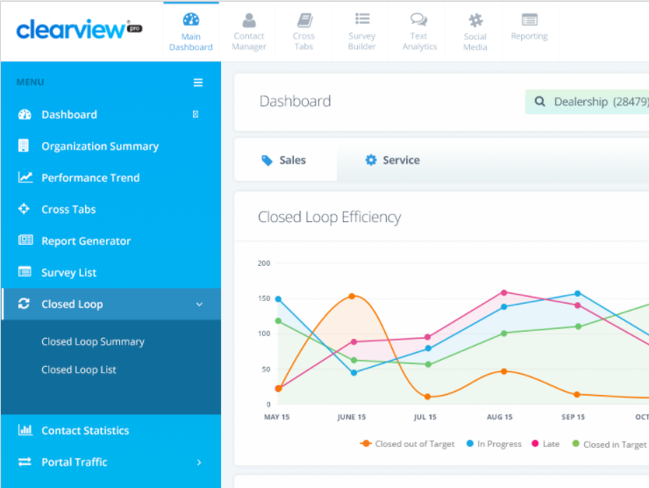

## Functionality

Whether you’re navigating dashboards or looking to document program success with some deep-data findings, ClearView gives you a complete, exportable view of any and all data relevant to your CX program.

### Date Range Selection

Users have the ability to view data by preselected date ranges.

**TCI Final:** The following date range selections will be available.

|  |  |
| --- | --- |
| * MTD | * R6M |
| * YTD | * R12M |
| * Previous Month | * Custom |
| * R3M (actual rolling 3 months) |  |

*Note: There will be no availability of the custom date range selection on the following dashboards: Main Dashboard, Closed Loop Summary, VoC Dashboard, Email Edits, and Social Media Dashboard.*

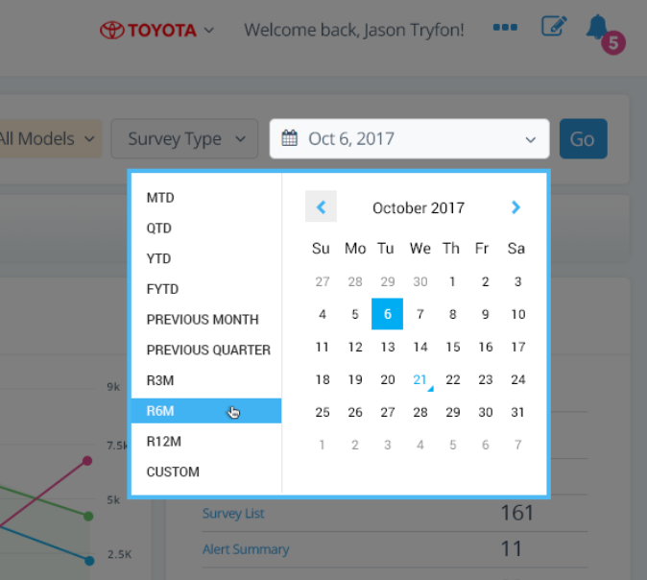

### Search Criteria

Users can search for specific customers by various data points throughout ClearView.

**TCI Final**:

| **Hierarchy:** | **Vehicle Model/Model Year:** | **Survey Type:** |
| --- | --- | --- |
| National, Zone, Category, Zone Category, Dealer, and Employee level | **Level 1**: “All” selection & Model Year & Model Year 1-3 / Model Year 4-7  **Level 2:** “All” selection & Hybrid/Non-Hybrid  **Level 3:** “All” selection & List of….  **Toyota Models:**  Yaris Hatchback  Yaris Sedan  Corolla  Corolla iM  86  Prius C  Prius  Prius V  Camry  Avalon  Sienna  C-HR  RAV4  Venza  Highlander  4Runner  Sequoia  Tacoma  Tundra  **Lexus Models:**  CT  IS  RC  RC F  ES  GS  GS F  LC  LS  NX  RX  GX  LX | Email, SMS, All |

* Hierarchy Search mock up:

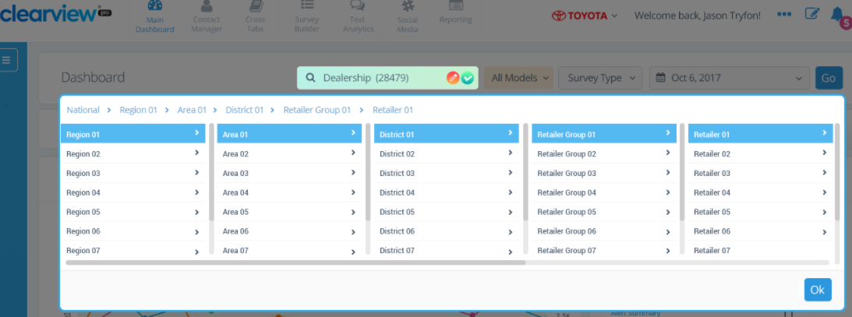

* Vehicle Model/ Model Year search mock up:

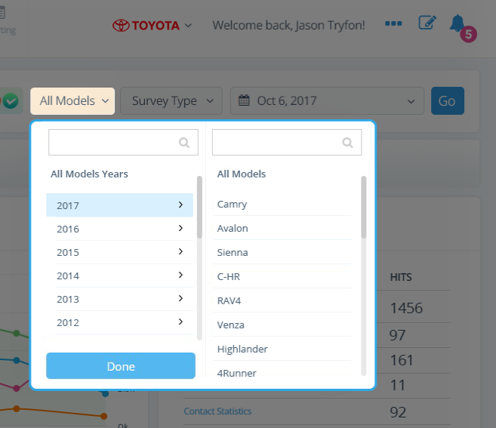

* Survey Type search mock up:

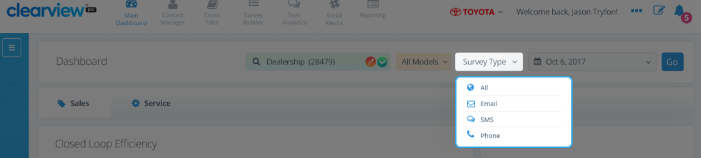

### Export Formats

Every screen within ClearView can be exported for printing or sharing purposes.

**TCI Final:** ClearView screens can exported in PDF and Excel format. Excel records, if over 10,000 rows, will export in .csv format. Excel downloads to include selected date range and filters.

### Customer Search

The Search page will contain a search function that allows users to search for surveys and view their status. The search criteria are:

* Customer Name
* Customer ID
* RO Number / Deal Number
* VIN
* Phone No.
* Email Address

The search results that display are based on the users’ data hierarchy access (i.e. Dealer users only see their own data, corporate users can view data for all Dealers). The results will display in a table format with the following column headers:

* Event Type (event type)
* Dealer Code
* Customer Name
* RO Number / Deal Number
* VIN
* Phone No.
* Email Address
* Event Date
* Survey Sent Date
* Status

The available status’s are:

* Scrubbed
* Pending Deployment
* Sent
* Completed
* Expired
* Abandoned
* Invalid

## Dashboard

Dashboard KPIs and Widgets are updated on a nightly basis to ensure optimal efficiencies and site speed.

### Key Performance Indicators (KPI)

Appearing at the top of the ClearView dashboard will be space allocated for specific KPI’s that are pertinent to Toyota Canada’s customer experience strategy.

**TCI Final:** Each dashboard will display four (4) key performance indicators (KPIs). KPI’s are calculated based on the survey received date, unless otherwise specified:

|  |  |  |  |  |  |
| --- | --- | --- | --- | --- | --- |
| **KPI Name** | **Description** | **Display on** | | | |
| **Overall** | **Sales** | **CPO** | **Service** |
| **Net Promotor Score (NPS)** | Calculated as the percent of promotor responses (responses of 9 or 10) subtracted by the percent of detractor responses (responses of 0 to 6) on the Recommend question within the survey (Q# - TBD). NPS scores can range from -100 to +100. | ✓* | ✓ | ✓ | ✓ |
| **Captured Contact Information (%)** | Calculated as the percent of valid events that contained a valid contact to send a survey (email or SMS).  *Note: Captured Contact Information is calculated by event received date.* |  | ✓ | ✓ | ✓ |
| **Closed Loop Rate (%)** | Calculated as the percent of surveys received within the selected date range that triggered a closed loop alert. |  | ✓ | ✓ | ✓ |
| **Closed Loop Resolution (%)** | Calculated as the percent of closed loop alerts that were closed within the selected time frame (please refer to section 9.4.4 – Closed Loop Target (KPI) for details). | ✓* | ✓ | ✓ | ✓ |

*Does not contain CPO

*Note: It is possible to add additional KPIs to the dashboard, but to ensure ease of comprehension it is recommended that no more than four (4) are displayed. Should additional visual data representations be required, widgets can be developed to meet these needs.*

**Ranking Details:**

National– No ranking displayed

Category – Rank to National

Zone – Rank to National

Zone Category – Rank to National Category

Territory – Rank to Zone & National

Dealer – Rank to zone & National

Dealer Category – Rank to Zone Category

**Event Tabs Details:**

|  |  |
| --- | --- |
| **Overall Dashboard** | Gauges show Sales NPS / Service NPS / Sales Closed Loop Resolution (%)/ Service Closed Loop Resolution (%)  Below the gauges the widgets will show the separate key drivers separated by event type.  The widgets displayed in the Overall Dashboard are:  Performance Trend  Comment Count Trend  Closed Loop Wheel  Areas of Improvement  Please refer to 9.2.2 for further details on the widget contents. |
| **Sales/Service/CPO** | All gauges and widgets displays data only pertaining to the event type selected |

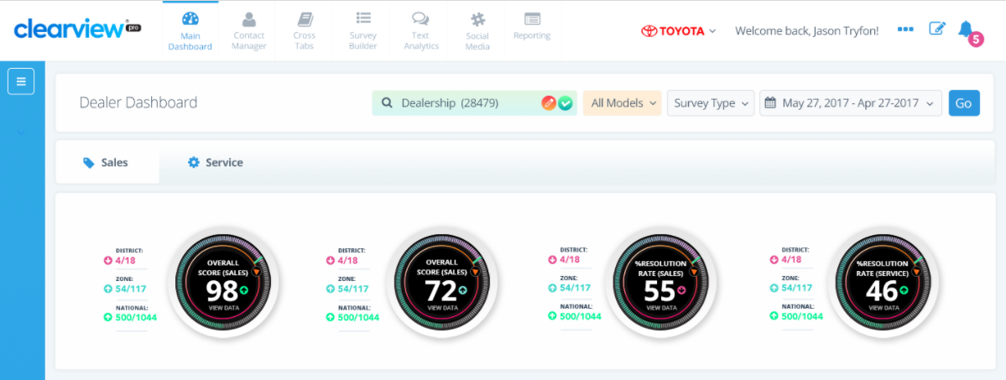

**Action Item:** iSKY to create wireframes for TCI review for Overall vs. Event Type specific dashboard.

### Dashboard Widgets

The data widgets will be displayed under the main KPIs listed above on the dashboard. These rich data visualizations will allow users to drill down into more specific customer experience results.

**TCI Final:** The following Dashboard Widgets will be included on the standard Toyota / Lexus Canada Dashboard:

| **Widget** | **Description** | **Click Through** | **Example/Calculation** |
| --- | --- | --- | --- |
| **Performance Trend** | KPI scores trended over set date range | Performance Trend | Based on Net Promotor Score (NPS) |
| **Closed Loop** | Overview of Closed Loop metrics | Closed Loop List | Closed Loop KPI  Total Counts of Closed Loop metrics |
| **Areas of Improvement** | Lowest scoring questions | Organization Summary | Dynamic based on results. Widget will be question level based showing three (3) lowest scoring questions on survey. |
| **Top/ Bottom Performers** | Top/bottom 5 retailers based on NPS | Organization Summary Report | Based on Net Promotor Score (NPS)  Dynamic based on hierarchy. Corporate level users view Dealerships, Dealer users view Advisors |
| **Comments Count Trend** | Total count of Positive, negative, neutral comments | Comment List | Survey volume compared to % of surveys with sentiment |
| **Closed Loop Efficiency** | Closed Loop month over month trend | Closed Loop List | N/A |
| **Key Performance** | Your highest/lowest scoring questions | Organization Summary Report | N/A |
| **Portal Traffic** | Counts of site page views | Portal Traffic Report | *Note: Only displayed on National hierarchy view* |
| **Survey Completion Rate** | Survey statistics | Contact Statistics | Total Events  # of Valid email addresses received  # of surveys sent  # of surveys started  # of completed surveys |

|  |  |
| --- | --- |
| **Performance Trend** | **Survey Completion Rate** |
| Reports on Net Promotor Score (NPS) | Total Events / # of Valid email addresses received / # of surveys sent / # of surveys started / # of completed surveys |
|  |  |

|  |  |  |
| --- | --- | --- |
| **Closed Loop** | **Areas of Improvement** | |
| Closed Loop KPI | 3 Lowest scoring questions | |
| Total Counts of Closed Loop metrics | Who is impacting scores – based on hierarchy | |
|  |  | |
| **Top/Bottom Performers** | **Comment Count Trend** | |
| Net Promotor Score | Survey volume compared to % of surveys with sentiment | |
|  |  | |
| **Closed Loop Efficiency** | |
|  | |

|  |  |
| --- | --- |
| **Key Performance** | **Portal Traffic** |
|  |  |

### Customized Dashboard

Users at every level can have the ability to customize their view on the dashboard by selecting several optional (maximum of five) widgets to display on their main dashboards.

**TCI Final:** The following optional widgets and corresponding visualizations for users to select. Please indicate which KPI’s are to be measured within each optional widget.

| **Optional Widget** | **Description** | **Click Through** | **KPI** |
| --- | --- | --- | --- |
| Dealer Performance | Scores by Dealer/Region/National | Organization Summary Report | Net Promotor Score |
| Year over Year | Current vs prior year NPS | Organization Summary Report | Net Promotor Score |
| Customer Comments | List of recent customer comments | Comment Search | N/A |
| Recommendation - By Region | Map showing recommendation scores | Organization Summary Report | N/A |
| Survey List | List of the most recent surveys received in real time | Selected Survey List | N/A |
| Recent Recommendations | Comments from recommend question | Survey List/Comment List | N/A |
| Target Score | Target set by OEM | Organization Summary Report | TBD |
| Heat Map | Totals by region in visual display | Organization Summary | Overall Survey Score |
| Sentiment Analysis | Word cloud and counts | Comment List | Word size indicates the frequency the word was used. |

|  |  |  |
| --- | --- | --- |
| **Dealer Performance** | | |
| Net Promotor Score | | |
|  | | |
| **Year Over Year** | | |
| Net Promotor Score | | |
|  | | |
| **Customer Comments** | **Recommendation by Region** | |
| List of recent comments submitted by customers. | Map showing recommendation scores. | |
|  |  | |
|  |  | |
| **Survey List** | | |
| Recently added surveys | | |
|  | | |
| **Recent Recommendations** | | **Target Score** |
| Recently added positive comments to recommend survey question | | NPS |
|  | |  |
| **Sentiment Analysis** | | **Heat Map** |
| Word counts pulled from question response verbatim | | KPI Overall Survey Score  E.g. Total Surveys received, NPS etc. |
|  | |  |

## Survey Results

The Survey List in ClearView is a centralized location that displays completed questionnaires received through all methodologies, including all information related to each response. These pages can be filtered by a wide range of criteria based on the user access levels.

### Survey List

Within the Survey List, you can drill down and review each profile, which includes the survey response by question as well as all related customer details.

**TCI Final**: See below mock up and column headers to be displayed. A toggle button will allow users to switch to Sales or Service view.

*Note: A survey list page will exist for each brand – Toyota and Lexus and each will have its own sales/service toggle*

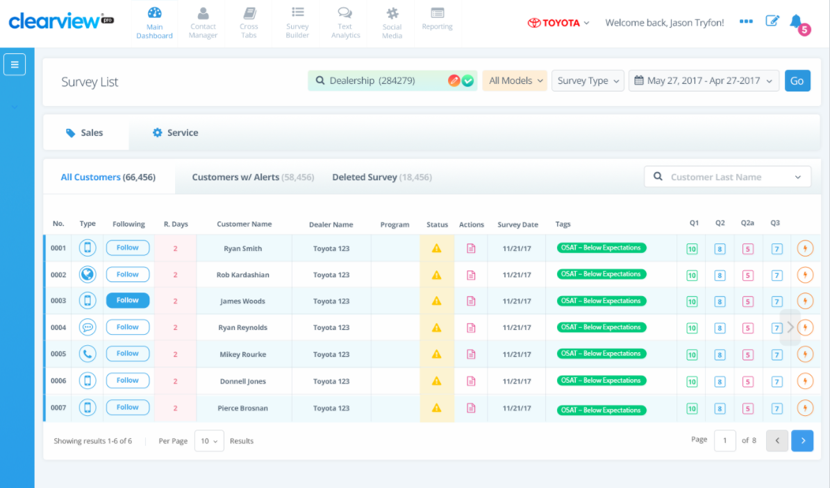

|  |  |  |
| --- | --- | --- |
| **Column Name** | **Description** | **Click Through** |
| Following | Option for a Management user to receive email updates on case | Once clicked, the user begins “following” the Closed Loop, and will receive notifications, along with the Closed Loop assignee for Closed Loop reminders, and will be notified in the event of status changes. |
| Customer Name | From Event data | Once clicked, will open the Customer History Page. Please see section 9.3.2 Customer History for details. |
| Customer ID |  |  |
| Dealer Name | From Event data | N/A |
| Advisor Name |  |  |
| Status | Closed Loop Status | Once clicked, will open the Customer History Page. Please see section 9.3.2 Customer History for details. |
| Action | Closed Loop Comments | Once clicked, will open the Customer History Page. Please see section 9.3.2 Customer History for details. |
| Vista | Corporate Closed Loop Created | Will display a *red X (or something)* if:  -Customer requested follow up by TCI within survey  -Closed Loop “escalation 2” to corporate  If a Vista Case is created, the “Closed Loop” is closed and no KPI credit is given. No Follow up email is sent. |
| Follow Up Response | Displays the Customers response to the follow up email |  |
| Survey Date | Date survey was submitted | N/A |
| Closed Loop Trigger (Tags) | The question “nickname” that triggered the Closed Loop. | Once clicked, will open the Customer History Page. Please see section 9.3.2 Customer History for details. |
| Q1-Qxx | Question responses submitted | Will be highlighted if a comment submitted on this question |

#### Customer Search

Corporate level users and below will be able to search for a specific Customer record by completing at least one (1) of the below search fields:

* Customer Last Name
* VIN
* Customer Code

### Customer History

When a user clicks on a specific customer response they will be brought to a customer history screen. Within the customer history, users are also able to conduct the Closed Loop process or review previous comments that were entered regarding the customer’s concerns.

**TCI Final:** See below mock up and column headers to be displayed. In the Closed Loop Section, Resolution tags are mandatory in order to close an issue. Any corporate user following an issue will not be displayed at the Dealer level.

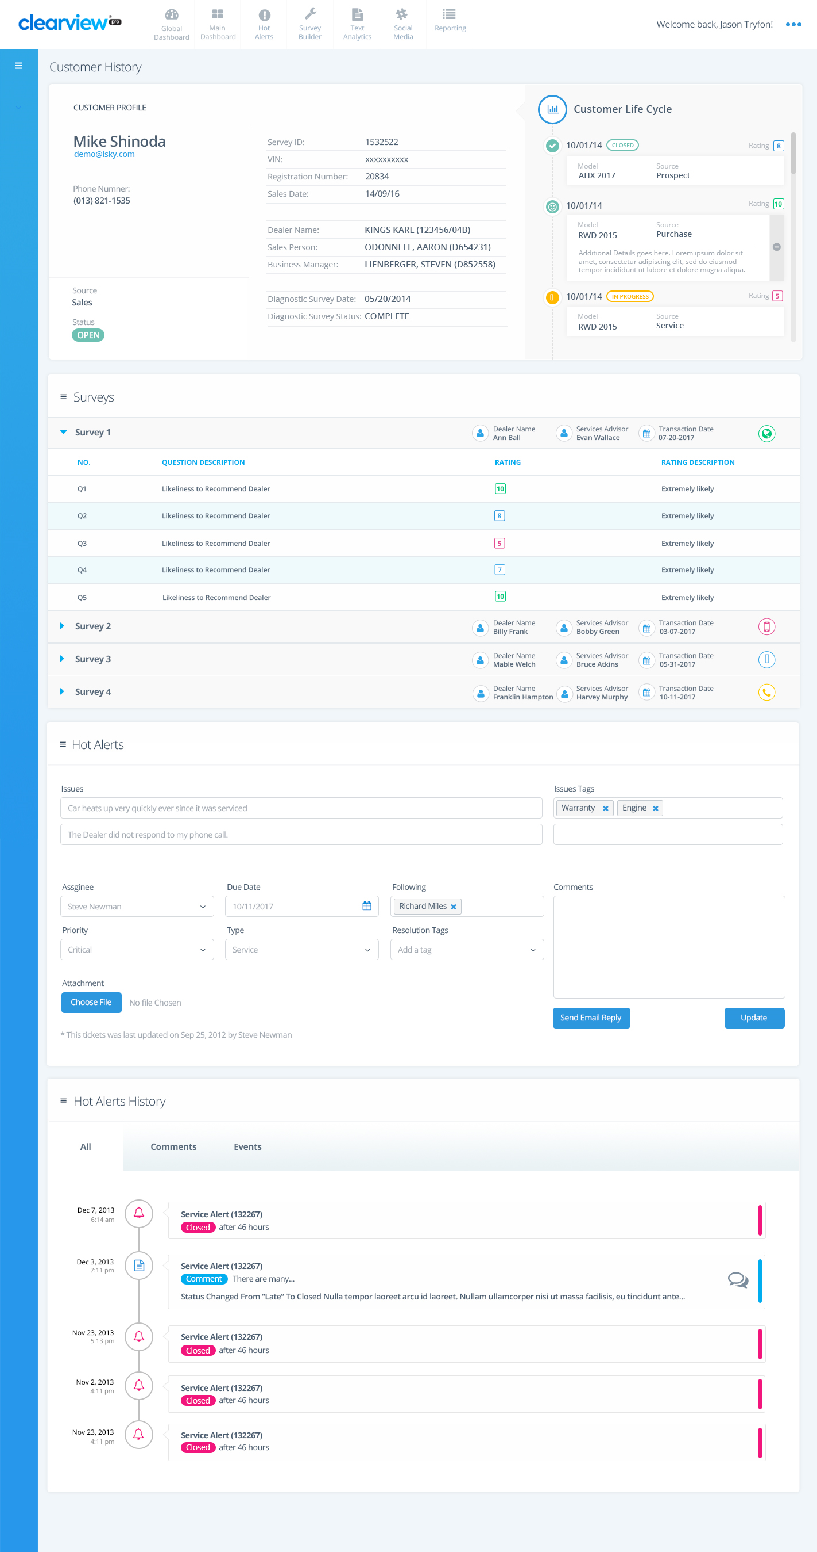



|  |  |  |
| --- | --- | --- |
| **Customer Profile** | **Surveys** | **Closed Loop** |
| Name | Question # | Issues - Questions Triggered |
| Email Address | Question Description | Issue Tags (please see below) |
| Personal phone | Question Rating | Assignee |
| Business phone | Question Rating Description | Comments |
| Personal cell phone | Previous Survey Replies | Attachments |
| Survey ID |  | Due Date |
| VIN |  | Following |
| Customer Code/ID |  | Comments |
| Transaction date |  | Type |
| Dealer Name |  | Resolution Status |
| Service Advisor / Sales Consultant |  | Resolution Tags (please see below) |
| Technician / F&I Manager |  |  |
| Survey Date |  |  |
| Source - Sales / Service |  |  |
| Closed Loop Status |  |  |

|  |  |
| --- | --- |
| **Tag Type** | **Tags** |
| Issue Tags | TBD |
| Resolution Tags | * Explained charges to customer * Apology – Additional employee training conducted * Apology * Booked new appointment – free diagnosis * Provided additional information * Additional request fulfilled * Vehicle returned * Resolved Repair issue * Emailed Customer * Apology – Free Oil Change * Apology – Parts Not Available * Complete Repair * Courtesy vehicle * Vehicle Replacement / Buy Back * Repair Cost Assistance |

## Closed Loop, Thresholds and Key Performance Indicators

ClearView’s case management module is designed for issue, or complaint resolution when a customer shows dissatisfaction in the survey or requires assistance.

### Closed Loop Triggers

Within the ClearView Closed Loop workflow, the survey threshold is the predetermined score set by the OEM that triggers the Closed Loop email alert. Any score that falls below the threshold will generate an alert flagged on the Dashboard for the Dealer to follow- up and resolve.

**TCI Final:** Sales and Service surveys questions 1, 3 & 5 with a score of 6 or less. Please refer to the full survey details within Appendix C.

In addition, the surveys will contain a checkbox that asks if the Customer would prefer contact from Toyota corporate. If the customer selects this checkbox, **a Closed Loop is not created** for the Dealership but an alert is sent to a centralized email inbox at Toyota Canada, where a Vista case will be created and managed (outside of ClearView).

### Escalation Alert Assignment Hierarchy

ClearView is equipped with an auto-assignment feature that automatically assigns a Closed Loop to a Manager for a below threshold survey response based on job title. This helps to create a sense of ownership when resolving customer satisfaction issues and is the starting point of the Closed Loop process.

The automatic assignment works in a hierarchical fashion from the top down, alerts are to be assigned to the next available role in the hierarchy should the first role in a specific category be unfilled.

**TCI Final:** If a Sales or Service survey triggers a Closed Loop, an alert is sent to the Sales or Service Manager within the Dealership, determined by the SSO Role ID (please refer to Appendix I – SSO Role Mapping for details).

If no Action is taken on the Closed Loop within two (2) business days from the Closed Loop generated date, the 1st Escalation alert is sent to the recipient specified within the User Admin module (please refer to 3.3 User Admin Module for details) and the issue is assigned to that user.

If no Action is taken on the Closed Loop within three (3) business days from the Closed Loop generated date, the 2nd Escalation alert is sent to Toyota Canada for creation of a Vista Case, and the Closed Loop is automatically closed with the status “Closed After Target”. If the Closed Loop is auto-closed, the Follow up email is not deployed.

During the User setup process, users can be allocated as an alert recipient either at the Dealer level, or as the corporate escalation contact within the user admin module.

* Notification Email – Initial Assignee (i.e. Sales or Service Manager)
* Dealer Escalation - 1st Escalation Contact (i.e. General Manager – Escalation point within Dealership)
* Corporate Escalation - 2nd Escalation Contact (Consumer Action Center) – Email notification sent to general inbox and auto-closed – Prevent follow up survey deployment.

### Alert Content

ClearView contains a variety of alert notifications that communicate issues directly to the user’s email inbox or smartphone. The content for ClearView alerts can be customized by Toyota Canada.

**TCI Final:** Please refer to Appendix B for the alert email content. .

### Follow-up Email Alert Assignment

If the customer responds negatively to the follow-up email, an email alert will be issued directly to Dealer management.

**TCI Final:** Follow up email alerts will be sent directly to the Sales or Service Manager.

*Note: Please refer to Appendix B for the proposed communication templates.*

### Closed Loop Target (KPI)

One of the KPIs built directly into the Closed Loop process is the Closed Loop Target. The Closed Loop Target is measured by the number of days between receipt of the below-threshold survey, and the date the issue was closed.

The target is used as a metric of the Closed Loop Rate Key Performance Indicator, and is one of the key drivers that define if the Dealer will receive Closed Loop credit.

**TCI Final:** Closed Loop should be closed within three (3) business days for both sales and service event types.

### Closed Loop Status

The ClearView Closed Loop process includes five (5) status types: New/In-progress, Late, Closed within Target, and Closed out of Target:

* New/In-Progress indicates that a customer issue has been received and assigned to a Manager for follow-up.
* Closed within Target indicates that the issue has been addressed and resolved by the Dealer within the given target.
* Closed out of Target indicates that the issue has been addressed and resolved by the Dealer outside of the given target.
* Late indicates that the issue has not been addressed and remains open in the system outside of the Target.

**TCI Final:** Status types are ClearView standard and only time management can be customized based on Toyota Canada’s business rules. Please refer to table below.

|  |  |  |  |
| --- | --- | --- | --- |
| Status | Icon | Time | Action/Alert |
| New |  | Time passed since Closed Loop Posted < 24 business hrs | Closed Loop notification sent to Assignee  Total **business** day = 0 |
| New |  | 24hrs <= Time passed since Closed Loop Posted < 48 business hrs | Reminder notification sent to Assignee  Total completed **business** days =  1 |
| Late |  | Time passed since Closed Loop Posted => 48 business hrs | Closed Loop Escalated to Dealer Escalation, notification sent to Assignee  Total completed **business** days = 2 |
| Late |  | Time passed since Closed Loop Posted = 72 business hrs | Closed Loop Escalated to Corporate Escalation, and auto-closed (closed after target). Follow up email is not sent.  Total **completed** **business** days >= 3 (once the 3rd business day has completed and the issue cannot be closed within target) |
| In Progress |  | N/A – Manual adjustment | The Status changes to “In Progress” when the Assignee changes the status of the Closed Loop and updates it from the Customer History page. |
| Closed within Target |  | Within set target | Assignee can change the status as needed. |
| Closed after Target |  | After set target | Assignee can change the status as needed. |

### Follow-up email

ClearView has a unique Closed Loop feature called the Follow-up email that allows Dealer management to confirm with the customer that their issue was dealt with in a professional and positive manner.

**TCI Final**: If a Closed Loop is triggered on a Sales or Service event, upon closure of the Closed Loop a follow up survey is delivered to the Customer to ensure they were satisfied with the Dealers response. If the Closed Loop is auto-closed (at 3 business days), the Follow up email is not deployed. If a customer has selected SMS as the preferred method of contact, the follow up survey invitation will be deployed by SMS. Please refer to Appendix B - Communication Template to review the Sales and Service communication text.

*Note: Please refer to Appendix B for the proposed communication templates.*

### Reopen/Close Closed Loop Option

In ClearView, the default setting for closed issues prevents them from being reopened. For those customers who respond negatively to the follow-up email, further action can take place and can be logged in the Comments section feature in the customer response. This default should remain active. If not, there is a risk of skewing the accuracy of the Closed Loop Rate.

**TCI Final:** Closed Loop cannot be reopened, however additional comments can be logged if desired.

### Closed Loop Summary

This Dashboard displays all Hot Alerts KPIs with the ability to drill down by hierarchy views.

**TCI Final:** Below is a proposed list of widgets and corresponding visualizations.

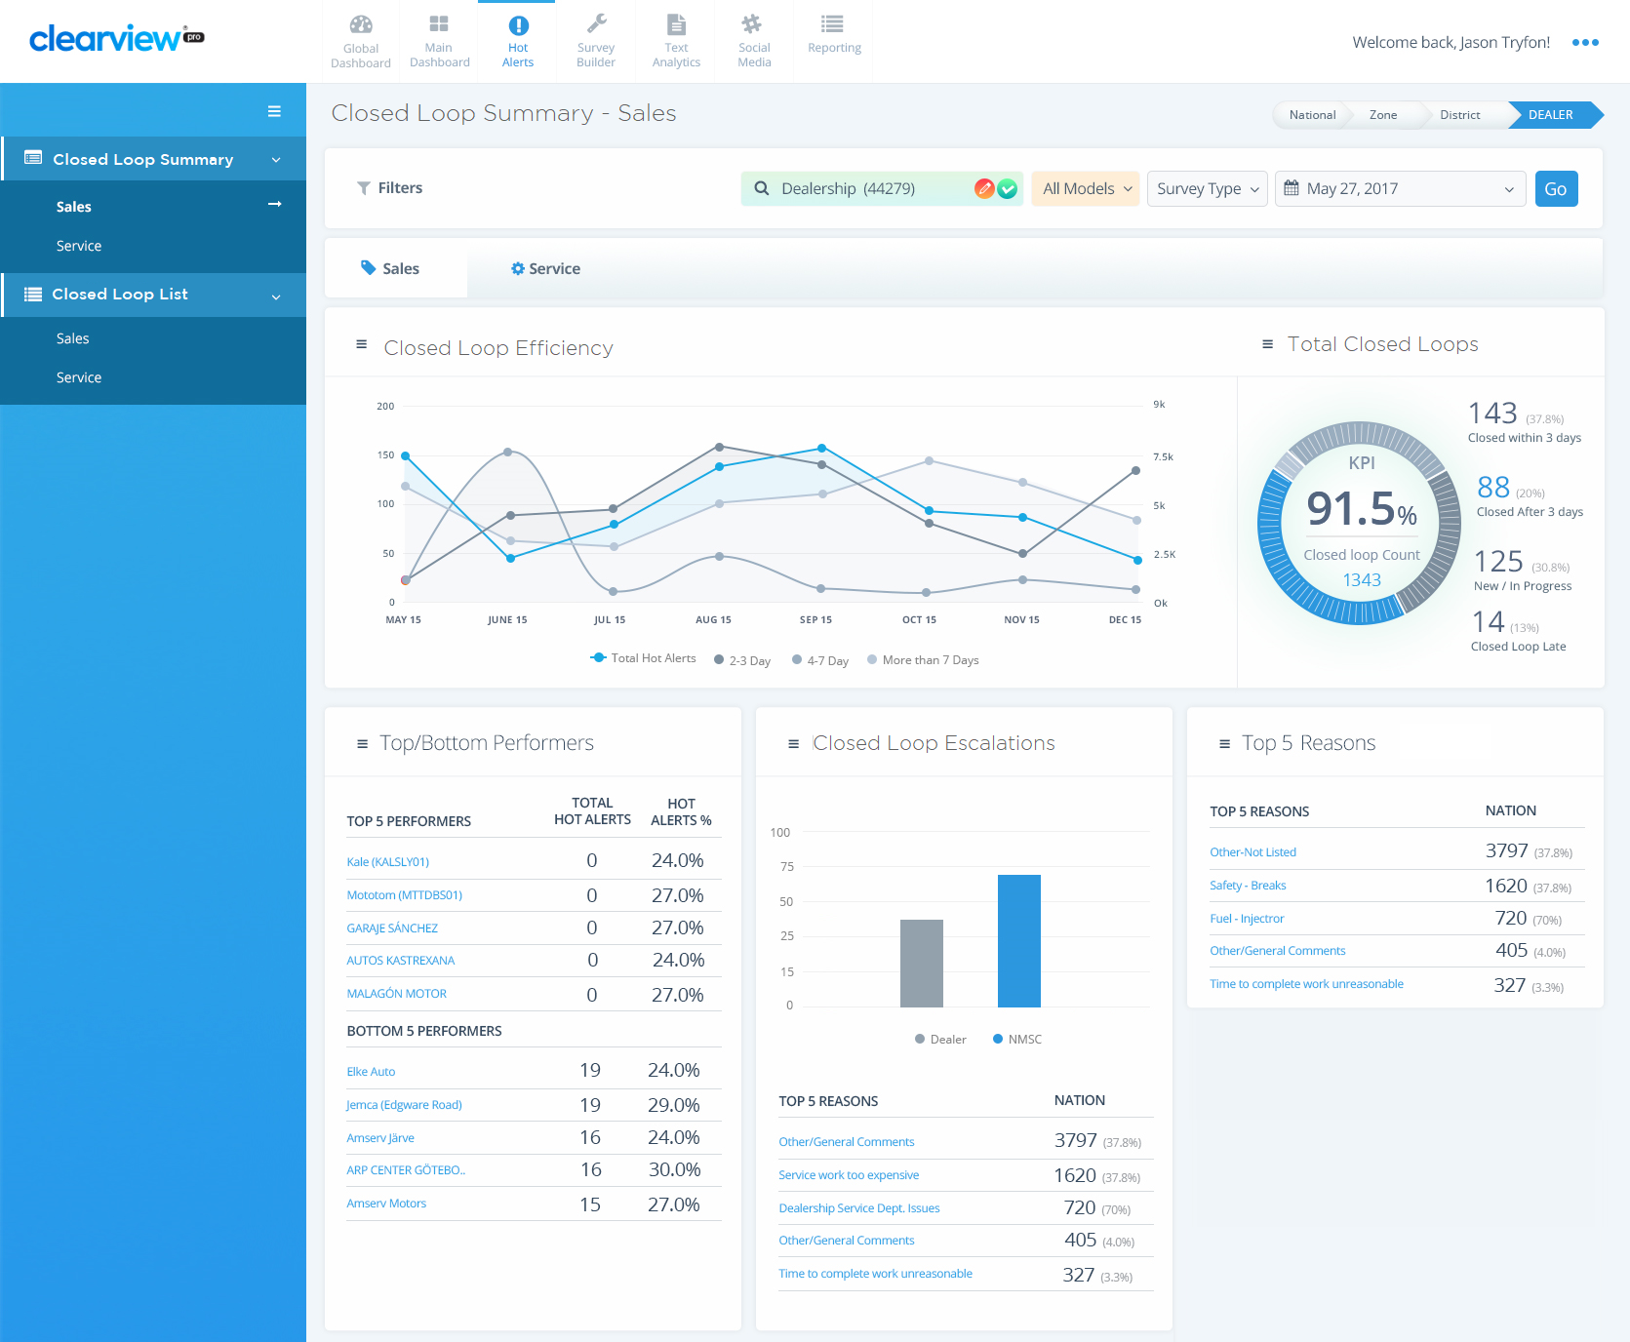

|  |  |  |
| --- | --- | --- |
| **Widget** | **Description** | **Click Through** |
| **Closed Loop Efficiency** | Monthly trend by Closed Loop status | Closed Loop List |
| **Total Closed Loops** | Pie Chart displaying the percentage allocation per Closed Loop Status | Closed Loop List |
| **Top/Bottom Performers** | **Corporate View**:  Top5/Bottom Dealers (count and Issue Resolution)  **On Dealer View:**  Top5/Bottom 5 Advisors  **Number Format:** Total Closed Loops = 1,000 / Issue Resolution = 100.0%. | Closed Loop List |
| **Reasons/Escalations** | Top 5 reasons from tags within Closed Loops (count)  Bar Graph shows percentage difference on Closed Loop assignment to Dealer/Corporate (based on Customer request from survey)  Number Format = 1,000 | Closed Loop List |
| **Top 5 Resolutions** | Optional – Additional top 5 reasons from an additional level of tags *related to product issues* within Closed Loops (count)  Number Format = 1,000 | Closed Loop List |

### Closed Loop List

This Dashboard displays all Closed Loops and details pertaining to each.

**TCI Final:** Below is a proposed list of column headers and corresponding visualizations.

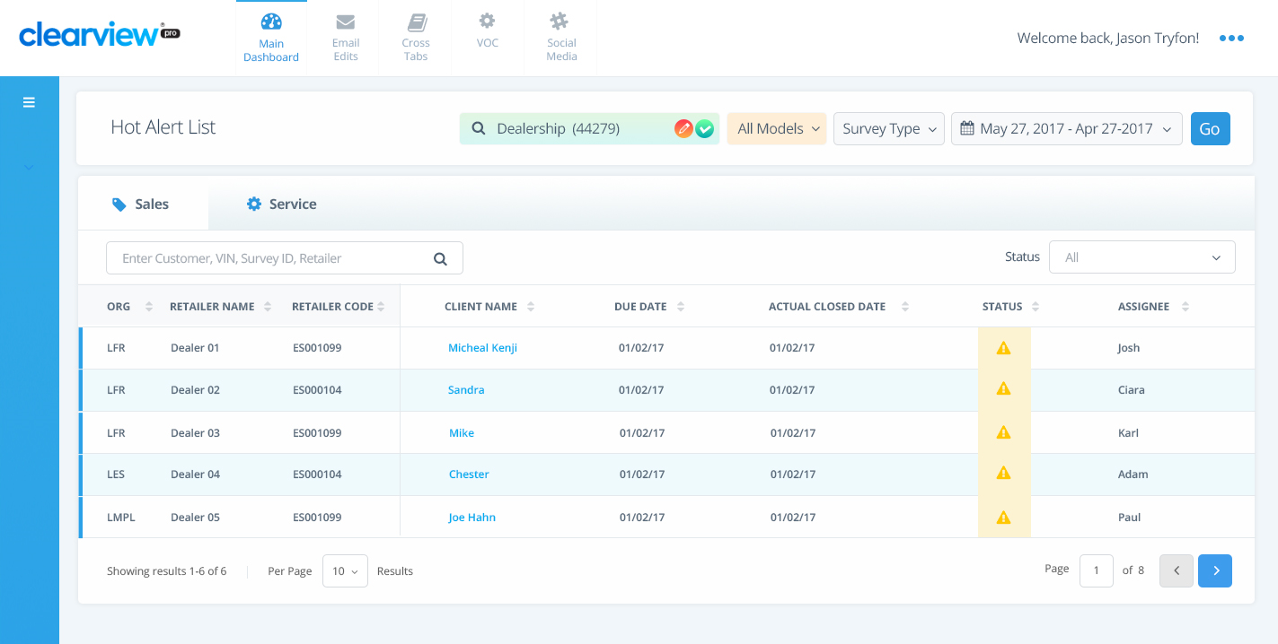

|  |  |  |
| --- | --- | --- |
| **Column Names:** | **Description** | **Click Through** |
| ORG (Hierarchy) | Displays the Region name the survey belongs to | N/A |
| Retailer Name | Displays the Dealer Name | N/A |
| Retailer Code | Displays the Dealer Code | N/A |
| Customer Name | Displays the Customers name | Customer History Page |
| Customer ID | Displays the Customer ID | Customer History Page |
| Due Date | Displays the date the Closed Loop is required to be closed | N/A |
| Actual Closed Date | Displays the date the Closed Loop was actually closed | N/A |
| Status | Displays the Closed Loop status | N/A |
| Follow Up Survey Response | Displays the Response to the Follow up Survey (Y or N) | N/A |
| Assignee | Displays the name of the user the Closed Loop is assigned to | N/A |

*Note: Columns ‘Dealer Name’ & ‘Dealer Code’ will be hidden on Dealer level.*

#### Customer Search

Corporate level users will be able to search for a specific Customer record in the Closed Loop List by completing at least one (1) of the below search fields:

* Customer Last Name
* VIN
* Customer Code

### Closed Loop Process Map

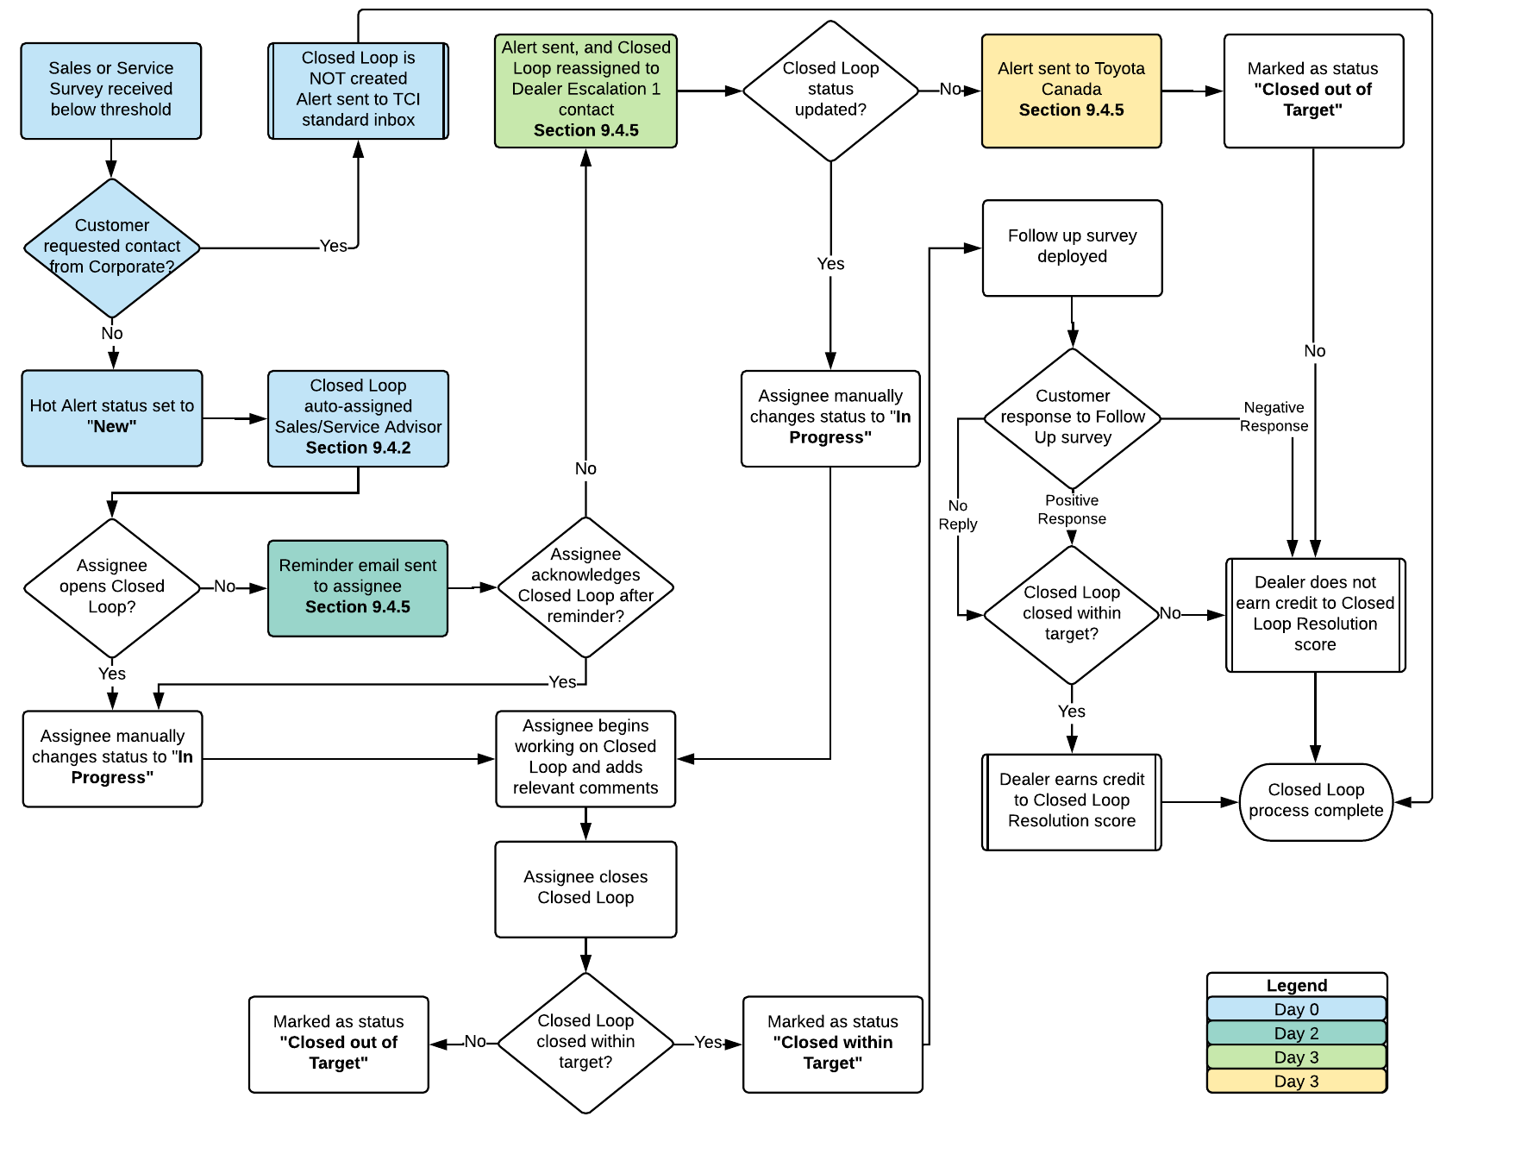

## Voice of Customer (VoC) - Textual and Sentiment Analysis

The text analytics module provides functionality to extract actionable items from textual data. This includes identification of customer sentiments, compliments, concerns and pain points so that appropriate actions can be taken to keep customers happy.

The Text analytics engine processes verbatim in two steps:

1. Sentiment Analysis - To identify if verbatim is positive, negative or neutral
2. Hierarchical Text Classification - To find broader and detailed category of the verbatim

### VoC Dashboard

The dashboard provides data spread by sentiments, trending categories, and top and bottom trending retailers using interactive charts. It also provides dominating customer sentiments overlaid on the geographical map.

The VoC dashboard comprises of the following widgets:

|  |
| --- |
| **Sentiment by Region** |
| Map of Canada, drillable by heirarchial mapping.  When viewing this widget on a National level, the whole country will display in the heat map color I.e. All of Canada will be shaded red/yellow/green |
| *Investigate how to color zone area’s on map geographically* |

|  |  |
| --- | --- |
| **Sentiment Analysis (Word Cloud)** | **Sentiment Count** |
| Word counts pulled from question response verbatim | Survey volume compared to % of surveys with sentiment |
|  |  |
| **Comments by Business Area (Area of Focus)** | **Emerging Trends by Category** |
| Total comments submitted by key drivers | Trend report based on category frequency |
|  |  |

### VoC Tree Report

The tree report provides a holistic view of textual data, presenting information from broader categories to fine tune with sentiments. For example, a user can identify from positive comments in ‘customer relations’ category to ‘Salesperson - attitude’. This enables users to identify positive or negative factors. VoC tree report also provides multiple filters to view data by questions, overall score and sentiment.

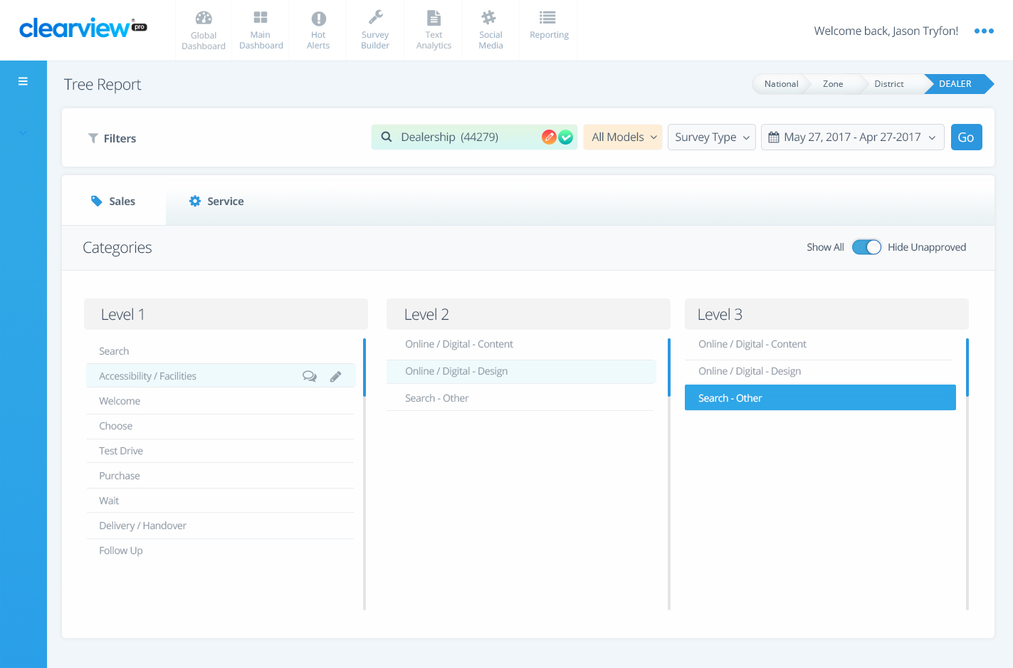

**TCI Final:** Please refer to the proposed categories within Appendix E.

### VoC Comment List

iSKY also provides details of each verbatim through the comment list page which can be access through drill down from VoC dashboard or Tree report. This module provides sentiment and categorizations of each comment which has been drilled down.

To support survey response interpretation from languages other than English, iSKY provides translation functionality which translates verbatim from different languages into English.

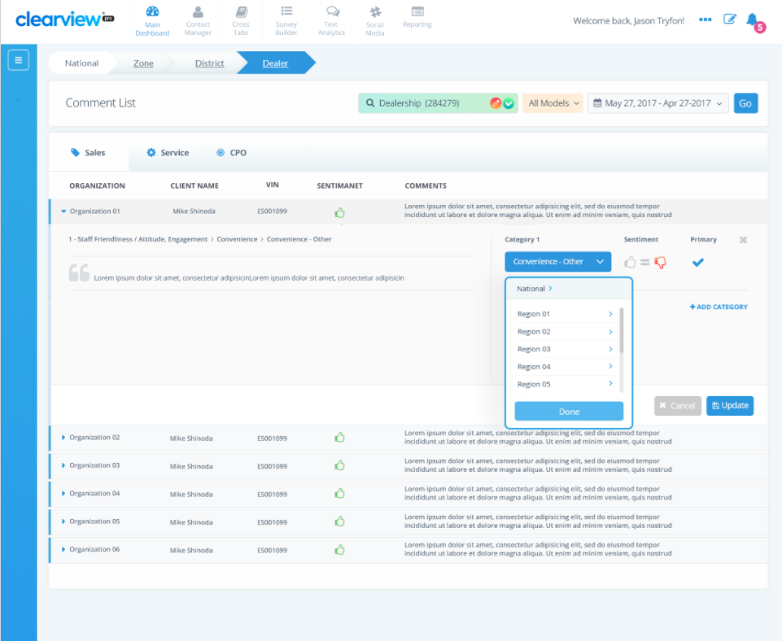

### VoC Interface

iSKY text analytics module is a continuous learning module which can always be improved by providing feedback and corrections. iSKY provides ‘Interface’ as a feedback loop system so that users’ input about the system can be captured and can be used to improve the system.

There are three submodules in interface which are described below:

1. Classification Scheme: module enables users to suggest new categories, its detail and examples of sample classification using keywords.
2. Word Filter: enables users to define keywords and phrases which should be filtered from the portal. These words could be swear words in different language and parasite words (helping words etc.)
3. Verbatim Classification: enables users to give feedback and correction on classification, sentiment and translation of verbatim. iSKY collects feedback and train engine to improve its accuracy.

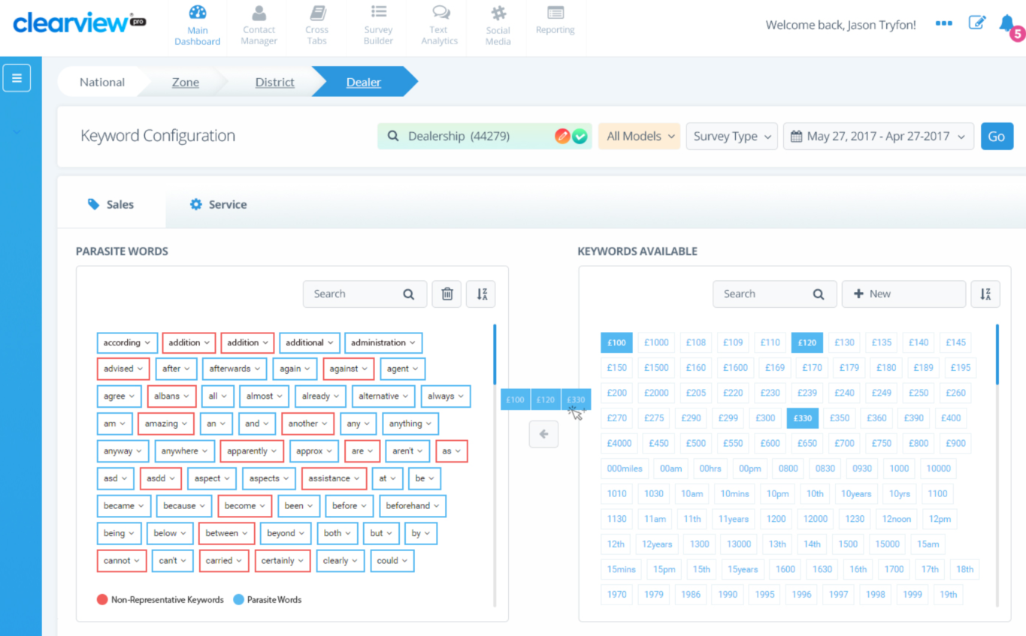

### VoC Process Map

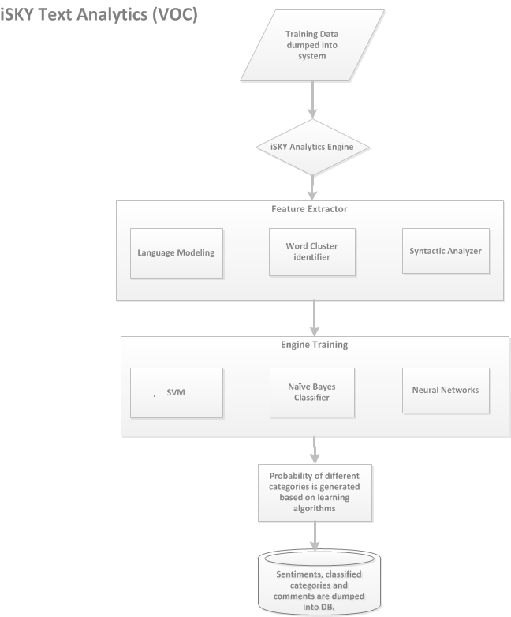



Section 10: Reporting

# Reporting

A core element of our ClearView platform is a suite of standard reports that provide a view of customer feedback, scores and statistics on a real-time basis, accessible 24/7. These reports represent the functionality that any user level needs and are easily navigated. Reports are only actionable if relevant information is provided..

## Contact Statistics

Provides a confirmation and full accounting of all records received for each program. This report details the outcome of each record, whether it is eligible or ineligible for surveying. This is also where users can understand what percentage of their customers are responding (Response Rate Analysis) and, more importantly, how they can improve the quality of the data submitted in order to drive more responses.

**TCI Final:** Report is selected from the main menu.

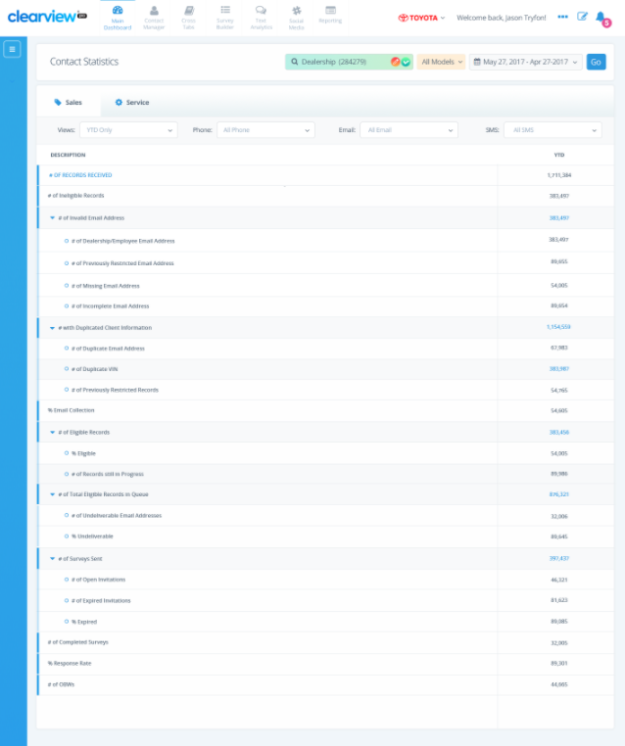

|  |  |
| --- | --- |
| **Top Level** | **Drill Down** |
| # of Received Events (pre-filter) |  |
| # of Ineligible Records | % Ineligible |
| # of Events that are too Old |
| # of Events with Invalid VIN |
| # of Invalid Sales Type |
| # of Do Not Contact Events (OEM) |
| # of Do Not Contact Events (survey previous) |
| # of Do Not Contact Events (DLR System) |
| # of Events with Restricted Contact Information |
| # of Events with Restricted Customer Name (business) |
| # of Events containing Dealership Information |
| # of Events with Missing Customer Information |
| # of Events with other Missing Required Information |
| # of Events with RDR or RO Error |
| # of Filtered Events based on Other Rules |
| # of Filtered Events based on Repeat Customer Rule |
| # of Eligible Events (post-filter) | % Eligible for Survey |
| # of Records still in Progress (previous month carry-over) |
| % Customer Information Collection | % Email Collection |
| % SMS Collection |
| # of Total Eligible Records in Queue | Email Survey Disposition Statistics |
| # of Do Not Contact Events (survey current) |
| # of Undeliverable Email Addresses |
| % Undeliverable |
| # of Valid Emails Collected & Sent |
| # of Valid Emails Collected (on original record) |
| # of Valid Emails Collected from Correction Center |
| # of Open Invitations |
| # of Expired Invitations |
| % Expired |
| # of Surveys Accessed |
| # of Surveys Abandoned |
| % of Surveys Abandoned |
| # of Surveys Completed on other channel |
| SMS Survey Disposition Statistics |
| # of Phone Numbers Collected |
| # of Surveys Completed on other channel |
| # of SMS Sent |
| # of Surveys Accessed |
| # of Surveys Abandoned |
| % of Surveys Abandoned |
| # of Do Not Contact Events (SMS) |
| # of Expired SMS |
| # of Survey Responses | # of Email Survey Responses |
| # of SMS Survey Responses |
| % Response Rate |  |
| # of Closed Loops |  |

## Portal Traffic

Web analytics reporting details user- and page-level activity. At the page level, reports will provide breakdowns of the number of hits by day and time interval. For those reports where multiple drill-through options exist, sub-level reports will identify exactly what was accessed within a single page. For users, reports will provide details of login frequency, the reports visited during each visit, and a ranking of most visited pages. No matter where the “click” occurs, ClearView will track and report it.

As a standard, we have defined three reports.

1) Login Summary

2) Login and Traffic Stats Details

3) Login and Site Traffic Summary

The log process is defined as follows: “each time that a page is refreshed the displayed information is saved/logged”, i.e. each click that generates a different page display or a reload will be counted in terms of pages and parameters.

### Login Summary

Reports refresh according to the time selection, i.e. user can select the time period for desired data.

**TCI Final:** Report is selected from the main menu.

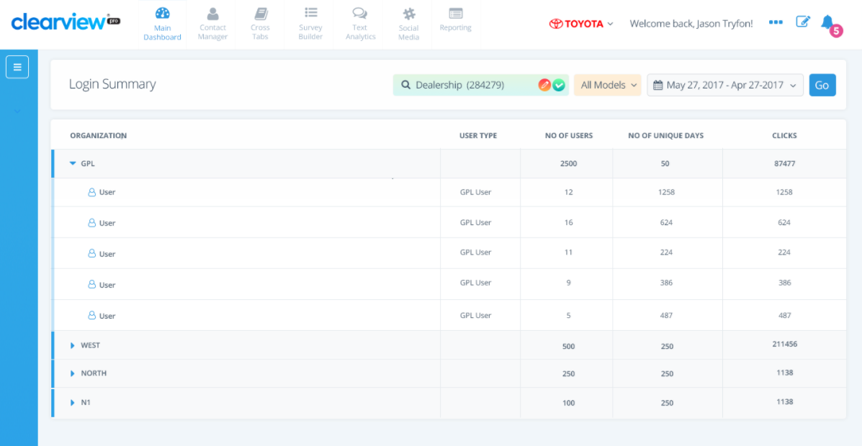

|  |  |
| --- | --- |
| **Column** | **Description** |
| Organization | The organization level hierarchy description based on TCI’s Hierarchy. |
| User Type | Type of access associated with the organization or the user |
| # of Users | Number of unique users per organization for the selected period |
| # of Unique Days | The total number of unique days when at least one user connected during the selected period. |
| Clicks | Number of clicks/refreshes for the selected period. |

### Login and Traffic Stats Details

Reports refresh according to the time selection, i.e. user can select the time period for desired data.

**TCI Final:** Report is selected from the main menu.

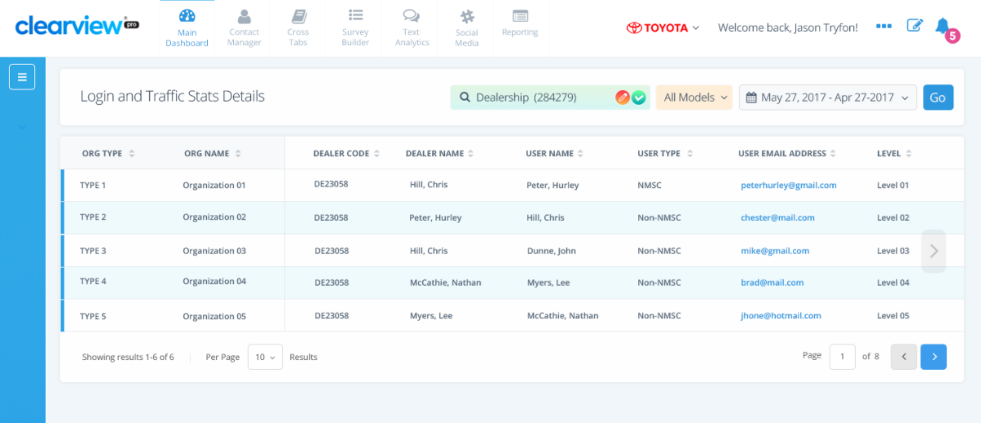

|  |  |
| --- | --- |
| **Column** | **Description** |
| Organization | The organization level hierarchy description based on TCI’s Hierarchy. |
| Dealer Code | Dealer Code that is used in the hierarchy file. |
| Dealer Name | Dealer name. |
| User Name | The full name (first and last) for the user. |
| User Type | Please refer to section 3.3 – User Admin Module to review the role types available |
| Level | The level user is assigned to will be displayed (e.g. Country, Group, Dealer, and Employee). |
| Module Accessed | The module user accessed (ClearView, External links, etc.). |
| Page Accessed | The page, menu item or link clicked on or clicked through. |
| Parameters Requested | Capture what users are requesting within the page (parameters). |
| Date/Time Accessed | The date and time user accessed the page. Display variable in EST Time Zone. |
| Date/Time Exited | The date and time user closed or switched the page. Display variable in EST Time Zone |
| Duration | Time spent on the page (Date/Time Exited - Date/Time Accessed). |

### Login and Site Traffic Summary

Reports refresh according to the time selection, i.e. user can select the time period for desired data.

**TCI Final:** Report is selected from the main menu.

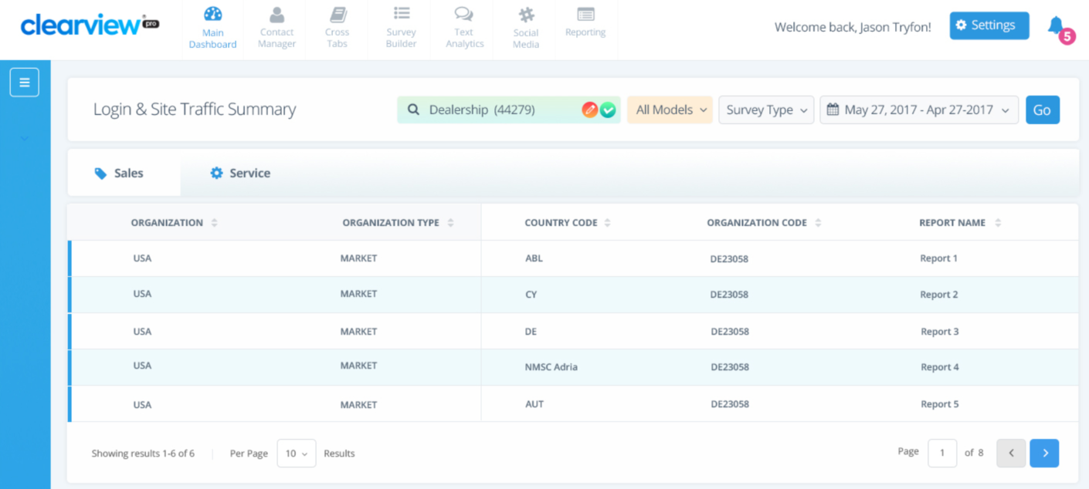

|  |  |
| --- | --- |
| **Column** | **Description** |
| Organization | The organization level hierarchy description based on TCI’s Hierarchy. |
| Country Code | Will always display CAN |
| Org Code | Organization Code that is used in the hierarchy file. |
| Report Name | The major report pages accessed will be displayed as columns in the summary report (e.g. Dashboard, Org Summary, Performance Trend, Report Generator, etc.). |

## Organization Summary

The Organization Summary report is a perfect summary level snapshot view that provides critical scores and statistics for all levels of the organization’s hierarchy in one view. For example, this report can be viewed at the employee-type level with comparisons to summary scores for the Dealer, area, regional and national levels. Any level can be created and included for comparison. Also available is the ability to view scores by different dates, such as report date or event date.

**TCI Final:** Report is selected from the main menu.

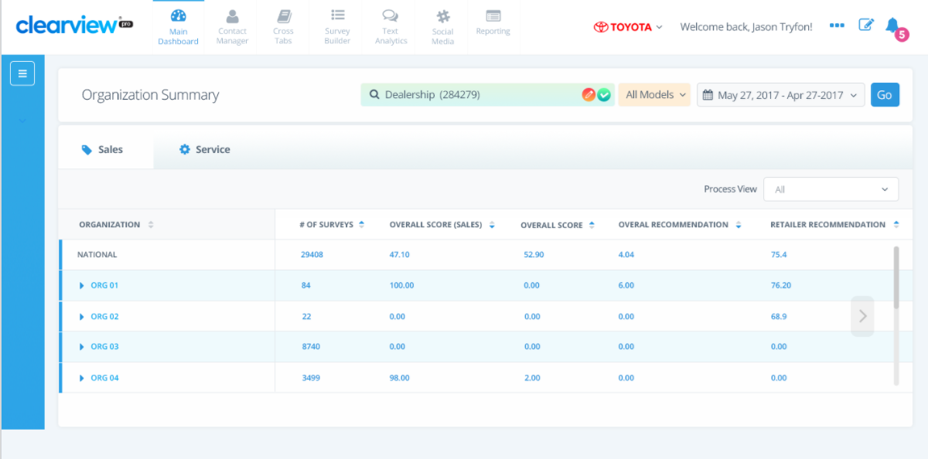

|  |  |
| --- | --- |
| **Column Headers** | |
| **Sales** | **Service** |
| Organization | Organization |
| # of Surveys | # of Surveys |
| Net Promotor Score (NPS) | Net Promotor Score (NPS) |
| Captured Contact Information (%) | Captured Contact Information (%) |
| Closed Loop Rate (%) | Closed Loop Rate (%) |
| Closed Loop Resolution (%) | Closed Loop Resolution (%) |
| %Valid Email | %Valid Email |
| %Valid SMS | %Valid SMS |
| % Hot Alerts Closed within Timeframe | % Hot Alerts Closed within Timeframe |
| Closed Loop Resolved within Target | Closed Loop Resolved within Target |
| Closed Loop Resolved out of Target | Closed Loop Resolved out of Target |
| Closed Loop In Progress | Closed Loop In Progress |
| Closed Loop Late | Closed Loop Late |

## Performance Trend

ClearView provides visualization tools to allow the user to effectively see KPIs trended over time, by survey question or any other metric captured by ClearView (e.g. average handling time for customer issues). Users can select the timeframe (MTD, QTD, 3MR, 6MR, 12MR, FiscalYTD, YTD) and tier of the organizational hierarchy for reporting. Users can also select other units for comparison (e.g. Dealer vs. area performance). Users can choose to turn on the Event Markers of those details for key events that may have affected performance in order to more easily understand why performance may or may not have changed. This report allows users to assess how much variance there is in performance and pinpoint opportunities for improvement.

* Cumulative: represents the Overall Score vs. the Date criteria

** Count: represents the Overall Score per month

**TCI Final:** Report is selected from the main menu.

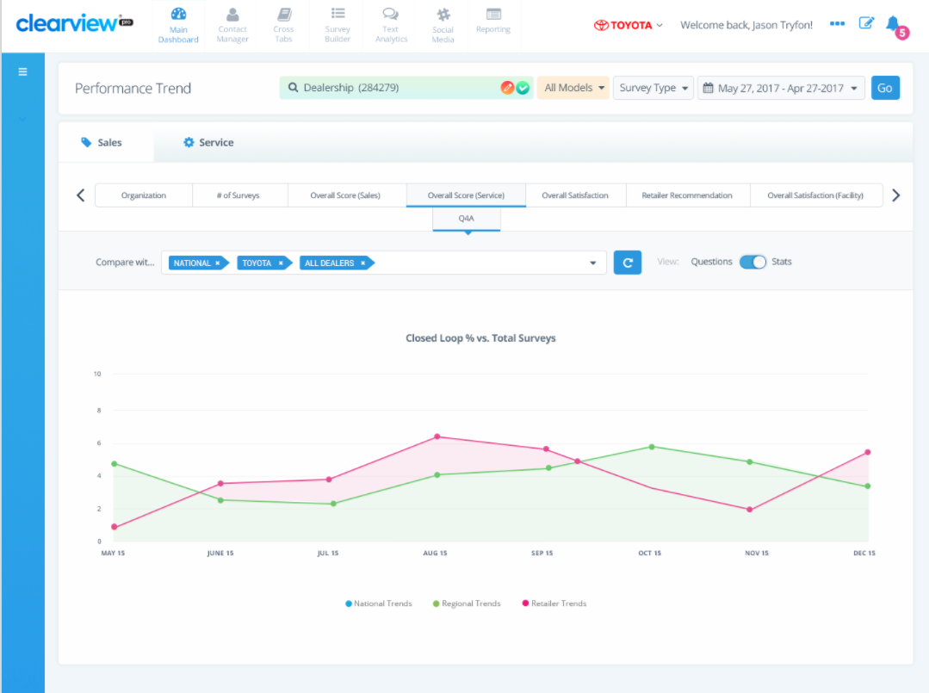

| **Questions** | **Stats – Sales** | **Stats - Service** |
| --- | --- | --- |
| Net Promotor Score - Sales | Organization | Organization |
| Net Promotor Score - Service | # of Surveys | # of Surveys |
| All Sales/Service Survey Questions | Net Promotor Score (NPS) | Net Promotor Score (NPS) |
|  | Captured Contact Information (%) | Captured Contact Information (%) |
|  | Closed Loop Rate (%) | Closed Loop Rate (%) |
|  | Closed Loop Resolution (%) | Closed Loop Resolution (%) |
|  | %Valid Email | %Valid Email |
|  | %Valid SMS | %Valid SMS |
|  | % Hot Alerts Closed within Timeframe | % Hot Alerts Closed within Timeframe |
|  | Closed Loop Resolved within Target | Closed Loop Resolved within Target |
|  | Closed Loop Resolved out of Target | Closed Loop Resolved out of Target |
|  | Closed Loop In Progress | Closed Loop In Progress |
|  | Closed Loop Late | Closed Loop Late |

## Manipulation Reports

We have standard reporting capabilities for tracking email addresses and IP addresses that have been duplicated across multiple customer survey returns. If the surveys are completed using the same E-mail address or IP address or for a certain Dealer then those records are flagged for Toyota Canada to investigate further. Business rules based on investigation results can be implemented to ensure fraudulent emails are filtered automatically.

**TCI Final:** Excel download from the main menu containing the following columns:

| **Column Headers** |
| --- |
| Month |
| Survey ID |
| Category |
| Zone |
| Dealer Code |
| Dealer Name |
| Client Name |
| Client Email Address |
| VIN |
| Sales/Service Associate Name |
| Business Manager/Technician Name |
| Survey Date |
| (Survey Q1} |
| …. |
| {Survey QX} |
| Profile Score |
| IP Address |
| Email Address |
| Phone Number |

## Crosstabs

The cross-tabulation tool makes maximum use of the flexible architecture of the database to allow “any variable by any variable” analysis in milliseconds. Users simply drag and drop the variables they want to see in a cross tab, select the data format they want (e.g. raw data, weighted data, percentages) and run the tab. The resulting display shows not only the required cross tab but also includes summary statistics together with tests of statistical significance, (t-test and chi- square tests), so that areas of true variance are immediately and clearly identified

Additional Cross Tabs features include:

* Transposing data (rows to columns, columns to rows) as user explores data results. To view the information in a user-friendly format
* Capability to see many measures in one view, tailored to specific need
* Enabling exploratory analysis, diagnose and dive into lower actionable levels (Retailer/Employee)
* Custom report views can help to review effectiveness of targeted grass roots training initiatives
* All cross tabulations generated are stored in a library for future access and can be easily exported
* Ad-Hoc Reporting

### Fields and Descriptions

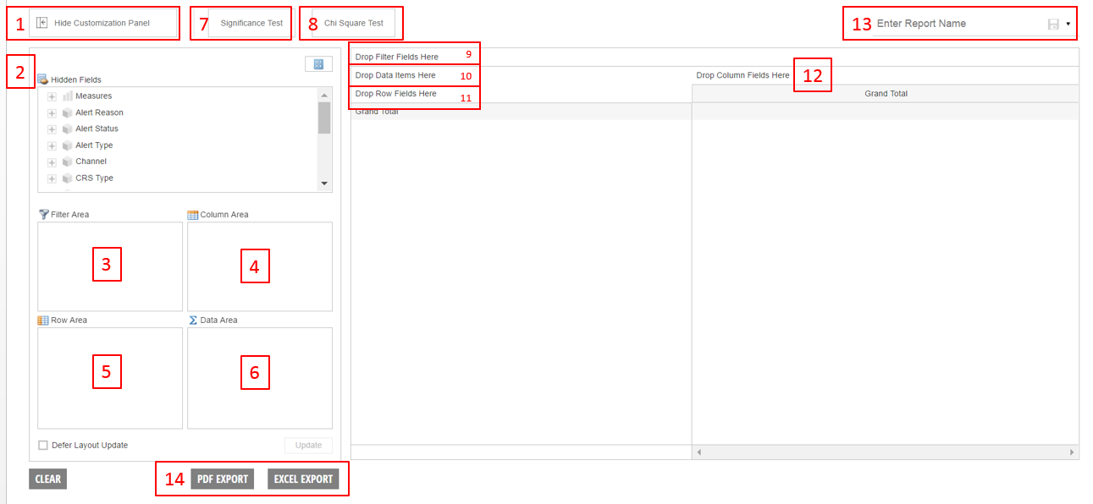

| **Field** | **Description** |
| --- | --- |
| 1. Customization Panel |  |
| Show |  |
| Hide |  |
| 2. Field Navigation Pane | The Hidden Fields list (2) shows a list of items that can be dragged into the report. The Hidden Fields list includes two types of items:  Measures, which include numeric or calculated data (KPIs).  Dimensions, which include data variables to filter, slice and dice data (all the other items in the Hidden Fields list that are not Measures). |
| Open Measure or Dimensions to see sub-fields |
| Close Measure or Dimension |
| Drag Measure(s) or Dimension(s) to Filter, Column, Row or Data Areas |
| Change panel view |
| 3. Filter Area (Quadrant) | Drag Dimensions to Filter Area (3) or Drop Filter Fields Here (9) to setup data filters. |
| Drag into |
| Drag out of |
| Funnel |
| 4. Column Area (Quadrant) | Drag Dimensions to Column Area (4) or Drop Column Fields Here (12) for those fields desired to be rendered as columns. |
| Drag into |
| Drag out |
| 5. Row Area (Quadrant) | Drag Dimensions Row Area (5) or Drop Row Fields Here (11) for those fields desired to be rendered as rows. |
| Drag into |
| Drag out of |
| 6. Data Area (Quadrant) | A Measure cannot be dragged into Row Area (5) or Column Area (4). To view data, you must include a Measure in a report. You can drag Measures into either of the following:  Data Area (6)  Drop Data Items Here (10) |
| Drag into |
| Drag out of |
| 7. Significance Test |  |
| 8. Chi Square Test |  |
| 9. Report Filters |  |
| Drag into |  |
| Drag out of |  |
| 10. Data Area |  |
| Drag into |  |
| Drag out of |  |
| 11. Rows |  |
| Drag into |  |
| Drag out of |  |
| 12. Columns |  |
| Drag into |  |
| Drag out of |  |
| 13. Report Name - Save |  |
| 14. Export |  |
| PDF |  |
| Excel |  |

Removing Measures and Dimensions from a Report

* To remove specific Measures and Dimensions from the report, drag them one by one into any location within Hidden Fields (2).
* To remove all Measures and Dimensions from the report, click Clear.

To add Measures or Dimensions, from Hidden Fields (2), click the plus sign to navigate available fields under the root folders (Measures, Alert Reason, etc.). Then drag the variable to appropriate report section (3, 4, 5, 6).

### Measure/Dimension Structure & Fields Available

**TCI Final:** Below is a list of selectable measures and fields within Crosstabs reporting tool

|  |  |  |  |  |  |  |
| --- | --- | --- | --- | --- | --- | --- |
| **Organization** | **Time Period** | **Survey Source** | **Vehicle Info** | **Contact Statistics** | **Survey Questions** | **Closed Loop** |
| Hierarchy | MTD: Month to date | Method | Model Type | Disposition - Scrub Rule | Question Categories | Status |
|  | QTDCY: Quarter CY | Survey Type | Model Type – Model | Disposition - Survey Status | Question Indexes | Reason |
|  | QTDFY: Quarter FY |  | Model Name | Third Party Survey Flag | Qualifier Questions | Name Assignee |
|  | 3MTD: Rolling-Three-Month |  |  |  | Questions Rating | Closed Loop Due Date |
|  | 6MTD: Rolling-Six-Month |  |  |  | Question Target** | Days |
|  | 12MTD: Rolling-Twelve-Month |  |  |  | Overall Score Target** |  |
|  | YTD: Year to date |  |  |  |  |  |
|  | KTD: Fiscal Year to date |  |  |  |  |  |
|  | Custom |  |  |  |  |  |

**May not be available during initial launch.

| **Key Performance Indicators** | | |
| --- | --- | --- |
| **Contact Statistics** | **Survey Statistics** | **Closed Loop Statistics** |
| # of Events | # of Survey Responses | # of Closed Loop |
| % Ineligible | % Reach Rate* | % Closed Loop Rate (Issue Rate) |
| % Eligible for Survey | % Response Rate** | % Non Closed Loop Rate (Non-Issue Rate) |
| # of Events (post-filter) | % Question Score | # of Closed Loop within 3 days (Timeframe ) |
| % Email Collection | % Indexed Question Score | # of Closed Loop > 3 days |
| % SMS Collection | % Weighted Question Score | # of Closed Loops |
| % Customer Information Collection | % Non-Weighted Survey  Score | % Closed Loop Rate within 3 days |
| % of Emails Opened | % Weighted Survey Score | % Closed Loop Rate > 3 days |
| % of SMS Opened | % of Survey Responses | % Closed Loop Rate |
| % of Emails Abandoned | Average Answer Rating | # of Closed Loops Confirmed as Unresolved |
| % of SMS Abandoned |  | % Resolution |
| % of Invitations Abandoned |  | Average Time to First Contact |
| % of Surveys Accessed |  | Average Time to Close |
| % of Surveys Abandoned |  |  |
| % Survey Abandoned |  |  |
| % Reach Rate (event)* |  |  |
| % Response Rate (event)** |  |  |

| **The values within Disposition - Survey Status are:** | **The values within Disposition - Scrub Rule are:** |
| --- | --- |
| # of Undeliverable Emails | # of Events that are too Old |
| # of Emails Collected | # of Events with Invalid VIN |
| # of Valid Emails Collected & Sent | # of Events with Invalid Dealer Code |
| # of Emails Opened | # of Events with Invalid Sales Type |
| # of SMS Opened | # of Do Not Contact Events (OEM) |
| # of Emails Abandoned | # of Do Not Contact Events (iSKY Survey previous) |
| # of SMS Abandoned | # of Do Not Contact Events (iSKY Survey current) |
| # of Invitations Abandoned | # of Events with Restricted Contact Information |
| # of Surveys Accessed | # of Events with Restricted Customer Name (business) |
| # of Surveys Abandoned | # of Events containing Dealership Information |
| # of Survey Responses (event) | # of Events with Missing Customer Information |
|  | # of Filtered Events based on Repeat Customer Rule |
|  | # of Events with Duplicated Customer Information |
|  | # of Events with RDR or RO Error |
|  | # of Filtered Events based on Other Rules |
|  | # of Filtered Events based on Repeat Customer Rule |
|  | # of Events with Duplicated Customer Information |
|  | # of Events with other Missing Required Information |

*Reach Rate = % of customers that responded to survey out of the entire customer population. This method of calculation ensures the same transactions/records are considered by being driven off the Record Received Date. **Reach Rate will never exceed 100%.**

**Response Rate = % of customers that responded to survey out of the customer population with valid e-mail (or valid contact information for multi-medium survey programs). This method of calculation ensures the same transactions/records are considered by being driven off the Record Received Date.  **Response Rate will never exceed 100%.**

## Report Generator

Report Generator allows users to create their own ad-hoc report developed from scores and calculations already included in the core program. The intuitive interface allows users to a drag and drop key metrics by any date range providing the data in chart, graph or raw data form. This feature also allows users to save their report templates for future use and where possible, share them with other levels of the organization by email.

### Attributes List

To see the Attributes within each Selection Group, user will click the black arrow next to the Selection Group and the relevant Attributes are listed.

| **Score** | **Contact Stats** |
| --- | --- |
| Stats – High Level | Contact Stats – High Level (#) |
| # of Survey Responses | # of Events (pre-filter) |
| % of Survey Responses (SMS Medium) | # of Filtered Events |
| % of Survey Responses (Email Medium) | # of Events (post-filter) |
| % Reach Rate* | # of Survey Responses (event) |
| % Response Rate** | # of Emails Collected |
| Overall Survey Score Target | % Eligible for Survey |
| Question Scores / Counts | % Response Rate** |
| NPS | % Response Rate** (Email Medium) |
| % Detractors | % Reach Rate* |
| % Passives | % SMS Collection |
| % Recommenders | % Email Collection |
| # of Detractors | Scrubbed Out (#) |
| # of Passives | For each disposition value, show count |
| # of Recommenders | Scrubbed Out (%) |
| % Question Score | For each disposition value, show percentage |
| % Indexed Question Score | Email Statistics |
| % Weighted Question Score | # of Survey Responses (Email Medium) |
| {Question}: Average Answer Rating | % Response Rate (Email Medium) |
| Question Score Target | SMS Statistics |
| Question Categories | # of Survey Responses (SMS Medium) |
| {Category} | % Response Rate (SMS Medium) |
| Weighted {Category} |  |
| Question Indices |  |
| (Index1} |  |
| …. |  |
| {IndexX} |  |
| Qualifying Question |  |
| (QQ1} |  |
| …. |  |
| {QQX} |  |
| Question Rating (actual customer answer to question(s)) |  |
| # |  |
| % |  |
| Optional Question |  |
| (OQ1} |  |
| …. |  |
| {OQX} |  |

| **Closed Loop (Closed Loop Statistics)** | **Raw Data (Detailed Extracts)** |
| --- | --- |
| Closed Loop Alerts | Retailer |
| # of Closed Loop | User List |
| # of Closed Loop | Event Information |
| # of Closed Loop Closed within 3 days | Survey Information – includes every answer and comment captured on survey |
| # of Closed Loop Closed > 3 days | Model |
| % Closed Loop Rate within 3 days (Timeframe) | Model Code |
| # of Closed Loops within 3 days (Timeframe) | Model Name |
| # of Closed Loops > 3 days | Closed Loop Information |
| % Closed Loop Rate > 3 days | Closed Loop Type |
| # of Closed Loops | Status |
| % Closed Loops Rate | Due Date |
| % Non- Closed Loop Rate | Closed Date |
| # of Closed Loops Confirmed as Unresolved | Reason |
| % Resolution |  |
| Average Time to First Contact |  |
| Average Time to Close |  |

*Reach Rate = % of customers that responded to survey out of the entire customer population. This method of calculation ensures the same transactions/records are considered by being driven off the Record Received Date. **Reach Rate will never exceed 100%.**

**Response Rate = % of customers that responded to survey out of the customer population with valid e-mail (or valid contact information for multi-medium survey programs). This method of calculation ensures the same transactions/records are considered by being driven off the Record Received Date.  **Response Rate will never exceed 100%.**

### Fields and Descriptions

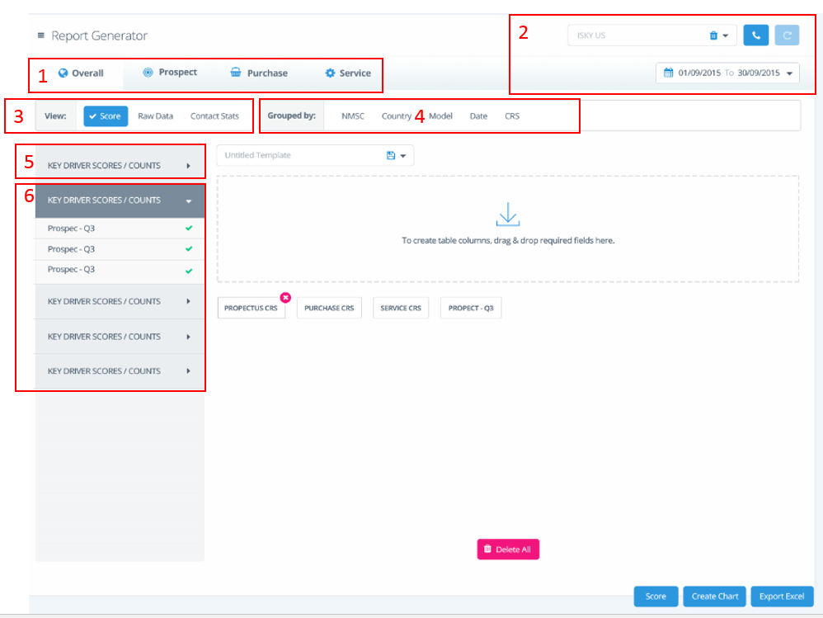

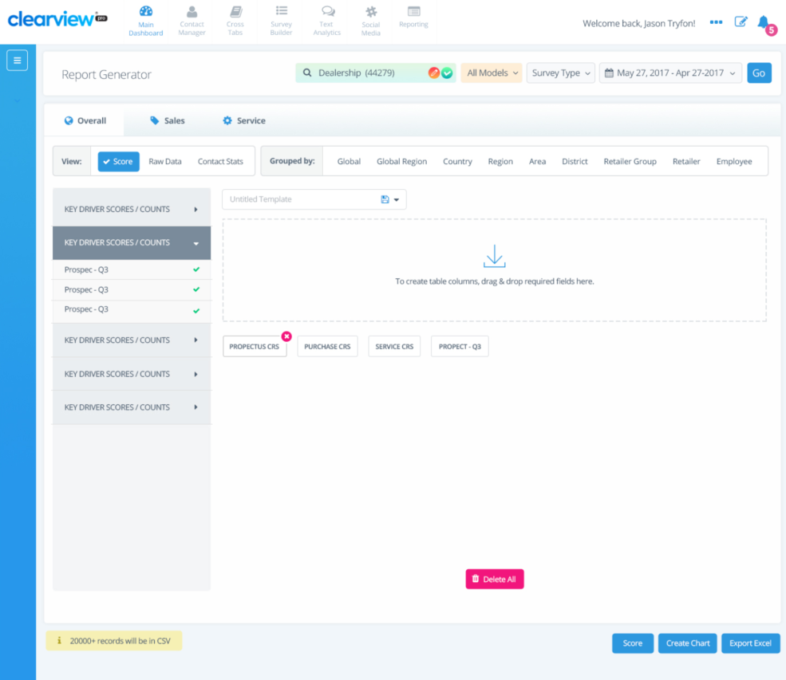

|  |
| --- |
| 1. Tabs Available for each survey type |
| Overall |
| Sales |
| Service |
| 2. Search Criteria |
| Hierarchy |
| Response Medium (All, Email, SMS) |
| Survey Type |
| Date Range (MTD, QTD, YTD, 3MTD, 6MTD, 12MTD, KTD (fiscal YTD), Custom) |
| 3. View (Data) |
| Score (Response Stats) |
| Raw Data (Detailed Extracts) |
| Contact Stats (Event Stats) |
| *The import file date is used for Contact Statistics data. The survey date is used for all other data. |
| 4. Group by (Filter Criteria) |
| Hierarchy |
| Vehicle Model |
| Date (time period - dependent on search criteria date range) |
| NPS (Index Groups) |
| Disposition (Contact Stats View only) |
| 5. Selection Group (*KPI Categories*) |
| 6. Attributes (*KPI Values*) |

## Additional Inbound/Outbound Data Feeds

ClearView can produce customized outbound data reports that can be utilized at the OEM to feed information to internal or external stakeholders, and populate data in additional systems separate from ClearView. The outbound data feeds can be produced in a variety of formats (i.e. MS Excel, XML, CSV, etc.) and scheduled to be automatically created and sent via email or Secure file transfer (SFTP).

Additionally, ClearView can receive inbound data feeds from external sources to be loaded and displayed within the ClearView system, such as LMS Training Certification, Mystery Shop Results, etc.

**TCI Final:** Toyota Canada requires a custom daily outbound data feed called the “Service ID Summary Report” which details which survey IDs were selected for use and which were not. *To include response details*

An inbound data feed, called the Dealer Update file, will trigger the Dealer buy/sell/termination process, please refer to Section 8.7 - Dealer Buy/Sell/Termination process for details.

|  |  |  |  |  |
| --- | --- | --- | --- | --- |
| **Number** | **Data Feed Name** | **Frequency** | **Inbound/Outbound** | **Delivery Method** |
| 1 | Service ID Summary Report | Daily | Outbound | sFTP |
| 2 | Dealer Update File | Daily | Inbound | sFTP |
| 3 | Customer Information Update | Daily | Inbound | API |
| 4 | Customer Informaiton Update | Daily | Outbound | API |
| 5 | mTAB – Sales | TBD | Outbound | API |
| 6 | mTab – Service | TBD | Outbound | API |

## Custom Reporting

In order to meet Toyota Canada’s reporting requirements, the following reports will be available through ClearView.

| **Report Name** | **Report Details** | **Report Frequency** | **Method of Delivery** | **Brand** |
| --- | --- | --- | --- | --- |
| **National Sales Results Report** | Displays all Sales KPIs by National, Zone, Category, Zone Category and Dealer for Sales survey for Toyota or Lexus dealers | Monthly (available EOM) | Excel download from ClearView site | Toyota  Lexus |
| **National Service Results report** | Displays all Service KPIs by National, Zone, Category, Zone Category and Dealer for Service survey for Toyota or Lexus dealers | Monthly (available EOM) | Excel download from ClearView site | Toyota  Lexus |
| **Consultation Dealer report** | Identifying low performing Toyota or Lexus dealers (low customer satisfaction scores) comparing bottom 10% of dealers to all other dealers by specific KPIs  Monthly trend of consultation vs all others with YoY for each  Ability to view the information at a national level as well as by zone and by CCR territory | Monthly (available EOM) | Excel download from ClearView site | Toyota  Lexus |



Section 11: ClearView Self Administration

# ClearView Self Administration

ClearView’s Self Administration interface allows users at all levels to self-manage key components of the system without having to engage iSKY’s development team.

## Survey Administration

Below are the features that survey builder offers:

**Existing Sales & Service Surveys**

* Add / Delete survey questions
* Set mandatory restrictions to survey questions
* Ability to add social media hyperlinks to Thank you Page
* Complete survey translations

**ePanel Surveys**

* Create new ad-hoc survey campaigns
* Select survey recipients from ePanel database (please refer to section 7.2 – Survey Group selection for details)
* Upload custom survey recipients (to be added to the ePanel Database please refer to section 7.2 – Survey Group selection for details)
* Set custom survey expiry dates
* Enter custom survey verbiage (for invitation, survey header text, and thank you page)
* Add / Delete survey questions
* Set mandatory restrictions to survey questions
* Ability to add social media hyperlinks to Thank you Page
* Complete survey translations
* Set required results counts & Anticipated Return Rate % per campaign
* Store details from created ad-hoc survey campaigns
  + Ability for user to preview / duplicate & modify previous survey
* Set custom survey tags (i.e. {employee} can be modified to Advisor or Consultant, etc.)
* Implement “soft launch” releases of ePanel surveys to specified recipients

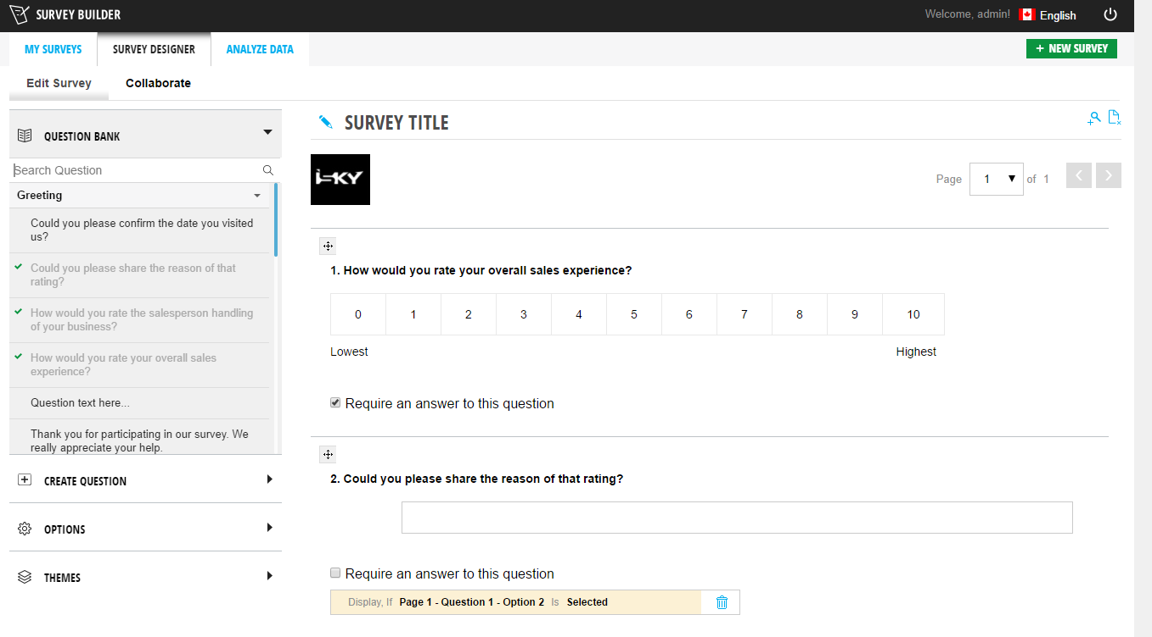

## Survey Removal

At iSKY we have the capability to implement a removal process, which allows users to “Appeal” survey results, sending removal requests to the business stakeholders for review and processing.

### Appeals

The Appeals module will consist of a communication tool that allows users to request survey removals, and for the national level corporate users to process or deny the requests.

The Appeals module will consist of two (2) pages:

1. Search
2. My Appeals

The Search page will contain a search function that allows users to search for surveys and request their removal. The search criteria are:

* Customer Name
* Customer ID
* RO Number / Deal Number
* VIN
* Phone No.
* Email Address

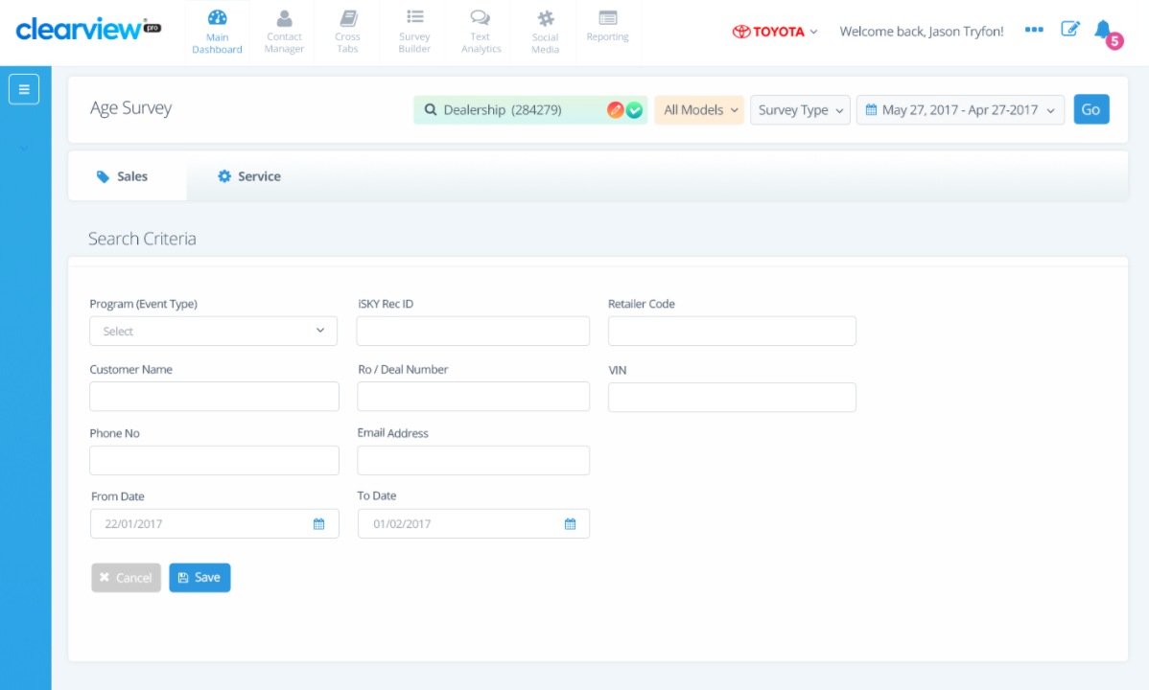The search results that display are based on the users’ data hierarchy access (i.e. Dealer users only see their own data, corporate users can view data for all Dealers). The results will display in a table format with the following column headers:

* Program (event type)
* Dealer Code
* Customer Name
* RO Number / Deal Number
* VIN
* Phone No.
* Email Address
* Survey Received Date
* Request Removal

Within the Request Removal column, a button will be displayed for all search results that have been submitted within the past forty-five (45) calendar days. All records that are older than past forty-five (45) calendar days will be displayed, but cannot be requested for removal.

Once the user selects “Request Removal” a popup appears that requests the reason for the removal, with the following preselected options:

* Sales Event was not In Person (i.e. vehicle purchased over the phone with remote delivery by a 3rd party)
* Sales Event Cancelled (unwind, cancelled delivery, etc.)
* Service Event was a result of sublet from other service center (i.e. Customer did not visit Dealership)
* Survey is rating other Dealership
* Customer Misunderstood Rating Scale
* Incorrect Customer (i.e. incorrect contact details, wrong customer, etc.)
* Corporate Employee
* Other (please explain)

If the user selects “other”, a mandatory text box is displayed where they must enter the removal reason before submitting the request.

Within the popup window, the user will be able to attach files to the Appeal request.

Once a survey removal request is submitted, an alert is sent to the National Level Appeals user (selected within the User Admin module, please refer to Section 3.3 – User Admin Module for details), and the information is also displayed in the My Appeals page.

The “My Appeals” page will display all appeals that were submitted regardless of status within the date range selected in the ClearView filters (please see 9.1.1 – Date Range selection for details).

The available survey status’s are:

* Pending – Appeal Request submitted
* Approved – Appeal approved, survey removed
* Denied = Appeal denied, survey not removed

The “My Appeals” page are based on the users’ data hierarchy access (i.e. Dealer users only see their own data, corporate users can view data for all Dealers). In addition, the “Approve Removal” and “Deny Removal” columns will not be visible to users that are not selected as Appeal Approvers within the User Admin module (please see section 3.3 – User Admin module for details).

When the user opens the “My Appeals” page, they will see a list of all appeals that are waiting on their response. The results will display in a table format with the following column headers:

|  |  |
| --- | --- |
| **Field** | **Description** |
| **Program (event type)** | Event type of the Survey |
| **Dealer Code** | Displays the RO Number / Deal Number |
| **Customer Name** | Displays the Customer Name – Links to the Customer History page |
| **RO Number / Deal Number** | Displays the event ID (RO or Deal Number) |
| **VIN** | Displays the customer VIN |
| **Phone No.** | Survey Received Date |
| **Email Address** | Customer Email Address |
| **Survey Received Date** | Displays the Survey received date |
| **Appeal Request Date** | Displays the date the survey appeal was submitted |
| **Status** | Displays the status of the survey appeal |
| **Removal Reason** | Displays the reason submitted for the Appeal  If “Other” the comments entered will be displayed |
| **Attachment** | Displays a clickable icon per attachment. Upon clicking the attachment file is downloaded and opened |
| **Approve Removal** | Contains an icon that if clicked will approve the Appeal request |
| **Deny Removal** | Contains an icon that if clicked will deny the Appeal request |

Within the Approve Removal and Deny Removal columns, two (2) button will be displayed (“Approve” in the Approve Removal column or “Deny” in the Deny Removal column).

If the National Level Appeals user selects “Approve” a confirmation notification is sent to the original requestor of the appeal, and the survey is removed from ClearView reporting.

If the National Level Appeals user selects “Deny” a popup window appears that requests the reason for the denial, with an open mandatory text box. Once the user submits their reasoning for the removal appeal denial, a confirmation notification is sent to the original requestor of the appeal.

Surveys that have been removed through the appeals deletion process are scrubbed from survey response score reporting, and survey response statistics (e.g. Email Capture, Closed Loop Resolution, and Contact Statistics reporting).

*Note: Please refer to Appendix B for the Appeals Alerts email notification content.*

### Survey List – Deleted Surveys Tab

A tab will be available on the Survey List page called “Deleted Surveys” that will display, based on the users data access level, a list of surveys that have been removed through the Appeals module, as well as surveys that have been removed through automated deletions.

An additional column will be added to the existing survey list page, which will display the type of removal (“Removal Type”). This column will indicate how the survey was removed:

* Sales Event was not In Person (i.e. vehicle purchased over the phone with remote delivery by a 3rd party)
* Sales Event Cancelled (unwind, cancelled delivery, etc.)
* Service Event was a result of sublet from other service center (i.e. Customer did not visit Dealership)
* Survey is rating other Dealership
* Customer Misunderstood Rating Scale
* Incorrect Customer (i.e. incorrect contact details, wrong customer, etc.)
* Corporate Employee
* Other

Upon clicking the Customer name from this list, the user will be navigated to the Customer History screen, please refer to Section 9.3.2 – Customer History for details.

## Translation Module

ClearView has a self-serve translation capability allowing users to update all parts of the system in as many languages as required. Once the translation module is engaged users have the ability to view the previous translation as well as the last date and time it was updated.

At the top of the Translation module, the user will be able to view the percentage of site translations have been reviewed and approved.

The Translation module will contain a column that allows users to indicate whether a translation has already been reviewed. If the translation is reviewed and approved, the user can mark the “reviewed” column with a checkmark. If the translation requires an update, the user is able to enter the new translation under the “New Translation” column. Once the user selects “Update Translation” the percent reviewed will be updated to reflect the new percentage of translations that have been updated.

Please review the mock up below.

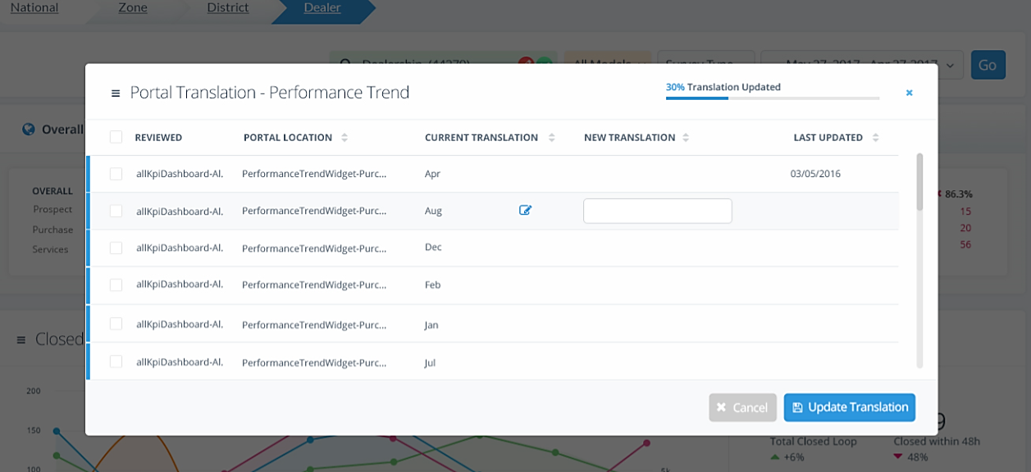

### Translation Update Tool for Email Notification

Addition of a feature to provide users with the ability to translate and update closed loop Notification emails and login notifications.

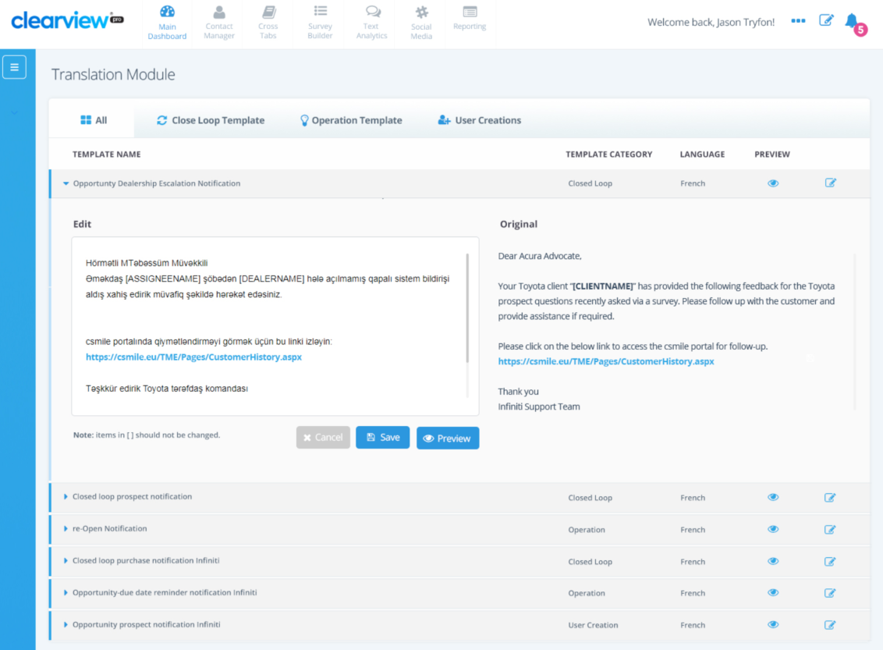

* Fixed Email templates in English provided in Appendix B Placeholders will be fixed (Means we will define placeholders in template like [DealerName] and user supposed not to change those and add any extra.
* Translations to be part of the portal translation module.
* No Notification will be sent from automatic purge process



Section 12: Branding and Imagery

# Branding and imagery

## Corporate Image Library Access

In order for iSKY to acquire approved and brand-compliant imagery for multiple uses within the surveys, communications and ClearView platform, please provide a Marketing contact that will provide access to a corporate identity (CI)-compliant library.

**TCI Final:** Please see below login details:

<https://adhub.toyota.ca/toyota/login>

<https://adhub.lexus.ca/toyota/login>

**User Name:** [Ashley.omran@ibex.co](mailto:Ashley.omran@ibex.co)

**Password:** ClearView1

## Survey imagery

iSKY has the ability to send model specific customized survey imagery based on the brand-compliant guidelines. Every invitation, survey, and thank you page will include an image of the current model year vehicle that was purchased or serviced. Should a model be discontinued, a generic image will be utilized.

Alternatively to ensure a consistent look and feel across all survey types a template can be utilized for invitations, surveys and thank you pages.

* Survey Email Invitation
* Survey Example
* Thank you page
* Follow-up Email Invitation
* Follow-up Survey



Section 13: Deliverables Summary

# Deliverables Summary

All items required to finalize the Blueprint document have been consolidated below for ease of reference.

|  |  |  |
| --- | --- | --- |
| **Section** | **Action Item** | **Required Date** |
| **1. Contact Information** | Identify the main Toyota Canada project stakeholders. | Complete |
| **2.1  Program Launch Strategy** | Confirm the proposed launch strategy. | Complete |
| **2.1  Program Launch Strategy** | Toyota Canada to confirm if a pilot is required. iSKY recommends if a pilot is run, that it run for approximately 30 days, and will include 20-30 of the higher performing dealers. | Complete |
| **2.2 UAT** | Identify users that will be participating in the User Acceptance Testing. | Complete |
| **3.1 Authentication and Authorization** | Provide documentation surrounding the Single Sign on platform. | N/A |
| **3.2 Program Hierarchy** | Provide iSKY with dealer list containing all levels of aggregation required (ex. Region, zone etc.) | Complete |
| **3.2 Program Hierarchy** | Toyota Canada to provide single sign on (SSO) role details, detailing the assignment of permissions to specific roles within Infostream. | Complete |
| **3.2 Program Hierarchy** | iSKY to map TCI SSO roles to ClearView system roles. | Complete |
| **3.2 Program Hierarchy** | TCI to review iSKY proposed role mapping | Complete |
| **3.2 Program Hierarchy** | iSKY to update the document to outline the separate hierarchy tables (separating category and territory): Toyota – Geographical layout is priority / Lexus – Category layout is priority. | Complete |
| **3.3  User Admin Module** | Confirm the proposed module access by role type | Complete |
| **4.1 Site and Survey URL** | Confirm the proposed site and survey URL | Complete |
| **4.3 From Email Address** | Confirm the proposed “From” Email address | Complete |
| **4.4 From Name** | Confirm the proposed “From” Name to show in the Email inbox | Complete |
| **4.5 Privacy Policy Link** | TCI to provide updated links. | Complete |
| **5.1 Survey Question Content** | Provide final survey question content, alert thresholds, scoring, and survey weighting. | Complete |
| **5.2 Survey Language Preference** | Confirm the languages that will be available within the surveys. | Complete |
| **5.3 Survey Communication Content** | Review and approve proposed communication package for all Customer facing survey communications. | Complete |
| **5.3 Survey Communication Content** | iSKY to provide soft copy of proposed communication content | Complete |
| **5.4 Survey Invitation Signature** | Confirm the survey invitation signatory for Sales & Service surveys. | Complete |
| **5.5 Unsubscribe Requirements** | Provide iSKY with historical list of unsubscribe customers in the format detailed | Prior to launch (approx. 2 weeks prior to launch) |
| **5.5 Unsubscribe Requirements** | iSKY to add “Unsubscribe Historical Details” to the project UAT schedule including final required dates. | Post Blueprint Sign Off |
| **6.1 Survey Process Times** | Confirm the proposed survey process times (delay before sending invitation) | Complete |
| **6.2 Survey Methodology** | Confirm the proposed survey methodology and order. | Complete |
| **6.2 Survey Methodology** | iSKY to update the above process maps to reflect 20 calendar day expiry. | Complete |
| **6.3 Reminder Surveys** | Confirm the proposed timing for sending a reminder invitation. | Complete |
| **6.4 Survey Link Validity** | Confirm the proposed survey link validity period. | Complete |
| **6.5 Survey Frequency** | Confirm the survey frequency interval for repeat customers | Complete |
| **6.6 Survey Time Zones** | Confirm the proposed survey deployment time frames. | Complete |
| **6.7 Business Days & National Holidays** | Confirm the proposed business days and National holidays | Complete |
| **6.7 Business Days & National Holidays** | TCI needs to implement provincial specific holidays and will provide list. | Complete |
| **6.8 Email Edits** | Confirm the proposed business rules surrounding the Email Edits module. | Complete |
| **6.10.1 Quarterly Gas Card Draw** | Review and confirm the proposed Quarterly Draw business rules, process, and proposed draw dates. | Complete |
| **6.10.1 Quarterly Gas Card Draw** | Legal sign off documentation and congratulatory letter to be drafted, reviewed and approved by Toyota Canada post Blueprint sign-off. | Post Blueprint Sign-off |
| **6.10.1 Quarterly Gas Card Draw** | Toyota Canada to provide access to “AdminTrack” | NA |
| **6.10.1 Quarterly Gas Card Draw** | iSKY to investigate addition of contest “write in” contestants (legal requirements) to project scope. | Complete |
| **6.10.1 Quarterly Gas Card Draw** | TCI to attempt to obtain the declaration form. | Complete |
| **6.9.2 Pinnacle Program** | Toyota Canada to provide business rules / calculations on the Pinnacle Program. | Complete |
| **6.9.2 Pinnacle Program** | iSKY to document Pinnacle Program in a no charge post launch Statement of Work | Post Blueprint Sign Off |
| **6.10.1 Email Process Map** | Review and approve the proposed process | Complete |
| **6.10.2 SMS Process Map** | Review and approve the proposed process | Complete |
| **7 ePanel Program** | Toyota Canada to review proposed ePanel Process | Complete |
| **7.3 Deployment** | iSKY to investigate if we can do a “soft launch” on ePanel surveys. | Complete |
| **7.4 Results Collection & Sharing** | Provide the required fields to be available in the results raw data export | Complete |
| **7.4 Results Collection & Sharing** | Toyota Canada to provide the names and email addresses of personnel who should have access to ePanel survey results. | Complete |
| **8.2 Import Data Feed** | Provide the desired file format / Review the iSKY proposed standard data feed template | Complete |
| **8.2 Import Data Feed** | iSKY to investigate importing data feed via API rather than sFTP. | Complete |
| **8.3 Import Feed Filters** | Review, complete, and approve the proposed filter criteria in Appendix D | Complete |
| **8.3 Import Feed Filters** | iSKY to provide final list of filter recommendations | Complete |
| **8.4 Launch Data Requirements** | Confirm the amount of historical event data will be provided at launch | Complete |
| **8.5 Data Delivery Alerts** | Provide the name and contact information of two (2) stakeholders to receive data delivery alert notifications | Complete |
| **8.6 Sales Unwind Process** | Confirm the proposed sales unwind process | Complete |
| **8.7 Dealer Buy/Sell Termination Logic** | Review and approve the proposed Dealer Buy/Sell Termination workflow | Complete |
| **8.7 Dealer Buy/Sell Termination Logic** | Provide the desired layout of the Dealer Update file | Complete |
| **8.8 VIN Decoder** | Toyota Canada to provide existing VIN Decoder documentation. | Complete |
| **8.8 VIN Decoder** | Toyota Canada to provide updated VIN Decoder details in the event of updates. | Monthly |
| **9.1.1 Date Range Selection** | Confirm the proposed date range selections | Complete |
| **9.1.2 Search Criteria** | Provide list of models available by brand | Complete |
| **9.2.1 Key Performance Indicators** | Confirm which Key Performance Indicators are to be displayed within the Dashboard | Complete |
| **9.2.1 Key Performance Indicators** | iSKY to create wireframes for TCI review for Overall vs. Event Type specific dashboard. | Complete |
| **9.2.2 Dashboard Widgets** | Confirm Dashboard Widgets to be displayed as a default on the ClearView Dashboard | Complete |
| **9.2.2 Dashboard Widgets** | Review and confirm the proposed layout for the Toyota Pinnacle Program widget. | N/A |
| **9.2.2 Dashboard Widgets** | iSKY to investigate creation of a widget that shows the display a breakdown of the different model year groups: Overall (1-7 model years/1-3 / 4-7) | Complete |
| **9.2.3 Customised Dashboard Widgets** | Please indicate which KPI’s are to be measured within each optional widget. | Complete |
| **9.3.1 Survey List** | Confirm columns required & validate inclusion of Sales Consultants | Complete |
| **9.3.2 Customer History** | TCI to provide their list of Resolution tags. | Complete |
| **9.4.1 Closed Loop Triggers** | Please identify Closed Loop triggers within the Sales & Service surveys. | Complete |
| **9.4.9 Closed Loop Summary** | TCI to review and provide final approval | Complete |
| **9.4.10 Closed Loop List** | TCI to review and provide final approval | Complete |
| **9.4.11 Closed Loop Process** | iSKY to updated | Complete |
| **9.4.2 Alert Escalation Hierarchy** | Confirm the proposed escalation hierarchy | Complete |
| **9.4.3 Alert Content** | Review and approve proposed communication package for alert verbiage | Complete |
| **9.4.4 Closed Loop Target (KPI)** | Confirm the proposed Closed Loop target time | Complete |
| **9.4.5 Closed Loop Status** | Implement two types of issues: Issue for Dealer and Issue for Corporate (based on Customer selection to survey checkbox) once survey content determined. | Complete |
| **9.4.5 Closed Loop Status** | Confirm the proposed time management on Closed Loop workflows. | Complete |
| **9.4.7 Follow-up Email Alert Assignment** | Confirm the proposed Follow up email alert assignment. | Complete |
| **9.5.2 VoC Tree Report** | Confirm the proposed Voice of Customer Tree Report Categories | Complete |
| **9.5 Voice of Customer (VoC)** | iSKY to setup VoC Demo for Toyota Team | Complete |
| **10.5 Manipulation Reports** | iSKY to investigate the addition of a summary duplicate email & IP summary report. Duplicate if an email or IP address appeared more than once | Complete |
| **10.8 Additional Inbound/Outbound Data Feeds** | iSKY to review data feeds vs “Integration Requirements Document” | Complete |
| **10.8 Additional Inbound/Outbound Data Feeds** | Toyota Canada to provide desired layout/format of the Service ID Summary Report. | Complete |
| **10.8 Additional Inbound/Outbound Data Feeds** | Toyota Canada to provide desired layout/format of the Dealer Update file. | Complete |
| **10.8 Additional Inbound/Outbound Data Feeds** | iSKY to provide pricing for Customer Information Update and mTAB data feeds (out of project scope) | Complete |
| **10.9 Custom Reporting** | Toyota Canada to provide desired report layouts. | Complete |
| **10.9 Custom Reporting** | Stacey to confirm on Consultation Report requirement | Complete |
| **11.2 Survey Removal** | Confirm alignment with appeals and deletion processes detailed | Complete |
| **11.2.1 Appeals** | Toyota to provide details on internal Appeals schedule (in regards to extending survey removal eligibility length) | Complete |
| **11.2.1 Appeals** | iSKY to confirm if survey removal eligibility cut-off is required | Complete |
| **11.2.1 Appeals** | Toyota to provide survey appeal removal guidelines | Complete |
| **11.2.1 Appeals** | iSKY to add My Appeals Page details for “requestor” with status including “pending” | Complete |
| **11.2.1 Appeals** | Toyota Canada requested the ability to add attachments to Appeal requests. iSKY to investigate and advise. | Complete |
| **12.1 Corporate Image Library Access** | Provide Marketing contact information (adhub) | Complete |

# Budget and Payment Terms

iSKY Inc. will invoice Toyota Canada Inc. upon the completion of the project in accordance with the provisions of this section and transmit the invoice to INFINITI Global electronically. Toyota Canada Inc. agrees to pay iSKY Inc. all undisputed amounts invoiced within thirty (30) days of invoice transmittal date.

|  |  |
| --- | --- |
| **Item** | **Cost** |
| Email Edits module | $15,000.00 |
| Survey Appeals/Removals Modules | $15,000.00 |
| Customer Information Update (inbound) | $5,000.00 |
| Customer Information Update (outbound) | $5,000.00 |
| mTAB - Sales | $5,000.00 |
| mTAB - Service | $5,000.00 |
| Advanced Tampering Suite of Reports | $2,000.00 monthly  or  $1,500.00 quarterly |

# Client sign-off

The undersigned agree that this document accurately details and meets the requirements of Toyota Canada. Any change or amendments to the specifications as details within this ClearView Blueprint will constitute a change and is subject to the Change Control process and review by iSKY and Toyota Canada

Should project requirements change or additional project requirements be requested after the Blueprint signoff, iSKY reserves the right to assign a new deliverable date in accordance with the new project criteria.

|  |  |
| --- | --- |
| **Toyota Canada Inc.** | |
| Name: |  |
| Title: |  |
| Date: |  |
| Signature: |  |
|  |  |
| **iSKY Inc.** | |
| Name: |  |
| Title: |  |
| Date: |  |
| Signature: |  |

# Appendix A: Creative Package

## Survey Imagery

### Survey Email Invitation

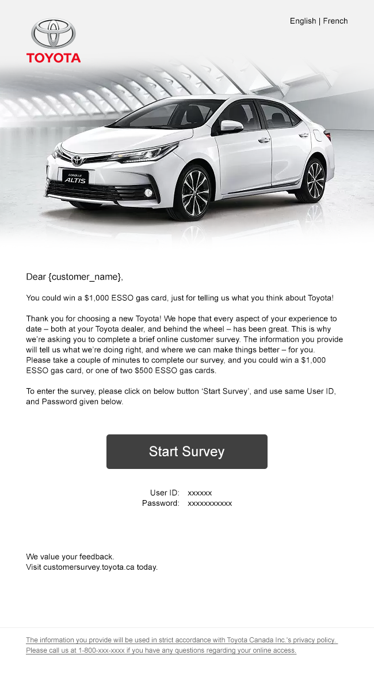

### Survey

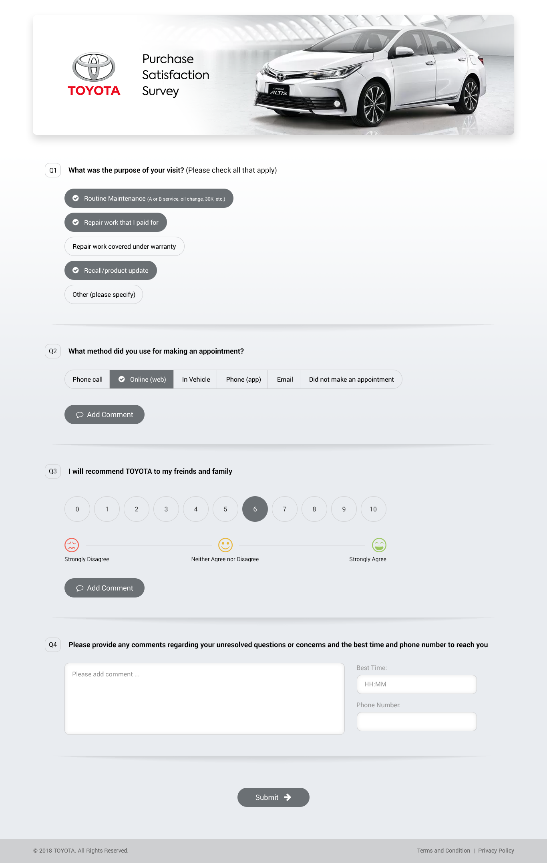

### Thank You Page

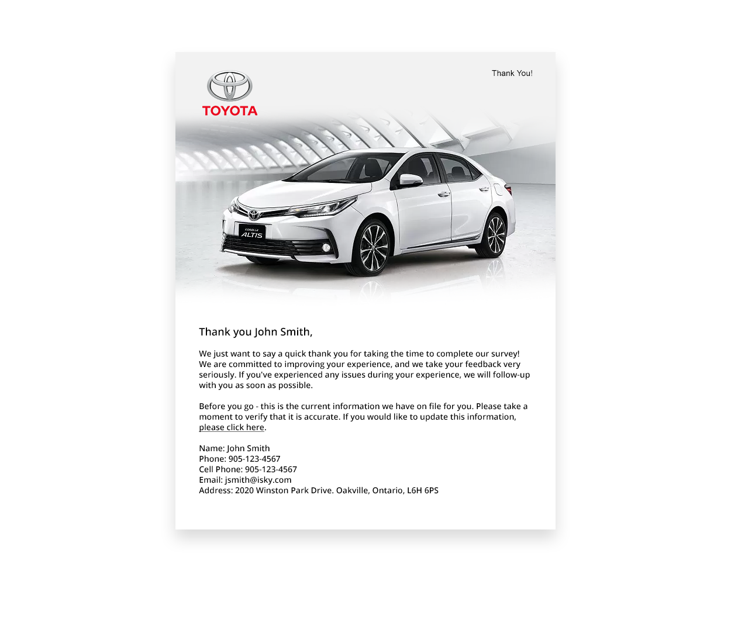

# Appendix B: Survey Communication Template

## Sales Survey Communication

|  | **Default Verbiage** | **Example Verbiage** |
| --- | --- | --- |
| **Email Invitation Subject Line** | Toyota Purchase Satisfaction Survey Invitation **{Customer_Name}** | Lexus Purchase Satisfaction Survey Invitation **{Customer_Name}** |
| **Email Invitation** | Dear (**Customer Name),**  You could win a $1,000 ESSO Gas Gift Card, just for telling us what you think about Toyota!  Thank you for choosing a new Toyota. We are committed to making your ownership experience an exceptional one. Your feedback is key to achieving this goal, and so we would very much like to gather your thoughts about your Toyota experience so far.  Please take a few minutes to complete our survey. As our thanks to you, your name will be entered in a draw to win one of 3 Esso Gas Gift Cards, 2 of which are valued at $500 and one is worth $1,000. Thank you for sharing your feedback with us and good luck with the draw.  **Time Sensitive – please respond at your earliest convenience**   **{Start survey button**}  Thanks again for choosing **Toyota**    Sincerely,  **Toyota Canada**  We value your feedback.  Contest Rules  The information you provide will be used in strict accordance with Toyota Canada Inc.'s privacy policy. Please call us at 1-888-TOYOTA8 if you have any questions regarding your online access.  If you would like to unsubscribe from receiving future email surveys, please click **{link_start}** here **{link_end}**. | Dear **(Customer Name),**  You could win a $1,000 Lexus Boutique Collection Gift Card, just for telling us what you think about Lexus!   Thank you for choosing a new Lexus. We are committed to making your ownership experience an exceptional one. Your feedback is key to achieving this goal, and so we would very much like to gather your thoughts about your Lexus experience so far.  Please take a few minutes to complete our survey. As our thanks to you, your name will be entered in a draw to win $1,000 Lexus Boutique Collection Gift Card. Thank you for sharing your feedback with us and good luck with the draw.  **Time Sensitive – please respond at your earliest convenience**   **{Start survey button**}  Thanks again for choosing **Lexus**    Sincerely,  **Lexus Canada**  We value your feedback.  Contest Rules  The information you provide will be used in strict accordance with Lexus Canada Inc.'s privacy policy. Please call us at 1-800-26-LEXUS if you have any questions regarding your online access.  If you would like to unsubscribe from receiving future email surveys, please click **{link_start}** here **{link_end}**. |
| **SMS Invite (149 characters)** | Thanks for your recent visit to Toyota. Please share your experience with us by following this link: **https://bitly.com/12345.** Reply STOP to opt out of receiving surveys. | Thanks for your recent visit to Lexus. Please share your experience with us by following this link: **https://bitly.com/12345.** Reply STOP to opt out of receiving surveys. |
| **Email Invitation Reminder Subject Line** | Reminder: Toyota Purchase Satisfaction Survey Invitation **{Customer_Name}** | Reminder: Lexus Purchase Satisfaction Survey Invitation **{Customer_Name}** |
| **Email Invitation Reminder Content** | Dear (**Customer Name),**  You could win a $1,000 ESSO Gas Gift Card, just for telling us what you think about Toyota!  Thank you for choosing a new Toyota. We are committed to making your ownership experience an exceptional one. Your feedback is key to achieving this goal, and so we would very much like to gather your thoughts about your Toyota experience so far.  Please take a few minutes to complete our survey. As our thanks to you, your name will be entered in a draw to win one of 3 Esso Gas Gift Cards, 2 of which are valued at $500 and one is worth $1,000. Thank you for sharing your feedback with us and good luck with the draw.  **Time Sensitive – please respond at your earliest convenience**   **{“Start Survey” button**}  Thanks again for choosing **Toyota**   Sincerely,  **Toyota Canada**  We value your feedback.  Contest Rules  The information you provide will be used in strict accordance with Toyota Canada Inc.'s privacy policy. Please call us at 1-888-TOYOTA8 if you have any questions regarding your online access.  If you would like to unsubscribe from receiving future email surveys, please click **{link_start}** here **{link_end}**. | Dear **(Customer Name),**  You could win a $1,000 Lexus Boutique Collection Gift Card, just for telling us what you think about Lexus!   Thank you for choosing a new Lexus. We are committed to making your ownership experience an exceptional one. Your feedback is key to achieving this goal, and so we would very much like to gather your thoughts about your Lexus experience so far.  Please take a few minutes to complete our survey. As our thanks to you, your name will be entered in a draw to win $1,000 Lexus Boutique Collection Gift Card. Thank you for sharing your feedback with us and good luck with the draw.  **Time Sensitive – please respond at your earliest convenience**   **{“Start Survey” button**}  Thanks again for choosing **Lexus**   Sincerely,  **Lexus Canada**  We value your feedback.  Contest Rules  The information you provide will be used in strict accordance with Lexus Canada Inc.'s privacy policy. Please call us at 1-800-26-LEXUS if you have any questions regarding your online access.  If you would like to unsubscribe from receiving future email surveys, please click **{link_start}** here **{link_end}**. |
| **Survey Header** | Dear **[Customer Name]**  We hope you will take a few minutes to let us know how we are doing, and how we can improve by completing the survey.  Please note that information from this survey may be shared with dealers as part of our ongoing training and performance improvement effort.  If there are concerns or questions, please call 1-888-TOYOTA8, or email to surveys@toyotaexperience.ca, or write to Toyota Canada Inc. at One Toyota Place, Scarborough, ON, M1H 1H9. | Dear John Doe,  We hope you will take a few minutes to let us know how we are doing, and how we can improve by completing the survey.  Please note that information from this survey may be shared with dealers as part of our ongoing training and performance improvement effort.  If there are concerns or questions, please call 1-800-26LEXUS, or email to surveys@lexusexperience.ca, or write to Lexus Canada Inc. at One Toyota Place, Scarborough, ON, M1H 1H9. |
| **Short Survey Thank you Page** | Thank you **{customer_name},**  We just want to say a quick thank you for taking the time to complete our survey! We are committed to improving your experience, and we take your feedback very seriously.  Would you be interested in taking approximately 3 minutes to answer some additional questions regarding your experience?   YES  NO  **If Yes – open extended survey**  **If No – open customer verification page that says the following.**  Before you go, this is the current information we have on file for you. Please take a moment to verify that it is accurate. If you would like to update this information, please click **{link_start}** here **{link_end}.**  Name: **{customer_name}**  Phone: **{customer_phone}**  Cell Phone: **{customer_mobile}**  Email: **{customer_email}**  Preferred Method of Communication: **{Dropdown – Email / SMS}** | Thank you John Doe,  We just want to say a quick thank you for taking the time to complete our survey! We are committed to improving your experience, and we take your feedback very seriously.  Would you be interested in taking approximately 3 minutes to answer some additional questions regarding your experience?   YES  NO  **If Yes – open extended survey**  **If No – open customer verification page that says the following.**  Before you go, this is the current information we have on file for you. Please take a moment to verify that it is accurate. If you would like to update this information, please click **{link_start}** here **{link_end}.**  Name: John Doe  Phone: 905 262 8877  Cell Phone: 905 262 8877  Email: johndoe@hotmail.com  Preferred Method of Communication: {Dropdown – Email / SMS} |
| **Extended Survey Thank you Page** | Thank you **{customer_name}**,  We, at Toyota, value our customers' opinions, and whenever possible use them to shape a future course of action. To help us gather your feedback, we have developed an online ePanel.  No more than once every 4 - 6 weeks, we will email an invitation to ePanel members to complete a very brief survey. A variety of topics will cover Toyota vehicles, their features, your driving experience, etc.  If you would like to become a member of Toyota's ePanel, please verify your email address below:  **{open text box for email address}**  Before you go, this is the current information we have on file for you. Please take a moment to verify that it is accurate. If you would like to update this information, please click **{link_start}** here **{link_end}**.   Name: **{customer_name}** Phone: **{customer_phone}** Cell Phone: **{customer_mobile}** Email: **{customer_email}**  Preferred Method of Communication**: {Dropdown – Email / SMS}** | Thank you John Doe,  We, at Toyota, value our customers' opinions, and whenever possible use them to shape a future course of action. To help us gather your feedback, we have developed an online ePanel.  No more than once every 4 - 6 weeks, we will email an invitation to ePanel members to complete a very brief survey. A variety of topics will cover Toyota vehicles, their features, your driving experience, etc.  If you would like to become a member of Toyota's ePanel, please verify your email address below:  **{open text box for email address}**  Before you go, this is the current information we have on file for you. Please take a moment to verify that it is accurate. If you would like to update this information, please click **{link_start}** here **{link_end}**.   Name: John Doe  Phone: 905 262 8877  Cell Phone: 905 262 8877  Email: johndoe@hotmail.com  Preferred Method of Communication: {Dropdown – Email / SMS} |
| **Follow-up SMS Invite (157 characters)** | Thanks for your recent survey feedback. Please share your follow up experience with us by clicking this link: **https://bitly.com/12345.** Reply STOP to opt out of receiving surveys. | Thanks for your recent survey feedback. Please share your follow up experience with us by clicking this link: **https://bitly.com/12345.** Reply STOP to opt out of receiving surveys. |
| **Follow Up Email** | Dear **{customer_name**},   I am sorry to hear that your purchase experience with us did not meet your expectations. One of our team members should have already been in contact with you, and I would like to verify that you were satisfied with the follow-up provided.   We want to ensure that we have addressed any concerns you have raised. Please let us know if we have addressed your concern(s) by clicking on the link below.   **{link_start}** Please click here **{link_end}**  Sincerely,  **Toyota Canada** | Dear **{customer_name**},   I am sorry to hear that your purchase experience with us did not meet your expectations. One of our team members should have already been in contact with you, and I would like to verify that you were satisfied with the follow-up provided.   We want to ensure that we have addressed any concerns you have raised. Please let us know if we have addressed your concern(s) by clicking on the link below.   **{link_start}** Please click here **{link_end}**  Sincerely,  **Lexus Canada** |
| **Follow up Survey** | Dear {**customer_name},**    First, we want to thank you for choosing **{dealer_name}** for your recent **{model}** purchase. We very much value your business and hope to provide you with the best possible service throughout your Toyota ownership experience.    More importantly, we were made aware that your recent survey feedback indicated we may not have met all of your expectations throughout the purchase process.  By participating in our survey, we not only want to make sure your feedback is helping shape the future of Toyota Canada, but also need to ensure that your voice is heard. We would like to thank you for sharing your thoughts and we want to make sure we have addressed your concerns.  If you have a moment, please indicate if we addressed your concerns appropriately:  **{link_start}** Yes, your team addressed my concerns. **{link_end}**  **{link_start}** No, your team did not address my concerns. **{link_end}**   Please add any additional feedback here: **{comment box}**  Happy, satisfied owners are important to us, and we want to make sure that we continue to earn your business. Thank you for giving us the opportunity to serve you better.    Sincerely,  **{Toyota Canada}** | Dear {customer_name},    First, we want to thank you for choosing {dealer_name} for your recent {model} purchase. We very much value your business and hope to provide you with the best possible service throughout your Toyota ownership experience.    More importantly, we were made aware that your recent survey feedback indicated we may not have met all of your expectations throughout the purchase process.  By participating in our survey, we not only want to make sure your feedback is helping shape the future of Lexus Canada, but also need to ensure that your voice is heard. We would like to thank you for sharing your thoughts and we want to make sure we have addressed your concerns.  If you have a moment, please indicate if we addressed your concerns appropriately:    {link_start} Yes, your team addressed my concerns. {link_end}  {link_start} No, your team did not address my concerns. {link_end}    Please add any additional feedback here:  {comment box}    Happy, satisfied owners are important to us, and we want to make sure that we continue to earn your business. Thank you for giving us the opportunity to serve you better.    Sincerely,  {Lexus Canada} |

## Service Survey Communication

|  | **Default Verbiage** | **Example Verbiage** |
| --- | --- | --- |
| **Email Invitation Subject Line** | Toyota Service Satisfaction Survey Invitation **{Customer_Name}** | Lexus Service Satisfaction Survey Invitation **{Customer_Name}** |
| **Email Invitation** | Dear (**Customer Name),**  You could win a $1,000 ESSO Gas Gift Card, just for telling us what you think about Toyota!  Thank you for choosing Toyota for your recent service visit! We are committed to making your ownership experience an exceptional one. Your feedback is key to achieving this goal, and so we would very much like to gather your thoughts about your Toyota service experience.  Please take a few minutes to complete our survey. As our thanks to you, your name will be entered in a draw to win one of 3 Esso Gas Gift Cards, 2 of which are valued at $500 and one is worth $1,000. Thank you for sharing your feedback with us and good luck with the draw.  **Time Sensitive – please respond at your earliest convenience**   {“Start Survey” button}  Thanks again for choosing Toyota    Sincerely,  **Toyota Canada**  We value your feedback.  Contest Rules  The information you provide will be used in strict accordance with Toyota Canada Inc.'s privacy policy. Please call us at 1-888-TOYOTA8 if you have any questions regarding your online access.  If you would like to unsubscribe from receiving future email surveys, please click {link_start} here {link_end}. | Dear (**Customer Name),**  You could win a $1,000 Lexus Boutique Collection Gift Card, just for telling us what you think about Lexus!   Thank you for choosing Lexusfor your recent service visit! We are committed to making your ownership experience an exceptional one. Your feedback is key to achieving this goal, and so we would very much like to gather your thoughts about your Lexus service experience.  Please take a few minutes to complete our survey. As our thanks to you, your name will be entered in a draw to win a $1,000 Lexus Boutique Collection Gift Card. Thank you for sharing your feedback with us and good luck with the draw.  **Time Sensitive – please respond at your earliest convenience**   {“Start Survey” button}  Thanks again for choosing Lexus    Sincerely,  **Lexus Canada**  We value your feedback.  Contest Rules  The information you provide will be used in strict accordance with Lexus Canada Inc.'s privacy policy. Please call us at 1-800-26-LEXUS if you have any questions regarding your online access.  If you would like to unsubscribe from receiving future email surveys, please click **{link_start}** here **{link_end}.** |
| **SMS Invite (149 characters)** | Thanks for your recent visit to Toyota. Please share your experience with us by following this link: **https://bitly.com/12345.** Reply STOP to opt out of receiving surveys. | Thanks for your recent visit to Lexus. Please share your experience with us by following this link: **https://bitly.com/12345.** Reply STOP to opt out of receiving surveys. |
| **Email Invitation Reminder Subject Line** | Reminder: Toyota Service Satisfaction Survey Invitation **{Customer_Name}** | Reminder: Lexus Service Satisfaction Survey Invitation **{Customer_Name}** |
| **Email Invitation Reminder Content** | Dear (**Customer Name),**  You could win a $1,000 ESSO Gas Gift Card, just for telling us what you think about Toyota!  Thank you for choosing Toyota for your recent service visit! We are committed to making your ownership experience an exceptional one. Your feedback is key to achieving this goal, and so we would very much like to gather your thoughts about your Toyota service experience.  Please take a few minutes to complete our survey. As our thanks to you, your name will be entered in a draw to win one of 3 Esso Gas Gift Cards, 2 of which are valued at $500 and one is worth $1,000. Thank you for sharing your feedback with us and good luck with the draw.   **Time Sensitive – please respond at your earliest convenience**   {“Start Survey” button}  Thanks again for choosing Toyota    Sincerely,  **Toyota Canada**  We value your feedback.  Contest Rules  The information you provide will be used in strict accordance with Toyota Canada Inc.'s privacy policy. Please call us at 1-888-TOYOTA8 if you have any questions regarding your online access.  If you would like to unsubscribe from receiving future email surveys, please click **{link_start}** here **{link_end}**. | Dear (**Customer Name),**  You could win a $1,000 Lexus Boutique Collection Gift Card, just for telling us what you think about Lexus!   Thank you for choosing Lexusfor your recent service visit! We are committed to making your ownership experience an exceptional one. Your feedback is key to achieving this goal, and so we would very much like to gather your thoughts about your Lexus service experience.  Please take a few minutes to complete our survey, and as our thanks to you, your name will be entered in a draw to win a $1,000 Lexus Boutique Collection Gift Card. Thank you for sharing your feedback with us and good luck with the draw.  **Time Sensitive – please respond at your earliest convenience**   {“Start Survey” button}  Thanks again for choosing Lexus   Sincerely,  **Lexus Canada**   We value your feedback.  Contest Rules  The information you provide will be used in strict accordance with Lexus Canada Inc.'s privacy policy. Please call us at 1-800-26-LEXUS if you have any questions regarding your online access.  If you would like to unsubscribe from receiving future email surveys, please click **{link_start}** here **{link_end}.** |
| **Survey Header** | Dear **[Customer Name]**,  We hope you will take a few minutes to let us know how we are doing, and how we can improve by completing the survey.  Please note that information from this survey may be shared with dealers as part of our ongoing training and performance improvement effort.  If there are concerns or questions, please call 1-888-TOYOTA8, or email to surveys@toyotaexperience.ca, or write to Toyota Canada Inc. at One Toyota Place, Scarborough, ON, M1H 1H9. | Dear **[Customer Name]**,  We hope you will take a few minutes to let us know how we are doing, and how we can improve by completing the survey.  Please note that information from this survey may be shared with dealers as part of our ongoing training and performance improvement effort.  If there are concerns or questions, please call at 1-800-26-LEXUS, or email to surveys@lexusexperience.ca, or write to Lexus Canada Inc. at One Toyota Place, Scarborough, ON, M1H 1H9. |
| **Short Survey Thank you Page** | Thank you **{customer_name},**  We just want to say a quick thank you for taking the time to complete our survey! We are committed to improving your experience, and we take your feedback very seriously.  Would you be interested in taking approximately 3 minutes to answer some additional questions regarding your experience?   YES  NO  **If Yes – open extended survey**  **If No – open customer verification page that says the following.**  Before you go, this is the current information we have on file for you. Please take a moment to verify that it is accurate. If you would like to update this information, please click **{link_start}** here **{link_end}.**  Name: **{customer_name}**  Phone: **{customer_phone}**  Cell Phone: **{customer_mobile}**  Email: **{customer_email}**  Preferred Method of Communication: **{Dropdown – Email / SMS}** | Thank you John Doe,  We just want to say a quick thank you for taking the time to complete our survey! We are committed to improving your experience, and we take your feedback very seriously.  Would you be interested in taking approximately 3 minutes to answer some additional questions regarding your experience?   YES  NO  **If Yes – open extended survey**  **If No – open customer verification page that says the following.**  Before you go, this is the current information we have on file for you. Please take a moment to verify that it is accurate. If you would like to update this information, please click **{link_start}** here **{link_end}.**  Name: John Doe  Phone: 905 262 8877  Cell Phone: 905 262 8877  Email: johndoe@hotmail.com  Preferred Method of Communication: {Dropdown – Email / SMS} |
| **Extended Survey Thank you Page** | Thank you **{customer_name}**,  We, at Toyota, value our customers' opinions, and whenever possible use them to shape a future course of action. To help us gather your feedback, we have developed an online ePanel.  No more than once every 4 - 6 weeks, we will email an invitation to ePanel members to complete a very brief survey. A variety of topics will cover Toyota vehicles, their features, your driving experience, etc.  If you would like to become a member of Toyota's ePanel, please verify your email address below:  **{open text box for email address}**  Before you go, this is the current information we have on file for you. Please take a moment to verify that it is accurate. If you would like to update this information, please click **{link_start}** here **{link_end}**.   Name: **{customer_name}** Phone: **{customer_phone}** Cell Phone: **{customer_mobile}** Email: **{customer_email}**  Preferred Method of Communication**: {Dropdown – Email / SMS}** | Thank you John Doe,  We, at Toyota, value our customers' opinions, and whenever possible use them to shape a future course of action. To help us gather your feedback, we have developed an online ePanel.  No more than once every 4 - 6 weeks, we will email an invitation to ePanel members to complete a very brief survey. A variety of topics will cover Toyota vehicles, their features, your driving experience, etc.  If you would like to become a member of Toyota's ePanel, please verify your email address below:  **{open text box for email address}**  Before you go, this is the current information we have on file for you. Please take a moment to verify that it is accurate. If you would like to update this information, please click **{link_start}** here **{link_end}**.   Name: John Doe  Phone: 905 262 8877  Cell Phone: 905 262 8877  Email: johndoe@hotmail.com  Preferred Method of Communication: {Dropdown – Email / SMS} |
| **Follow Up Email** | Dear **{customer_name**},  I am sorry to hear that your recent service visit with us did not meet your expectations. One of our team members should have already been in contact with you, and I would like to verify that you were satisfied with the follow-up provided.  We want to ensure that we have addressed any concerns you have raised. Please let us know if we have addressed your concern(s) by clicking on the link below. **{link_start}** Please click here **{link_end}**Sincerely, **{signature}** | Dear **{customer_name**},  I am sorry to hear that your recent service experience with us did not meet your expectations. One of our team members should have already been in contact with you, and I would like to verify that you were satisfied with the follow-up provided.  We want to ensure that we have addressed any concerns you have raised. Please let us know if we have addressed your concern(s) by clicking on the link below. **{link_start}** Please click here **{link_end}**Sincerely, **{signature}** |
| **Follow-up SMS Invite (157 characters)** | Thanks for your recent survey feedback. Please share your follow up experience with us by clicking this link: **https://bitly.com/12345.** Reply STOP to opt out of receiving surveys. | Thanks for your recent survey feedback. Please share your follow up experience with us by clicking this link: **https://bitly.com/12345.** Reply STOP to opt out of receiving surveys. |
| **Follow up Survey** | Dear {**customer_name},**    First, we want to thank you for choosing **{dealer_name}** for your recent **{model}** service. We very much value your business and hope to provide you with the best possible service throughout your Toyota ownership experience.    More importantly, we were made aware that your recent survey feedback indicated we may not have met all of your expectations throughout your service experience.  By participating in our survey, we not only want to make sure your feedback is helping shape the future of Toyota Canada, but also need to ensure that your voice is heard. We would like to thank you for sharing your thoughts and we want to make sure we have addressed your concerns.  If you have a moment, please indicate if we addressed your concerns appropriately:  **{link_start}** Yes, your team addressed my concerns. **{link_end}**  **{link_start}** No, your team did not address my concerns. **{link_end}**   Please add any additional feedback here: **{comment box}**  Happy, satisfied owners are important to us, and we want to make sure that we continue to earn your business. Thank you for giving us the opportunity to serve you better.    Sincerely,  **{Toyota Canada}** | Dear **{customer_name}**,    First, we want to thank you for choosing **{dealer_name}** for your recent {model} service. We very much value your business and hope to provide you with the best possible service throughout your Toyota ownership experience.    More importantly, we were made aware that your recent survey feedback indicated we may not have met all of your expectations throughout your service experience.  By participating in our survey, we not only want to make sure your feedback is helping shape the future of Lexus Canada, but also need to ensure that your voice is heard. We would like to thank you for sharing your thoughts and we want to make sure we have addressed your concerns.  If you have a moment, please indicate if we addressed your concerns appropriately:    **{link_start**} Yes, your team addressed my concerns. **{link_end}**  **{link_start}** No, your team did not address my concerns. **{link_end}**    Please add any additional feedback here:  **{comment box}**    Happy, satisfied owners are important to us, and we want to make sure that we continue to earn your business. Thank you for giving us the opportunity to serve you better.    Sincerely,  **{Lexus Canada}** |

## Standard (Shared) Communication

|  | **Default Verbiage** | **Example Verbiage** |
| --- | --- | --- |
| **Customer Information Update Page** | Please take a moment to verify the following information.   Name: **{customer_name}** Phone: **{customer_phone}** Cell Phone: **{customer_mobile}** Email: **{customer_email}** Address: **{customer_address}** | Please take a moment to verify the following information.   Name: **{customer_name}** Phone: **{customer_phone}** Cell Phone: **{customer_mobile}** Email: **{customer_email}** Address: **{customer_address}** |
| **Email Unsubscribe Thank You Page** | You have successfully unsubscribed and will no longer receive email surveys from **{brand}** | You have successfully unsubscribed and will no longer receive email surveys from Toyota |
| **Unsubscribed Already** | You have already unsubscribed from receiving email surveys. | You have already unsubscribed from receiving email surveys. |
| **Survey Link Expiry** | The survey you are trying to access is no longer valid. | The survey you are trying to access is no longer valid. |
| **Survey Link Completed** | The survey you are trying to access has already been completed. | The survey you are trying to access has already been completed. |
| **Survey Link Deactivated** | The survey you are trying to access is no longer valid. | The survey you are trying to access is no longer valid. |
| **Survey Link Invalid** | You have reached this page because the survey link provided is invalid.   Your feedback is important to us.   Please copy and paste the URL found at the bottom of the email you received into your internet browser in order to complete the survey. | You have reached this page because the survey link provided is invalid.   Your feedback is important to us.   Please copy and paste the URL found at the bottom of the email you received into your internet browser in order to complete the survey. |
| **Incomplete Questions Pop-up** | Please complete the question(s) in red. | Please complete the question(s) in red. |

## Closed Loop Alert Content

|  | **Default Verbiage** |
| --- | --- |
| **Sales – Closed Loop Notification Subject Line  Day 0** | A ClearView sales survey Closed Loop has been assigned to you - Day 0 |
| **Sales – Closed Loop Notification Content  Day 0** | Hello **{assignee_name}**,   A new Sales survey response has triggered a Closed Loop in the ClearView system and is assigned to you.  Please ensure that you resolve this Closed Loop within three (3) calendar days from the survey date. Below are the details:   Customer Name: **{Customer_name}** Customer Phone **{customer_phone}** Customer Email: **{customer_email}**  Sale Type: **{New/CertifiedUsed}** Salesperson Name: **{salesperson_name}** Finance Manager Name: **{finance_name}** Survey Date: **{survey_response_date}** NPS Score: **{NPS}** VIN: **{VIN}** Reason for Closed Loop: **{List Closed Loop Tags}**  Please be sure to log into the ClearView site to view the full survey response, and take appropriate action on the Closed Loop. |
| **Sales – Closed Loop Notification Subject Line  Day 1** | A ClearView sales survey Closed Loop has been assigned to you - Day 1 |
| **Sales – Closed Loop Notification Content  Day 1** | Hello **{assignee_name}**,   As a reminder, a new Sales survey response has triggered a Closed Loop in the ClearView system and is assigned to you.  Please ensure that you resolve this Closed Loop within three (3) calendar days from the survey date. Below are the details:   Customer Name: **{Customer_name}** Customer Phone **{customer_phone}** Customer Email: **{customer_email}**  Sale Type: **{New/CertifiedUsed}** Salesperson Name:  **{salesperson_name}** Finance Manager Name:  **{finance_name}** Survey Date: **{survey_response_date}** NPS Score: **{NPS}** VIN: **{VIN}** Reason for Closed Loop: **{List Closed Loop Tags}**  Please be sure to log into the ClearView site to view the full survey response, and take appropriate action on the Closed Loop. |
| **Sales - Closed Loop Notification Subject Line  Day 2** | A ClearView sales Closed Loop requires attention - Day 2 |
| **Sales - Closed Loop Notification Content  Day 2** | Hello **{dealer_escalation_name}**,   A Sales survey response has triggered a Closed Loop in the ClearView system and is currently assigned to your Dealership, pending action.  Please ensure that you resolve this Closed Loop today. Below are the details:   Customer Name: **{Customer_name}** Customer Phone **{customer_phone}** Customer Emai**l: {customer_email}**  Sale Type: **{New/CertifiedUsed}** Salesperson Name: **{salesperson_name}** Finance Manager Name:  **{finance_name}** Survey Date: **{survey_response_date}** NPS Score: **{NPS}** VIN: **{VIN}** Reason for Closed Loop: **{List Closed Loop Tags}**  Please be sure to log into the ClearView site to view the full survey response, and take appropriate action on the Closed Loop. |
| **Sales - Closed Loop Notification Subject Line  Day 3** | **{DealerCode} {DealerName}**ClearView Sales Closed Loop requires attention - Day 3 |
| **Sales - Closed Loop Notification Content  Day 3** | Hello **{corporate_escalation}**,   A Sales survey response has triggered a Closed Loop in the ClearView system and is currently assigned to **{DealerName}**, pending action.  Please ensure that you resolve this Closed Loop today. Below are the details:   Customer Name: **{Customer_name}** Customer Phone **{customer_phone}** Customer Email: **{customer_email}**  Sale Type: **{New/CertifiedUsed}** Salesperson Name: **{salesperson_name}** Finance Manager Name:  **{finance_name}** Survey Date: **{survey_response_date}** NPS Score: **{NPS}** VIN: **{VIN}** Reason for Closed Loop: **{List Closed Loop Tags}**  Please follow up with {DealerName} to ensure this Closed Loop is resolved today. |
| **Sales Follow Up - No Response content Subject Line** | Follow-up email alert - Negative response |
| **Sales Follow Up - No Response content** | The customer below has provided a negative response to the follow-up email. Please address this concern immediately and update the ClearView tool accordingly.   Customer Name: **{Customer_name}** Customer Phone **{customer_phone}** Customer Email: **{customer_email}**  Sale Type: **{New/CertifiedUsed}** Service Advisor Name: **{ServiceAdvisor_name}** Technician Name:  **{technician_name}** Survey Date: **{survey_response_date}** NPS Score: **{NPS}** VIN: **{VIN}** Reason for Closed Loop: **{List Closed Loop Tags}** Follow up Response: **{Yes/No}** Follow up Comments: **{Follow up comments}** |
| **Service - Closed Loop Notification Subject Line  Day 0** | A ClearView service survey Closed Loop has been assigned to you - Day 0 |
| **Service - Closed Loop Notification Content  Day 0** | Hello **{assignee_name}**,   A new Service survey response has triggered a Closed Loop in the ClearView system and is assigned to you.  Please ensure that you resolve this Closed Loop within three (3) calendar days from the survey date. Below are the details:   Customer Name: **{Customer_name}** Customer Phone **{customer_phone}** Customer Email: **{customer_email}**  Service Advisor Name:  **{ServiceAdvisor_name}** Technician Name:  **{technician_name}**  Survey Date: **{survey_response_date}** NPS Score: **{NPS}** VIN: **{VIN}** Reason for Closed Loop: **{List Closed Loop Tags}**  Please be sure to log into the ClearView site to view the full survey response, and take appropriate action on the Closed Loop. |
| **Service - Closed Loop Notification Subject Line  Day 1** | A ClearView service survey Closed Loop has been assigned to you - Day 1 |
| **Service - Closed Loop Notification Content  Day 1** | Hello **{assignee_name}**,   As a reminder, a new Service survey response has triggered a Closed Loop in the ClearView system and is assigned to you.  Please ensure that you resolve this Closed Loop within three (3) calendar days from the survey date. Below are the details:   Customer Name: **{Customer_name}** Customer Phone **{customer_phone}** Customer Email: **{customer_email}**  Service Advisor Name:  **{ServiceAdvisor_name}** Technician Name:  **{technician_name}** Survey Date: **{survey_response_date}** NPS Score: **{NPS}** VIN: **{VIN}** Reason for Closed Loop: **{List Closed Loop Tags}**  Please be sure to log into the ClearView site to view the full survey response, and take appropriate action on the Closed Loop. |
| **Service - Closed Loop Notification Subject Line  Day 2** | A ClearView service Closed Loop requires attention - Day 2 |
| **Service - Closed Loop Notification Content  Day 2** | Hello **{dealer_escalation_name}**,  A Sales survey response has triggered a Closed Loop in the ClearView system and is currently assigned to your Dealership, pending action.  Please ensure that you resolve this Closed Loop today. Below are the details:   Customer Name: {**Customer_name}** Customer Phone **{customer_phone}** Customer Email: **{customer_email}**  Service Advisor Name:  **{ServiceAdvisor_name}** Technician Name:  **{technician_name}** Survey Date: **{survey_response_date}** NPS Score: **{NPS}** VIN: **{VIN}** Reason for Closed Loop: **{List Closed Loop Tags}**  Please be sure to log into the ClearView site to view the full survey response, and take appropriate action on the Closed Loop. |
| **Service - Closed Loop Notification Subject Line  Day 3** | **{DealerCode} {DealerName}** ClearView service Closed Loop requires attention - Day 3 |
| **Service - Closed Loop Notification Content  Day 3** | Hello **{corporate_escalation}**,   A Service survey response has triggered a Closed Loop in the ClearView system and is currently assigned to **{DealerName}**, pending action.  Please ensure that you resolve this Closed Loop today. Below are the details:   Customer Name: **{Customer_name}** Customer Phone **{customer_phone}** Customer Email: **{customer_email}**  Service Advisor Name:  **{ServiceAdvisor_name}** Technician Name:  **{technician_name}**  Survey Date: **{survey_response_date}** NPS Score: **{NPS}** VIN: **{VIN}** Reason for Closed Loop: **{List Closed Loop Tags}**  Please follow up with {DealerName} to ensure this Closed Loop is resolved today. |
| **Service Follow Up - No Response Content Subject Line** | Follow-up email alert - Negative response |
| **Service Follow Up - No Response content** | The customer below has provided a negative response to the follow-up email. Please address this concern immediately and update the ClearView tool accordingly.   Customer Name: **{Customer_name}** Customer Phone **{customer_phone}** Customer Email: **{customer_email}**  Service Advisor Name: **{ServiceAdvisor_name}** Technician Name:  **{technician_name}**  Survey Date: **{survey_response_date}** NPS Score: **{NPS}** VIN: **{VIN}** Reason for Closed Loop: **{List Closed Loop Tags}** Follow up Response: **{Yes/No}** Follow up Comments: **{Follow up comments}** |

## Data Tracking Alerts

|  |  |
| --- | --- |
| **Data Tracking Alert Subject Line** | ClearView Data File Issue |
| **Data Tracking Alert - Missing File Content** | The Toyota Canada Client Experience automated data delivery monitoring system has discovered the following error:  Import file submission has failed for two consecutive days  Last file submission date: July 1, 2017 10:00:00 AM EST  Records received - June 30, 2017 10:00:00 AM EST |
| **Data Tracking Alert - Record Deviation** | The Toyota Canada Client Experience automated data delivery monitoring system has discovered the following error:  Record deviation count has been detected: Import record contained %ImportFileRecordCount% records. |

## Gas Card Contest – Contest Rules

OFFICIAL CONTEST RULES

1. No purchase or survey completion is necessary to enter or win. Completing the survey does not improve one’s chances of winning. The Toyota Canada Customer Satisfaction Survey Contest (the “Contest”) is open to legal residents of Canada who have reached the age of majority in their province of residence at the time of entry in the Contest. Employees and the immediate family of employees of Toyota Canada Inc. or iSKY Inc. and their affiliated companies and subsidiaries, distributors, retailers, and advertising and promotion agencies, are not eligible to participate. “Immediate family” is defined as parents, siblings, children or spouse. Contest starts midnight (Eastern Standard Time) on the first calendar date of each quarter (July 1, 2018, and October 1, 2018) and ends the last date of the quarter by 11:59PM (September 30, 2018 and December 31, 2018).

2. There are two ways to enter the Contest.

a) To enter by completing the survey: By completing the survey in its entirety, you will be automatically entered in the Contest. You may enter one (1) additional time via mail. Only one (1) e-mail address per entrant and only one entrant per e-mail address. Internet entries received other than through the survey URL are invalid.

Survey must be submitted by 11:59PM (Eastern Standard Time) on the last calendar day of the quarter. b) To enter without completing the survey: Neatly hand print your full name, address (including postal code), telephone number (including area code), birth date and, if available, an active e-mail address on a 3" x 5" card and mail to:

iSKY Inc. Attention: Contest Entry: Toyota Canada Customer Satisfaction Survey Contest2010 Winston Park Drive, 2nd Floor Oakville, ON L6H 6P5

Mail entries must be postmarked and received by iSKY Inc. by the last calendar date of the quarter.

c) No person may submit more than a total of two (2) Contest entries, regardless of the method of entry. Submitting more than two (2) Contest entries in total constitutes a violation of the rules and automatically disqualifies the person so acting from the Contest.

No mechanically or electronically reproduced entries are allowed.

3. iSKY Inc. is not responsible for mail or electronic transmissions that are lost, late, stolen, mutilated, incomplete, illegible, damaged, garbled, destroyed, delayed, misdirected or postage-due. iSKY is also not responsible for any typographical errors in any materials relating to the Contest or for any problems or technical malfunctions, errors, omissions, interruptions, deletions, defects, delays in operation of transmission, communication failures, destruction or unauthorized access to, or alteration of, entries. Incomplete non-conforming or illegible entries will be disqualified. Contest materials void if reproduced, forged, damaged, altered or tampered with in any way, if they are obtained outside authorized legitimate channels, or if they contain printing, production, typographical, mechanical or other errors. Multiple entries processed by scripting, computerization, and other mechanical means or otherwise not in compliance with hese Official Rules will be disqualified.

4. There will be a total of six (6) prizes available to be won with three (3) prizes awarded on each draw date(see Rule 5 below). In each quarter, three (3) prizes will be awarded. One (1) prize of a $1,000 Esso Gas Gift Card will be awarded. Two (2) prizes of $500 Esso Gas Gift Cards will be awarded. Any costs or expenses incurred by the winners in claiming or using their prizes will be the sole responsibility of the winners. Prizes must be accepted as awarded; no cash substitutes. iSKY reserves the right to substitute prizes of equal or greater value.

5. There will be a total of two (2) random draw dates held during the Contest. The 1st draw will be held for entries received between 12:00 am (ET) on July 1, 2018 and 11:59 PM (ET) on September 30, 2018 with the draw being held on October 16, 2018. The 2nd draw will be held for entries received between 12:00 am (ET) on October 1, 2018 and 11:59 PM (ET) on December 31, 2018 with the draw being held on January 16, 2019. All draws will be held at approximately 10:00 am (ET) in Oakville, ON. Winners to be determined in random drawings from all eligible entries received by iSKY Inc., whose decisions are final on all matters pertaining to the Contest. Odds of winning prizes in the random drawings depend on the total number of qualified entries received. All entries become the property of iSKY Inc. and none will be returned.

6. Before being declared a winner, a selected entrant must correctly answer, unassisted, a time-limited mathematical skill-testing question, which will be administered by mail.

7. iSKY Inc. may withdraw, amend or terminate the Contest at any time or any reason without prior notice but subject to applicable laws. Without limiting the foregoing, if for any reason the Contest cannot be executed as planned, including infection by computer virus, bugs, tampering, unauthorized intervention, fraud, technical failures, or any other causes beyond the control of iSKY Inc. that corrupt or affect the security, administration, fairness, integrity or proper conduct of the Contest, iSKY Inc. reserves the right, at its sole discretion, to disqualify any individual who tampers with the entry process and to cancel, terminate, modify or suspend the Contest in its entirety. If the Contest is compromised or becomes technically corrupted in any way, electronically or otherwise, iSKY Inc. reserves the right to stop accepting all entries and to select winners for the prize by random drawing from among all eligible entries received as at such time, including all those received via mail.

8. Winners will be notified by mail or e-mail on or about fifteen (15) days after the drawing. All winners will be required to execute and return a Declaration of Eligibility and Liability and Publicity Release within seven (7) days of notification or prize will be forfeited and awarded to an alternate winner. Prizes are not transferable; no substitutions allowed. Any taxes are solely the responsibility of each prize winner.

9. By entering, winners consent to the use of their names, place of residence, photographs, likenesses and/or biographical information for advertising and promotion purposes in any and all media without limitation and without compensation, except where prohibited by law.

10. By entering, unless prohibited by law, participants agree that Toyota Canada Inc., iSKY Inc., and their affiliated companies and subsidiaries, respective officers, directors, employees and retailers shall have no liability in connection with the acceptance or use of the prizes awarded. Entrants also agree that such entities are not responsible or liable for any damage to an entrant's or third party's computer and/or its contents, related to or resulting from any part of the Contest.

11. To be notified of the Prize Winners please send a self-addressed, stamped #10 business size envelope to be received by the last calendar date of each quarter to:

iSKY Inc. Attention: Contest Results: Toyota Canada Customer Satisfaction Survey Contest 2010 Winston Park Drive, 2nd Floor Oakville, ON L6H 6P5

For access to full contest rules online, please visit:

https://www.customersurvey.toyota.ca/toyota/Rules.html. If you would like to receive these rules by mail please send a self-addressed, stamped #10 business size envelopes to the above noted address.

# Appendix C – Survey Content

*Note: Within highlighted areas on survey, verbiage to update based on brand:*

|  |  |  |
| --- | --- | --- |
|  | **Toyota** | **Lexus** |
| **Sales** | Salesperson | Assistant Sales Manager |
| **Service** | Service Advisor | Assistant Service Manager |

## Sales Survey

|  |  |  |  |  |  |  |  |
| --- | --- | --- | --- | --- | --- | --- | --- |
| **Q #** | **Question Category** | **Question** | **Question Type** | **Anchor Words** | **Question Scoring** | **Closed Loop Trigger** | **Add Comment Available** |
| 1 | Recommend Dealership | I will recommend <dealership name> to my friends and family | 0 – 10 rating scale | 0 = Strongly Disagree  10 = Strongly Agree | 0 = 0  1 = 10  Etc.  10 = 100 | Score of 6 or lower | Yes |
| 2 | Recommend Score | Please share why you gave us that score | Comment Box | N/A | N/A |  | No |
| 3 | Trust | I trust <dealership name> | 0 – 10 rating scale | 0 = Strongly Disagree  10 = Strongly Agree | 0 = 0  1 = 10  Etc.  10 = 100 | Score of 6 or lower | Yes |
| 4 | Value | I felt that my business was valued by <dealership name> | 0 – 10 rating scale | 0 = Strongly Disagree  10 = Strongly Agree | 0 = 0  1 = 10  Etc.  10 = 100 |  | Yes |
| 5 | Respect | I was treated with respect | 0 – 10 rating scale | 0 = Strongly Disagree  10 = Strongly Agree | 0 = 0  1 = 10  Etc.  10 = 100 | Score of 6 or lower | Yes |
| 6 | Passion | I am proud to be associated with <brand> | 0 – 10 rating scale | 0 = Strongly Disagree  10 = Strongly Agree | 0 = 0  1 = 10  Etc.  10 = 100 |  | Yes |
| 7 | Follow up | Please check the box if you would like someone from <brand name> Canada Head Office to contact you regarding a concern or question | Check Box | N/A | N/A |  | No |

## Sales Survey – Extended

|  |  |  |  |  |  |  |  |
| --- | --- | --- | --- | --- | --- | --- | --- |
| **Q #** | **Question Category** | **Question** | **Question Type** | **Anchor Words** | **Question Scoring** | **Closed Loop Trigger** | **Add Comment Available** |
| 8 | Appearance of Facility | <dealership name>’s facility was welcoming comfortable, clean and well laid out | 0 – 10 rating scale | 0 = Strongly Disagree  10 = Strongly Agree | 0 = 0  1 = 10  Etc.  10 = 100 |  | Yes |
| 9 | Attentiveness | I was greeted promptly when I entered the dealership | 0 – 10 rating scale | 0 = Strongly Disagree  10 = Strongly Agree | 0 = 0  1 = 10  Etc.  10 = 100 |  | Yes |
| 10 | Integrity | My <Salesperson/Sales Consultant> acted with a high level of integrity throughout the sales process | 0 – 10 rating scale | 0 = Strongly Disagree  10 = Strongly Agree | 0 = 0  1 = 10  Etc.  10 = 100 |  | Yes |
| 11 | Understood Needs | My <Salesperson/Sales Consultant> asked me about my personal vehicle needs to assist in selecting the right vehicle(s) for me | 0 – 10 rating scale | 0 = Strongly Disagree  10 = Strongly Agree | 0 = 0  1 = 10  Etc.  10 = 100 |  | Yes |
| 12 | Knowledge | My <Salesperson/Sales Consultant> was knowledgeable and able to answer any questions that I had | 0 – 10 rating scale | 0 = Strongly Disagree  10 = Strongly Agree | 0 = 0  1 = 10  Etc.  10 = 100 |  | Yes |
| 13 | Test Drive Offer | The test drive allowed me to experience the car in situations that were relevant to me | Multiple Choice | Yes  No  I did not require a test drive  I was not offered a test drive | Yes = 100  No = 0  Not Required = N/A  Not Offered = 0 |  | Yes |
| 14 | Consideration of Time | My <Salesperson/Sales Consultant> was considerate of my time and was responsive to me | 0 – 10 rating scale | 0 = Strongly Disagree  10 = Strongly Agree | 0 = 0  1 = 10  Etc.  10 = 100 |  | Yes |
| 15 | Financing Discussion Duration | Once you began talking about Financing, how long did it take to conclude your financing discussions | Multiple Choice | Within 30 minutes  Within 45 minutes  Within 60 minutes  More than 60 minutes | 30 = 100  45 = 66  60 = 33  >60 = 0 |  | Yes |
| 16 | Paperwork Time | My time was considered by the person handling the paperwork | 0 – 10 rating scale | 0 = Strongly Disagree  10 = Strongly Agree | 0 = 0  1 = 10  Etc.  10 = 100 |  | Yes |
| 17 | Clarity of Explanation | The person handling the paperwork clearly explained the documents to me | 0 – 10 rating scale | 0 = Strongly Disagree  10 = Strongly Agree | 0 = 0  1 = 10  Etc.  10 = 100 |  | Yes |
| 18 | Condition of Vehicle | My vehicle was delivered in showroom condition | 0 – 10 rating scale | 0 = Strongly Disagree  10 = Strongly Agree | 0 = 0  1 = 10  Etc.  10 = 100 |  | Yes |
| 19 | Vehicle Features and Controls | During the delivery of your vehicle, the amount of time spent reviewing your new vehicle’s features and controls was right for you | 0 – 10 rating scale | 0 = Strongly Disagree  10 = Strongly Agree | 0 = 0  1 = 10  Etc.  10 = 100 |  | Yes |
| 20 | Features and Controls Diagnostic | Are there any features or controls that you would have liked us to go over again or get more explanation on (check all that apply)? | Checklist | TBD | N/A |  | Yes |
| 21 | Introduction to Service | I was introduced to the Service department | Multiple Choice | Yes  No  N/A | Yes = 100  No = 0  N/A – N/A |  |  |
| 22 | First Appointment Offer | My <Salesperson/Sales Consultant>/Delivery Specialist helped to setup my first service appointment | Multiple Choice | Yes  No  N/A | Yes = 100  No = 0  N/A – N/A |  |  |
| 23 | Follow-up | Did the dealership contact you after you took your vehicle home to ensure they address any further questions or concerns you may have? | Multiple Choice | Yes  No  N/A | Yes = 100  No = 0  N/A – N/A |  |  |
| 24 | Improvement Feedback | If there was one thing you would like <dealership name> to improve on, what would that be? | Comment Box | N/A | N/A |  | No |
| 25 | Comment | Please let us know if you have any additional comments regarding your experience | Comment Box | N/A | N/A |  | No |
| 26 | Cross-shopping | Please list up to three vehicles (make and model) you considered, with the first being the vehicle you most strongly considered | 3 drop down lists | TBD | N/A |  | No |
| 27 | Shopping Influence | Please select the most influential reason you purchased your model over other models | Make/Model List | TBD | N/A |  | No |
| 28 | TBD | Is this your first ever vehicle? | Multiple Choice | Yes  No | N/A |  | No |
| 29 | TBD | *\*ONLY DISPLAYED IF Q28 RESPONSE IS NO\**  Is this the first NEW vehicle you have ever purchased/leased? | Multiple Choice | Yes  No | N/A |  | No |
| 30 | TBD | *\*ONLY DISPLAYED IF Q28 RESPONSE IS NO\**  Tell us about the vehicle you replaced or the last vehicle your household acquired | Make/Model List | TBD | N/A |  | No |
| 31 | TBD | How did you originally acquire this vehicle? | Multiple Choice | Purchased New  Leased New  Purchased Used  Leased Used | N/A |  | No |
| 32 | Gender | Are you…? | Multiple Choice | Male  Female  Prefer not to answer | N/A |  | No |
| 33 | Age | In what year were you born? | Multiple Choice | List of years with “Prefer not to answer” | N/A |  | No |
| 34 | Education | What was the last year of school you completed? | Multiple Choice | Grade school  High school  College graduate  University graduate  Postgraduate degree  Trade school  Other  Prefer not to answer | N/A |  | No |
| 35 | Marital Status | Are you…? | Multiple Choice | Married  Single  Widowed  Divorced/Separated  Living with domestic partner  Prefer not to answer | N/A |  | No |
| 36 | Income | Which one of the following best describes your household’s total annual income before taxes in <year>? | Multiple Choice | List with “Prefer not to answer” | N/A |  | No |

## Service Survey

|  |  |  |  |  |  |  |  |
| --- | --- | --- | --- | --- | --- | --- | --- |
| **Q #** | **Question Category** | **Question** | **Question Type** | **Anchor Words** | **Question Scoring** | **Closed Loop Trigger** | **Add Comment Available** |
| 1 | Recommend Dealership | I will recommend <dealership name> to my friends and family | 0 – 10 rating scale | 0 = Strongly Disagree  10 = Strongly Agree | 0 = 0  1 = 10  Etc.  10 = 100 | Score of 6 or lower | Yes |
| 2 | Recommend Score | Please share why you gave us that score | Comment Box | N/A | N/A |  | No |
| 3 | Trust | I trust <dealership name> | 0 – 10 rating scale | 0 = Strongly Disagree  10 = Strongly Agree | 0 = 0  1 = 10  Etc.  10 = 100 | Score of 6 or lower | Yes |
| 4 | Value | I felt that my business was valued by <dealership name> | 0 – 10 rating scale | 0 = Strongly Disagree  10 = Strongly Agree | 0 = 0  1 = 10  Etc.  10 = 100 |  | Yes |
| 5 | Respect | I was treated with respect | 0 – 10 rating scale | 0 = Strongly Disagree  10 = Strongly Agree | 0 = 0  1 = 10  Etc.  10 = 100 | Score of 6 or lower | Yes |
| 6 | Passion | I am proud to be associated with <brand> | 0 – 10 rating scale | 0 = Strongly Disagree  10 = Strongly Agree | 0 = 0  1 = 10  Etc.  10 = 100 |  | Yes |
| 7 | FRFT | Were the expected services performed on your vehicle, completed during this visit? | Multiple Choice | Yes  No | Yes = 100  No = 0 |  |  |
| 8 | Follow up | Please check the box if you would like someone from <brand name> Canada Head Office to contact you regarding a concern or question | Check Box | N/A | N/A |  | No |

## Extended Service Survey

|  |  |  |  |  |  |  |  |
| --- | --- | --- | --- | --- | --- | --- | --- |
| **Q #** | **Question Category** | **Question** | **Question Type** | **Anchor Words** | **Question Scoring** | **Closed Loop Trigger** | **Add Comment Available** |
| 9 | Scheduling method | How did you schedule this visit? | Multiple Choice | Called for an appointment  Contacted by the dealer  Scheduled over the internet  Went to facility without an appointment | N/A |  | Yes |
| 10 | Scheduling Ease | Booking my service appointment was easy and efficient | 0 – 10 rating scale | 0 = Strongly Disagree  10 = Strongly Agree | 0 = 0  1 = 10  Etc.  10 = 100 |  | Yes |
| 11 | Convenience of Appt | I was able to schedule my service appointment within (days) of my desired date | Multiple Choice | X days  y days  >z days (global standard) | TBD |  | Yes |
| 12 | Attentiveness | I was greeted promptly when I entered the dealership | 0 – 10 rating scale | 0 = Strongly Disagree  10 = Strongly Agree | 0 = 0  1 = 10  Etc.  10 = 100 |  | Yes |
| 13 | Walk-around | The dealership performed a walk-around inspection of my vehicle | Multiple Choice | Yes  No  N/A | Yes = 100  No = 0  N/A – N/A |  | Yes |
| 14 | Walk-around (ask if “Yes” to Q13) | The walk-around inspection was thorough and I was advised of any findings | 0 – 10 rating scale | 0 = Strongly Disagree  10 = Strongly Agree | 0 = 0  1 = 10  Etc.  10 = 100 |  | Yes |
| 15 | Drop-off Timeliness | The drop-off process was timely and efficient | 0 – 10 rating scale | 0 = Strongly Disagree  10 = Strongly Agree | 0 = 0  1 = 10  Etc.  10 = 100 |  | Yes |
| 16 | Time Management | My <Service Advisor / Assistant Service Manager> set a service completion time expectation for me | 0 – 10 rating scale | 0 = Strongly Disagree  10 = Strongly Agree | 0 = 0  1 = 10  Etc.  10 = 100 |  | Yes |
| 17 | Work to Perform | My <Service Advisor / Assistant Service Manager> clearly explained the work that would be performed on my vehicle | 0 – 10 rating scale | 0 = Strongly Disagree  10 = Strongly Agree | 0 = 0  1 = 10  Etc.  10 = 100 |  | Yes |
| 18 | Progress Updates | My <Service Advisor / Assistant Service Manager> kept me informed of service completion progress and updates | 0 – 10 rating scale | 0 = Strongly Disagree  10 = Strongly Agree | 0 = 0  1 = 10  Etc.  10 = 100 |  | Yes |
| 19 | Integrity | My <Service Advisor / Assistant Service Manager> acted with a high level of integrity throughout the service process | 0 – 10 rating scale | 0 = Strongly Disagree  10 = Strongly Agree | 0 = 0  1 = 10  Etc.  10 = 100 |  | Yes |
| 20 | Amenities | I was satisfied with the dealership amenities made available to me | 0 – 10 rating scale | 0 = Strongly Disagree  10 = Strongly Agree | 0 = 0  1 = 10  Etc.  10 = 100 |  | Yes |
| 21 | Comfort | The waiting area was clean and comfortable | 0 – 10 rating scale | 0 = Strongly Disagree  10 = Strongly Agree | 0 = 0  1 = 10  Etc.  10 = 100 |  | Yes |
| 22 | Quality of Work | The work performed on my vehicle was thorough and addressed any stated concerns | 0 – 10 rating scale | 0 = Strongly Disagree  10 = Strongly Agree | 0 = 0  1 = 10  Etc.  10 = 100 |  | Yes |
| 23 | Condition of Vehicle | My vehicle was returned to me in the same or better level of cleanliness | 0 – 10 rating scale | 0 = Strongly Disagree  10 = Strongly Agree | 0 = 0  1 = 10  Etc.  10 = 100 |  | Yes |
| 24 | Ready When Promised | My vehicle was ready for me within the timeframe that was communicated to me | 0 – 10 rating scale | 0 = Strongly Disagree  10 = Strongly Agree | 0 = 0  1 = 10  Etc.  10 = 100 |  | Yes |
| 25 | Work Performed | My <Service Advisor / Assistant Service Manager> explained the work that was done and followed through with my specific request(s) | 0 – 10 rating scale | 0 = Strongly Disagree  10 = Strongly Agree | 0 = 0  1 = 10  Etc.  10 = 100 |  | Yes |
| 26 | Service Plan | My <Service Advisor / Assistant Service Manager> reviewed the maintenance menu for my vehicle with me and recommended future services and timelines | 0 – 10 rating scale | 0 = Strongly Disagree  10 = Strongly Agree | 0 = 0  1 = 10  Etc.  10 = 100 |  | Yes |
| 27 | Vehicle Pick-up | My time was respected during the pickup process | 0 – 10 rating scale | 0 = Strongly Disagree  10 = Strongly Agree | 0 = 0  1 = 10  Etc.  10 = 100 |  | Yes |
| 28 | Follow-up | Were you contacted via phone/email after the service was completed to see if the work was performed to your satisfaction? | Multiple Choice | Yes  No  N/A | Yes = 100  No = 0  N/A – N/A |  | Yes |
| 29 | Return to Service | I will return to <dealership name> for my future service needs | 0 – 10 rating scale | 0 = Strongly Disagree  10 = Strongly Agree | 0 = 0  1 = 10  Etc.  10 = 100 |  | Yes |
| 30 | Improvement Feedback | If there was one thing you would like <dealership name> to improve on, what would that be? | Comment box | N/A | N/A |  | No |
| 31 | Comment | Please let us know if you have any additional comments regarding your experience | Comment box | N/A | N/A |  | No |
| 32 | Gender | Are you…? | Multiple Choice | Male  Female  Prefer not to answer | N/A |  | No |
| 33 | Age | In what year were you born? | Multiple Choice | List of years with “Prefer not to answer” | N/A |  | No |
| 34 | Education | What was the last year of school you completed? | Multiple Choice | Grade school  High school  College graduate  University graduate  Postgraduate degree  Trade school  Other  Prefer not to answer | N/A |  | No |
| 35 | Marital Status | Are you…? | Multiple Choice | Married  Single  Widowed  Divorced/Separated  Living with domestic partner  Prefer not to answer | N/A |  | No |
| 36 | Income | Which one of the following best describes your household’s total annual income before taxes in <year>? | Multiple Choice | List with “Prefer not to answer” | N/A |  | No |

# Appendix D: Data Requirements

## Sales Import Data Feed

|  |  |  |  |
| --- | --- | --- | --- |
| **Field ID** | **Field** | **Map From/As** | **Notes** |
| 1 | orgUnitCode | Dealer Code |  |
| 2 | orgUnitType | 1 |  |
| 3 | orgUnitName1 | Blank |  |
| 4 | orgUnitName2 | Blank |  |
| 5 | orgUnitStreet | Blank |  |
| 6 | orgUnitCity | Blank |  |
| 7 | employeeCode | Dealer Associate ID (possibly their SSO Id) |  |
| 8 | employeeType | "C" (Sales Consultant) |  |
| 9 | employeeName1 | Dealer Associate Last Name |  |
| 10 | employeeName2 | Dealer Associate First Name |  |
| 11 | additionalemployeeCode | Dealer Associate ID (possibly their SSO Id) | If possible |
| 12 | additionalemployeeType | "M" (Business Manager) | If possible |
| 13 | additionalemployeeName1 | Dealer Associate Last Name | If possible |
| 14 | additionalemployeeName2 | Dealer Associate First Name | If possible |
| 15 | orgUnitId | Blank |  |
| 16 | customerCode | Customer Number |  |
| 17 | customerorderNo | Blank |  |
| 18 | customerLang | Customer Preferred Language (English or French) |  |
| 19 | customerbirthdate | Blank |  |
| 20 | customerType | 1 |  |
| 21 | usageType | 1 |  |
| 22 | salesType | Sales Type |  |
| 23 | customercategory | Blank |  |
| 24 | customerstatus | Customer Status |  |
| 25 | customerName1 | Customer Last Name |  |
| 26 | customerName2 | Customer First Name |  |
| 27 | customerName3 | Blank |  |
| 28 | customerName4 | Blank |  |
| 29 | customerTitle | Customer Title |  |
| 30 | customerOccupation | Blank |  |
| 31 | customerGender | Blank |  |
| 32 | customerSalutation | Blank |  |
| 33 | customerDescription | Blank |  |
| 34 | customerRemark | Blank |  |
| 35 | preferredChannel | 2 |  |
| 36 | addressPostal1 | Customer Address |  |
| 37 | addressPostal2 | Customer Postal/Zip |  |
| 38 | addressPostal3 | Customer City |  |
| 39 | addressPostal4 | Customer Country Name |  |
| 40 | addressPostal5 | Customer Province/State |  |
| 41 | postalCountry | Blank |  |
| 42 | addressBusinessName1 | Customer Alternate Last Name |  |
| 43 | addressBusinessName2 | Customer Alternate First Name |  |
| 44 | addressBusiness1 | Blank |  |
| 45 | addressBusiness2 | Blank |  |
| 46 | addressBusiness3 | Blank |  |
| 47 | addressBusiness4 | Blank |  |
| 48 | addressBusiness5 | Blank |  |
| 49 | addressBusinessCountry | Blank |  |
| 50 | phone1 | Customer Telephone - Home |  |
| 51 | phone2 | Customer Telephone - Business + 'x' + Customer Telephone - Business Ext. | |
| 52 | phone3 | Customer Cell Phone |  |
| 53 | phone4 | Blank |  |
| 54 | preferredPhone | 1 |  |
| 55 | emailType1 | Customer's Email Address |  |
| 56 | emailType2 | Blank |  |
| 57 | preferredEmail | 1 |  |
| 58 | productIdent | Vehicle Model Code |  |
| 59 | productVIN | Vehicle VIN |  |
| 60 | productDate | Vehicle Registration Date |  |
| 61 | eventDate | Vehicle Delivery Date |  |
| 62 | productName | Vehicle Model Name |  |
| 63 | productInfo1 | Blank |  |
| 64 | productInfo2 | Blank |  |
| 65 | productBrand | Vehicle Brand (Toyota or Lexus) |  |
| 66 | productRemark | Blank |  |
| 67 | eventCode | "TNP" + Dealer Code + Deal # + Delivery Date (YYYYMMDD)  "LNP" + Dealer Code + Deal # + Delivery Date (YYYYMMDD)  "TCP" + Dealer Code + Deal # + Delivery Date (YYYYMMDD)  "LCP" + Dealer Code + Deal # + Delivery Date (YYYYMMDD) | |
| 68 | eventType | 2 |  |
| 69 | repairCosts | Blank |  |
| 70 | repairType | Blank |  |
| 71 | NavigationSystem | Blank |  |
| 72 | Color | Vehicle Color Description |  |
| 73 | Unwind | Blank |  |
| 74 | OptInEmail | Yes |  |
| 75 | OptInPhone | No |  |
| 76 | OptInSMS | No |  |
| 77 | RestrictedEmails | No |  |
| 78 | OperationCode | Blank |  |
| 79 | LoanLeaseFlag | Loan Or Lease Flag |  |

## Service Import Data Feed

|  |  |  |  |
| --- | --- | --- | --- |
| **Field ID** | **Field** | **Map From/As** |  |
| 1 | orgUnitCode | Dealer Code |  |
| 2 | orgUnitType | 1 |  |
| 3 | orgUnitName1 | Blank |  |
| 4 | orgUnitName2 | Blank |  |
| 5 | orgUnitStreet | Blank |  |
| 6 | orgUnitCity | Blank |  |
| 7 | employeeCode | Dealer Associate ID (possibly their SSO Id) |  |
| 8 | employeeType | "A" (Service Advisor) |  |
| 9 | employeeName1 | Dealer Associate Last Name |  |
| 10 | employeeName2 | Dealer Associate First Name |  |
| 11 | additionalemployeeCode | Dealer Associate ID (possibly their SSO Id) | If possible |
| 12 | additionalemployeeType | "T" (Service Technician - Lead) | If possible |
| 13 | additionalemployeeName1 | Dealer Associate Last Name | If possible |
| 14 | additionalemployeeName2 | Dealer Associate First Name | If possible |
| 15 | orgUnitId | Blank |  |
| 16 | customerCode | Customer Number |  |
| 17 | customerorderNo | Blank |  |
| 18 | customerLang | Customer Preferred Language (English or French) |  |
| 19 | customerbirthdate | Blank |  |
| 20 | customerType | 1 |  |
| 21 | usageType | 1 |  |
| 22 | salesType | Blank |  |
| 23 | customercategory | Blank |  |
| 24 | customerstatus | Customer Status |  |
| 25 | customerName1 | Customer Last Name |  |
| 26 | customerName2 | Customer First Name |  |
| 27 | customerName3 | Blank |  |
| 28 | customerName4 | Blank |  |
| 29 | customerTitle | Customer Title |  |
| 30 | customerOccupation | Blank |  |
| 31 | customerGender | Blank |  |
| 32 | customerSalutation | Blank |  |
| 33 | customerDescription | Blank |  |
| 34 | customerRemark | Blank |  |
| 35 | preferredChannel | 2 |  |
| 36 | addressPostal1 | Customer Address |  |
| 37 | addressPostal2 | Customer Postal/Zip |  |
| 38 | addressPostal3 | Customer City |  |
| 39 | addressPostal4 | Customer Country Name |  |
| 40 | addressPostal5 | Customer Province/State |  |
| 41 | postalCountry | Blank |  |
| 42 | addressBusinessName1 | Customer Alternate Last Name |  |
| 43 | addressBusinessName2 | Customer Alternate First Name |  |
| 44 | addressBusiness1 | Blank |  |
| 45 | addressBusiness2 | Blank |  |
| 46 | addressBusiness3 | Blank |  |
| 47 | addressBusiness4 | Blank |  |
| 48 | addressBusiness5 | Blank |  |
| 49 | addressBusinessCountry | Blank |  |
| 50 | phone1 | Customer Telephone - Home |  |
| 51 | phone2 | Customer Telephone - Business + 'x' + Customer Telephone - Business Ext. |  |
| 52 | phone3 | Customer Cell Phone |  |
| 53 | phone4 | Blank |  |
| 54 | preferredPhone | 1 |  |
| 55 | emailType1 | Customer's Email Address |  |
| 56 | emailType2 | Blank |  |
| 57 | preferredEmail | 1 |  |
| 58 | productIdent | Vehicle Model Code |  |
| 59 | productVIN | Vehicle VIN |  |
| 60 | productDate | Blank |  |
| 61 | eventDate | Repair Date (RO Open) |  |
| 62 | productName | Vehicle Model Name |  |
| 63 | productInfo1 | Blank |  |
| 64 | productInfo2 | Blank |  |
| 65 | productBrand | Vehicle Brand (Toyota or Lexus) |  |
| 66 | productRemark | Blank |  |
| 67 | eventCode | "TRO" + Dealer Code + Repair Order # + Repair Date (YYYYMMDD)  "LRO" + Dealer Code + Repair Order # + Repair Date (YYYYMMDD) |  |
| 68 | eventType | 3 |  |
| 69 | repairCosts | Repair Cost |  |
| 70 | repairType | Repair Type (C = Customer Pay, W = Warranty, I = Internal) |  |
| 71 | NavigationSystem | Blank |  |
| 72 | Color | Vehicle Colour Description |  |
| 73 | Unwind | Blank |  |
| 74 | OptInEmail | Yes |  |
| 75 | OptInPhone | No |  |
| 76 | OptInSMS | No |  |
| 77 | RestrictedEmails | No |  |
| 78 | OperationCode | Paint and Body Shop Flag |  |
| 79 | LoanLeaseFlag | Blank |  |
| 80 | RepairPayType | Pay Type (C=Customer, W=Warranty, I=Internal, CW=Customer and Warranty, CI=Customer and Internal, WI=Warranty and Internal, CWI=Customer, Warranty and Internal) |  |

## Lexus

|  |  |  |  |
| --- | --- | --- | --- |
| **Code** | **Zone** | **Dealership** | **NVR CAT** |
| 1130 | Pacific | Jim Pattison Lexus Northshore | 2 |
| 1131 | Pacific | OpenRoad Lexus - Port Moody | 2 |
| 1138 | Pacific | Regency Lexus | 1 |
| 1141 | Pacific | OpenRoad Lexus - Richmond | 1 |
| 1144 | Pacific | Lexus of Kelowna | 3 |
| 1145 | Pacific | Jim Pattison Lexus Victoria | 3 |
| 14086 | Prairie | Lexus of Calgary | 1 |
| 14090 | Prairie | Lexus Of Edmonton | 1 |
| 14097 | Prairie | Lexus South Pointe | 1 |
| 14104 | Prairie | Lexus of Royal Oak | 2 |
| 24015 | Prairie | Taylor Lexus | 3 |
| 24023 | Prairie | Ens Lexus | 3 |
| 34030 | Prairie | Birchwood Lexus | 3 |
| 42044 | Central | Ken Shaw Lexus | 2 |
| 42076 | Central | Lexus of London | 2 |
| 42336 | Central | Lexus of Oakville | 1 |
| 42337 | Central | Northwest Lexus | 1 |
| 42338 | Central | Lexus of Richmond Hill | 1 |
| 42346 | Central | Lexus of Windsor | 3 |
| 42352 | Central | Erin Park Lexus | 1 |
| 42353 | Central | Heffner Lexus | 2 |
| 42357 | Central | Don Valley North Lexus | 1 |
| 42361 | Central | Tony Graham Lexus | 2 |
| 42364 | Central | Lexus of Barrie | 3 |
| 42365 | Central | Lexus of Kingston | 3 |
| 42366 | Central | Lexus Downtown | 1 |
| 42370 | Central | Lexus On the Park | 1 |
| 42372 | Central | Lexus of Lakeridge | 2 |
| 42373 | Central | Performance Lexus | 3 |
| 42374 | Central | Bel-Air Lexus | 3 |
| 53190 | Quebec | Lexus Gabriel Brossard | 2 |
| 53193 | Quebec | Spinelli Lexus Pointe-Claire | 2 |
| 53194 | Quebec | Lexus Gabriel St-Laurent | 2 |
| 53195 | Quebec | Lexus Laval | 2 |
| 53204 | Quebec | Park Avenue Lexus Sainte-Julie | 3 |
| 53207 | Quebec | Boulevard Lexus | 2 |
| 53208 | Quebec | Spinelli Lexus | 2 |
| 65023 | Atlantic | Lexus of Saint John | 3 |
| 75040 | Atlantic | O'Regan's Lexus | 3 |

## Event Data Filters

|  |  |  |  |  |
| --- | --- | --- | --- | --- |
| **Rule #** | **Business Rule** | **Determined By** | **Sales or Service** | **Filter Category** |
| 1 | A customer cannot complete another Service survey within 60 calendar days of completion of a previous Service survey | Import Data Feed:  VIN found in Historical Cumulative Import Data  The survey frequency, by event type, filter is determined by: Dealer ID + Event date + customerCode. | Service | Repeat Customer (please see section 6.5 – Survey Frequency for details) |
| 2 | Exclude Surveys for TMMC employees | Import Data Feed:  Phone = 5196531111 | Sales  Service | Fraud detection |
| 3 | Exclude surveys for customers where a phone number matches a dealer phone number | Import Data Feed:  is PhoneNumber found in Dealer Update File:  PhoneNumber1 or PhoneNumber2 | Sales  Service | Fraud detection |
| 4 | Exclude E (Independent Company), G, (Fleet), J (Daily Rental) | Import Data Feed:  SalesType | Sales | Business rules |
| 6 | Exclude out of country Customers | Import Data Feed:  addressPostal5 does not contain a Canadian province / territory (Standard 2 character codes) | Sales  Service | Business rules |
| 7 | Exclude Customers where primary name is a company and no alternate name has been provided | Import Data Feed:  Customername1 or customername2 contain:  Inc.  Ltd.  Co.  *And*  No alternate name entered in addressBusinessName1 or addressBusinessName2 | Sales  Service | Business rules |
| 8 | Exclude invalid Dealer codes | Import Data Feed: orgUnitCode  *Is not found in*  Dealer Update File:  orgUnitCode field in file | Sales  Service | Record sanctity |
| 9 | Exclude Customer Addresses that are the same as a Dealer Address | Import Data Feed: addressPostal1  *Is found in*  Dealer Update File:  Address | Sales  Service | Fraud detection |
| 10 | Exclude inactive Dealer Codes | Import Data Feed: orgUnitCode Is found in Dealer Update File: orgUnitCode field in file AND dealer active flag is set to False | Sales  Service | Record sanctity |
| 11 | Exclude Invalid Model | Import Data Feed:  VIN checked against VIN Decoder table (joined by character value/position) | Sales  Service | Record sanctity |
| 12 | Exclude Repair Orders where the RO date is before or on the Purchase Date | Service Import Data Feed: eventDate + product VIN + ProductDate | Service | Business rules |
| 13 | Exclude Repair Orders that have Paint or Body Shop flags | Service Import Data Feed:  OperationCode is PB | Service | Business rules |
| 14 | Exclude Repair Orders on vehicles older than 84 months old | Service Import Data Feed:  is ModelYear (or 10th digit of VIN) older than currentYear - 7 | Service | Business rules |
|
|
|
|
| 15 | Exclude Repair Orders if vehicle has not yet been delivered | Service Import Data Feed: is CustomerID = '' OR null | Service | Business rules |
| 16 | Exclude if Customer has opted out of the iSKY Survey Process | Import Data Feed:  Any contact information field is found within the unsubscribe listing | Sales  Service | Business rules |
| 17 | Exclude if Invalid Customer | Import Data Feed:  customerName1 and/or productVIN and/or customer code are blank | Sales  Service | Record sanctity |
| 18 | Exclude if Brand is not Lexus / Toyota | Import Data Feed: productBrand is Lexus / Toyota  *(Toyota surveys only Toyota & Lexus surveys only Lexus)* | Sales Service | Record sanctity |
| 19 | Exclude (Event) record if {CustomerInfo} is missing or empty where CustomerInfo is CustomerID(or code) | Import Data Feed: customer code is " or blank | Service | Record sanctity |
| 20 | Exclude Internal Repair Orders | Import Data Feed:  PayType is I | Service | Record sanctity |

# Appendix E: VoC Tree Report Categories

## Sales

|  |  |  |  |  |
| --- | --- | --- | --- | --- |
| **LEVEL 1** | **>** | **LEVEL 2** | **>** | **LEVEL 3** |
| **Category Name** |  | **Category Name** |  | **Category Name** |
| **Search**  About customers' searching experience for information to buy a car | > | **Online / Digital - Content**  About customer's experience about the content that we provided online | > | **Availability**  About the availability of the online content (price, model info, vehicle specification, pictures, videos, contact information…,etc.) that the customers are looking for |
| > | **Accuracy and Reliability**  About the accuracy and reliability about the content offered online |
| > | **Online / Digital - Content - Other**  Other topics about online content other than above categories in this section* (= under the same parent category) |
| > | **Submit Online Request** |
| > | **Online Request Response** |
| > | **Request Test Drive** |
| > | **Online / Digital - Design**  About the design of online website/platform/tool, etc. | > | **Intuitive and User Friendly**  About if the online website/platform/tool is intuitive and user friendly |
| > | **Online / Digital - Design - Other**  Other topics about design of online website/platform/tool other than above categories in this section |
| > | **Search - Other**  Other topics about customers' search experience other than above categories in this section | - | - |
| **Accessibility / Facilities**  About the accessibility and facilities of the dealer | > | **Hours of Operation**  About the hours of operation for the dealer | > | **Working on Weekends**  Customers' comments about opening/working on weekends |
| > | **Weekday Timings**  Customers' comments about opening hours on weekdays |
| > | **Hours of Operation - Other**  Other topics about dealer operation hours other than above categories in this section |
| > | **Convenience of Location**  About the convenience of location of the dealer | - | - |
| > | **Space Limitation**  About the space of showroom, waiting area, etc. of the dealer | - | - |
| > | **Availability of Coffee/Tea**  About availability of coffee/tea or if coffee/tea is offered by the dealer | - | - |
| > | **Availability of Wifi**  About availability of WIFI offered by the dealer |  |  |
| - | - |
| > | **Cleanliness** |
| > | **Snacks / Food** |
| > | **Appearance** |
| > | **Comfort** |
| > | **Parking Lot**  About the parking lot availability, space, etc. of the dealer | - | - |
| > | **Accessibility / Facilities - Other**  Other topics about customers' experience about the accessibility and facilities of the dealer other than above categories in this section | - | - |
| **Welcome**  Customers' comments about the welcoming by the dealer when they enter the dealer/showroom | > | **Reception**  About the reception by the dealer when they enter the dealer/showroom | > | **Greeting**  About the greeting by the dealer staff when they enter the dealer/showroom |
| > | **Receptionist**  Customers' comments about receptionist of the dealer |
| > | **Reception - Wait Time**  About the waiting time until the customer is received by the staff of the dealer |
| > | **Reception - Other**  Other topics about the reception by the dealer when entering the dealer/showroom other than above categories in this section |
| > | **Welcome - Other**  Other topics about the welcoming by the dealer when entering the dealer/showroom other than above category in this section | - | - |
| **Choose**  About customers' experience on "choose a car to test drive or to buy" | > | **Vehicle Availability**  About the availability of the vehicle or car model that the customer is interested in | > | **Model Availability in the Market**  About availability of the vehicle or car model that customer wants |
|  | > | Stock Availability |
|  | About the dealer stock availability of the vehicle or car model that customer wants |
|  | > | **Vehicle Availability - Other** |
|  | Other topics about vehicle availability other than above categories in this section |
| > | **Salesperson**  About the salesperson's soft (behaviors) and hard (knowledge) skills when helping the customer to choose a vehicle | > | **Salesperson Knowledge**  About the salesperson's knowledge on the car models |
| > | **Salesperson Attitude**  About the salesperson's attitude when dealing with the customer in choosing the car |
| > | **Salesperson Honesty** |
| > | **Pushy / Rude** |
| > | **Ask Questions to Determine Needs** |
| > | **Ask about Budget** |
| > | **Demontrate Vehicle Features and Controls** |
| > | **Salesperson - Other**  Other topics about the salesperson other than above categories in this section |
| > | **Choose - Other**  Other topics about "choosing a car" other than above categories in this section | - | - |
| **Test Drive**  About customers' experience on test-driving the car | > | **Offered a Test Drive** | - | - |
| > | **Test Drive Availability**  About availability of test drive at the dealer |
| > | **Thoroughness of Test Drive**  About the effectiveness (how the test drive is organised, explanation before/during/after the test drive by the staff, etc.) of test drive organised by the dealer | - | - |
| > | **Model Available for Test Drive**  About if a test drive car for the car model that customer wants is available for test drive | - | - |
| > | **Test Drive - Other**  Other topics about test drive other than above categories in this section | - | - |
| **Purchase**  About customers' experience in the purchase/buying process | > | **Additional Cost**  About additonal cost other than cost of the vehicle | - | - |
| > | **Contract Conditions** | - | - |
| About the contract conditions for purchasing the vehicle |
| > | **Overall Offer** | - | - |
| About the overall offer to the customer for purchasing the vehicle by the dealer |
| > | **Promotions** | - | - |
| About the promotion for purchasing the vehicle |
| > | **Purchase Process Efficiency** | - | - |
| About the efficiency of the purchase process |
| > | **Purchase Process Time** | - | - |
| About the time spent in the purchase process |
| > | **Finance**  About the financing for purchasing the vehicle | > | **Finance / Insurance** |
| About the financing / insurance offer by the dealer |
| > | **Finance Business Manager** |
| About the knowledge, attitude and behaviors of the financing staff at the dealer |
| > | **Financing & Warranty Options** |
| About options of financing for purchasing the vehicle and options of warranty on the vehicle |
| > | **Ease of Agreement on Final Price** |
| > | **Clarity in Explaining Documentation** |
| > | **Professionalism** |
| > | **Finance - Other** |
| Other topics about financing other than above categories in this section |
| > | **Prices**  About pricing / prices of vehicle, parts & accessories, services, etc. | > | **Prices of Parts** |
| About the prices of parts & accessories |
| > | **Service Charges** |
| About the charges / pricing of services |
| > | **Cost of Vehicle** |
| About the price / cost or pricing of the vehicle |
| > | **Prices - Other** |
| Other topics about pricing / prices other than above categories in this section |
| > | **Dealer Specific Policy / Incentives**  About dealer specific policy / offer / incentives to customers for purchasing the vehicle | > | **Gifts** |
| About gifts offered by the dealer to customer when purchasing the vehicle |
| > | **Free Maintenance** |
| About free maintenance on the vehicle offered by the dealer to the customer |
| > | **Other Incentives** |
| Other policies / offers / incentives offered by the dealer other than above categories in this section |
| > | **Purchase - Other** | - | - |
| Other topics about "purchase" experience other than above categories in this section |
| **Wait**  About customers' waiting experience when they wait for their new car to be delivered | > | **Keep Me Updated** | - | - |
| About the dealer keeping the customer updated about the delivery of his/her new car |
| > | **Info Provided During Wait** | - | - |
| About the information (accessories, maintenance, knowledge on the vehicle, etc.) provided by the dealer while the customer is waiting for his/her new car |
| > | **Wait - Other** | - | - |
| Other topics about customers' waiting experience when they wait for their new car to be delivered other than above categories in this section |
| **Delivery / Handover**  About customers' experience about the delivery/handover of their new car | > | **Indefinite or Late Delivery**  About the delivery of the new car is indefinite or delayed by the dealer | - | - |
| **Delivery Process Satisfaction**  About customers' satisfaction about the whole delivery process | - | - |
| **Vehicle Condition**  About the new car condition (cleanliness, damages, etc.) when it is delivered to the customer | - | - |
| **Delivery / Handover - Other**  Other topics about customers' experience about the delivery/handover of their new car other than above categories in this section | > | **Demontrate Vehicle Features and Controls** |
| > | **Review Owner's Manual** |
| > | **Introduction to Service Department** |
| > | **Entune / Enform** |
| > | **Offer to set vehicle preferences** |
| **Follow Up**  About the follow-up activities to the customer by the dealer after the new car is delivered to customer | > | **Contact After Delivery**  About the contact made by the dealer after the delivery of customer's new car | > | Happening of Contact  About if the contact has happened or customer's comments about a contact should happen or the contact itself |
| > | Satisfaction on Answers to Questions  About customers' satisfaction on the answers to their questions from the contact provided by the dealer |
| > | Contact After Delivery - Other  Other topics about the dealer contact after delivery other than above categories in this section |
| > | **Follow Up - Other**  Other topics about the follow-up activities other than above categories in this section | - | - |
| **Staff Friendliness / Attitude, Engagement**  About customers' comment on the staff friendliness, attitude and engagement at the dealership | > | **Attitude** | - | - |
| About the attitude of staff that the customer has experienced at the dealer |
|  | **Honesty** | - | - |
|  | **Responsivness** | - | - |
| > | **Knowledge**  About the knowledge of staff that the customer has experienced at the dealer | - | **Entune / Enform** |
| > | **Tone**  About the tone of staff that the customer has experienced at the dealer | > | **Friendliness** |
| About the friendliness of staff that the customer has experienced at the dealer |
| > | **Professional** |
| About the professionalism of staff at the dealer |
| > | **Confidence** |
| About the confidence and trust that the dealer staff has built with the customer |
| > | **Tone - Other** |
|  | Other topics about tone at the dealer other than above categories in this section |
| > | **Transparency**  About the transparency provided to customers by the dealer | > | **Information** |
| About the transparency on information provided to customer by the dealer |
| > | **Transparency - Other** |
| Other topics about transparency other than above category in this section |
| > | **Convenience**  About the convenience provided to customer by the dealer | > | **Communications** |
| About convenience provided to customer by the dealer in terms of communications |
| > | **Time Management** |
| About convenience provided to customer by the dealer in terms of time management |
| > | **Convenience - Other** |
| Other topics about convenience provided to customer by the dealer other than above categories in this section |
| > | **Staff Friendliness / Attitude, Engagement - Other**  Other topics about staff friendliness, attitude and engagement at the dealership other than above categories in this section | - | - |
| Product  Customers' comments about the car product, brand, etc. | > | **Product Recommendation**  About customer's recommendation on product | - | - |
| > | **OEM Brand Recommendation**  About customer's recommendation on OEM brand | - | - |
| > | **Engine**  About the engine of the car | - | - |
| > | **Fuel System**  About the fuel system of the car | - | - |
| > | **Ignition System**  About the ignition system of the car | - | - |
| > | **Electrical System**  About the electrical system of the car | - | - |
| > | **Exhaust System**  About the exhaust system of the car | - | - |
| > | **Braking System**  About the braking system of the car | - | - |
| > | **Suspension and Steering System**  About the suspension and steering system of the car | - | - |
|  |
| > | **Entune / Enform**  About the infotainment system |  |  |
|  |  |
| > | **Interior Accessories**  About the interior accessories of the car | - | - |
| > | **Body / Paint**  About the body and paint of the car | - | - |
| > | **Transmission**  About the transmission of the car | - | - |
| > | **Exterior Accessories**  About the exterior accessories of the car | - | - |
| > | **Wheels / Hub**  About the wheels and hub of the car | - | - |
| > | **Lights**  About the lights of the car | - | - |
| > | **Window**  About the window of the car | - | - |
| > | **A/C or Heater**  About the air conditioning or heater of the car | - | - |
| > | **Seats**  About the seats of the car | - | - |
| > | **Product - Other**  Other topics about product other than above categories in this section | - | - |
| General | > | **Dealership Recommendation**  Customer's general comments about recommending the dealer |  |  |
| > | **Process**  About the purchase process in general |  |  |
| > | **General Comments**  True general comments, e.g. "everything is OK", "all is perfect", "nothing more to comment", etc. |  |  |
| > | **Overall Sales Experience**  Customers' comments about their overall purchase experience from the dealer | > | **Service Quality**  About the quality of services provided to customer by the dealer |
| > | **Overall Sales Experience - Other**  Other topics about customer's overall experience about the purchase experience other than above category in this section |
| > | **Purchase - Other**  Other topics about customer's general/overall purchase experience other than above categories in this section | - | - |
| **Unclassified**  About other topics other than above level 1 categories | - | - | - | - |

## Service

|  |  |  |  |  |
| --- | --- | --- | --- | --- |
| **LEVEL 1** | **>** | **LEVEL 2** | **>** | **LEVEL 3** |
| **Category Name** | **>** | **Category Name** | **>** | **Category Name** |
| **Service Trigger**  About the trigger of service (maintenance, repair) for customers' vehicle | > | **Contact for Service** | > | **Happening of Contact** |
| About the contact activities to customers by the dealer | About if the contact happened or customer comments about the contact for service |
|  | > | **By Phone** |
|  | About phone contact |
|  | > | **By Text** |
|  | About text contact |
|  | > | **By Email** |
|  | About Email contact |
|  | > | **Contact for Service - Other** |
|  | Other topics about the contact for Service other than above categories in this section |
| > | **Contact Proactivity** | > | **On-Time** |
| About dealer's proactivity of contacting the customers | About if the contact was on time |
|  | > | **Late** |
|  | About if the contact was late |
|  | > | **Contact Proactivity - Other** |
|  | Other topics about dealer's contact proactivity other than above categories in this section |
| > | **Service Trigger - Other** | - | - |
| Other topics about service trigger other than above categories in this section |
| **Appointment**  About customers' experience on making an appointment for servicing (maintenance, repair, etc.) their car | > | **Appointment Availability** | - | - |
| About the availability of appointment that customer can get |
| > | **Appointment Reminder** |  |  |
| About the dealership staff sending appointment reminder |  |  |
| > | **Appointment Coordinator** | - | - |
| About the dealer staff who coordinate/make the appointment for customers |
| > | **Appointment - Wait Time** | - | - |
| About the time duration (waiting time) from the moment of making the appointment till the appointment date , e.g. "I called the dealer to make an appointment for the maintenance on my car, however I could only get an appointment 2 months later." |
| > | **Online / Digital** | > | **Online / Digital - Other** |
| About the online experience on making appointment for servicing the car | Other topics about online experience on making appointment for service the car other than above categories in this section |
| > | **Appointment - Other** |  |  |
| Other topics about appointment other than above categories in this section |
| **Accessibility / Facilities**  About the accessibility and facilities of the dealer | > | **Hours of Operation** | > | **Working on Weekends** |
| About the hours of operation for the dealer | Customers' comments about opening/working on weekends |
|  | > | **Weekday Timings** |
|  | Customers' comments about opening hours on weekdays |
|  | > | **Hours of Operation - Other** |
|  | Other topics about dealer operation hours other than above categories in this section |
| > | **Convenience of Location** | - | - |
| About the convenience of location of the dealer |
| > | **Space Limitation** | - | - |
| About the space of showroom, waiting area, etc. of the dealer |
| > | **Cleanliness** |  |  |
| > | **Snacks / Food** |  |  |
| > | **Appearance** |  |  |
| > | **Comfort** |  |  |
| > | **Availability of Coffee/Tea** | - | - |
| About availability of coffee/tea or if coffee/tea is offered by the dealer |
| > | **Availability of Wifi** | - | - |
| About availability of WIFI offered by the dealer |
| > | **Parking Lot** | - | - |
| About the parking lot availability, space, etc. of the dealer |
| > | **Accessibility / Facilities - Other** | - | - |
| Other topics about customers' experience about the accessibility and facilities of the dealer other than above categories in this section |
| **Welcome**  Customers' comments about the welcoming by the dealer when they enter the dealer | > | **Reception** | > | **Greeting** |
| About the reception by the dealer when they enter the dealer | About the greeting by the dealer staff when they enter the dealer |
|  | > | **Receptionist** |
|  | Customers' comments about receptionist of the dealer |
|  | > | **Reception - Wait Time** |
|  | About the waiting time until the customer is received by the staff of the dealer |
|  | > | **Reception - Other** |
|  | Other topics about the reception by the dealer when entering the dealer other than above categories in this section |
| > | **Welcome - Other** | - | - |
| Other topics about the welcoming by the dealer when entering the dealer other than above category in this section |
| **Car Drop Off**  About customers' experience on dropping off the car for the service | > | **Explanation of work to be done** | - | - |
| About dealer or dealer staff's explanation about the work to be done on the car |
| > | **Service Advisor** | > | **Service Advisor Knowledge** |
| About the service advisor's soft (behaviors) and hard (knowledge) skills when helping the customer for the service (maintenance, repair) | About the service advisor's knowledge about maintenance or repair |
|  | > | **Service Advisor Attitude** |
|  | About the service advisor's attitude when dealing with the customer for servicing the car |
|  | > | **Walk-around** |
|  | > | **Service Advisor Thoroughness** |
|  | > | **Service Advisor Responsiveness** |
|  | > | **Service Advisor - Other** |
|  | Other topics about the Service Advisor during drop off other than above categories in this section |
| > | **Prices** | > | **Prices of Parts** |
| About pricing / prices of parts & accessories, services, etc. | About the pricing/prices of parts & accessories |
|  | > | **Service Charges** |
|  | About the pricing/prices of maintenance/repair |
|  | > | **Prices - Other** |
|  | Other topics about pricing/prices other than above categories in this section |
| > | **Dealer Specific Policy / Incentives**  About dealer specific policy / offer / incentives to customers for servicing the vehicle | > | **Gifts** |
| About gifts offered by the dealer to customer when dropping the car for service |
| > | **Other Incentives** |
| Other policies / offers / incentives offered by the dealer when customer drop the car for service other than above categories in this section |
| > | **Loaner vehicle** |  |  |
| > | **Timeliness** |  |  |
| > | **Car Drop Off - Other** | - | - |
| Other topics about dropping off the car for service other than above categories in this section |
| **In Service**  About customers' experience when their car is in the service (maintenance, repair) | > | **Status Update**  About the status update on the service (maintenance, repair) provided by the dealer | - | - |
| > | **Time Taken for Service**  About the time taken for the maintenance/repair | - | - |
| > | **Wait - In Service**  About customer's waiting experience (either at the dealer or at home) while he/she is waiting for the maintenance/repair to be finished | - | - |
| > | **Fixed Right First Time**  Mainly about repairing the car correctly at one time (the first time) | > | **New Issues Developed**  new issues are developed on the car while repairing or maintaining (mainly about repair) the car |
| > | **Issues not Resolved**  the car issues are not resolved after the repair |
| > | **Declined Repair**  The dealer declined to repair the car |
| > | **Parts not Available**  The parts for repair are not available and availability of parts for repair |
| > | **Overall Satisfaction** |
| About overall satisfaction about the repair |
| > | **Fixed Right First Time - Other**  Other topics about repair other than above categories in this section |
| > | **Availability of Parts**  About parts availability for maintenance | - | - |
| > | **Overall Satisfaction**  About overall satisfaction on the car maintenance | - | - |
| > | **In Service - Other**  Other topics about car maintenance or repair other than above categories in this section | - | - |
| **Pick Up**  About customers' experience on picking up their car after the service | > | **Adherence to Agreed Pick-up Time**  About if the dealer adhere to the agreed pich-up time | - | - |
| > | **Adherence to Agreed Work**  About if the dealer adhere to the agreed work for the maintenance or repair | - | - |
| > | **Book Next Service** |  |  |
| > | **Time to Complete Pickup** |  |  |
| > | **Accuracy of estimate** |  |  |
| > | **Explanation of work performed** |  |  |
| > | **Contacted when vehicle ready** |  |  |
| > | **Pick Up - Other**  Other topics about customers' pick-up experience other than above categories in this section | - | - |
| **Follow Up**  About the follow-up activities to the customer by the dealer after the service (maintenance, repair) | > | **Contact After Delivery**  About the contact made by the dealer after customer pick up the car after the service | > | **Happening of Contact**  About if the contact has happened or customer's comments about a contact should happen or the contact itself |
| > | **Satisfaction on Answers to Questions**  About customers' satisfaction on the answers to their questions from the contact provided by the dealer |
| > | **Contact After Delivery - Other**  Other topics about the dealer contact after delivery other than above categories in this section |
| > | **Follow Up - Other**  Other topics about the follow-up activities other than above categories in this section | - | - |
| **Staff Friendliness / Attitude, Engagement**  About customers' comment on the staff friendliness, attitude and engagement at the dealership | > | **Attitude**  About the attitude of staff that the customer has experienced at the dealer | - | - |
| > | **Knowledge**  About the knowledge of staff that the customer has experienced at the dealer | - | - |
| > | **Tone**  About the tone of staff that the customer has experienced at the dealer | > | **Friendliness**  About the friendliness of staff that the customer has experienced at the dealer |
| > | **Professional**  About the professionalism of staff at the dealer |
| > | **Confidence**  About the confidence and trust that the dealer staff has built with the customer |
| > | **Tone - Other**  Other topics about tone at the dealer other than above categories in this section |
| > | **Transparency**  About the transparency provided to customers by the dealer | > | **Information**  About the transparency on information provided to customer by the dealer |
| > | **Transparency - Other**  Other topics about transparency other than above category in this section |
| > | **Convenience**  About the convenience provided to customer by the dealer | > | **Communications**  About convenience provided to customer by the dealer in terms of communications |
| > | **Time Management**  About convenience provided to customer by the dealer in terms of time management |
| > | **Convenience - Other**  Other topics about convenience provided to customer by the dealer other than above categories in this section |
| > | **Staff Friendliness / Attitude, Engagement - Other**  Other topics about staff friendliness, attitude and engagement at the dealership other than above categories in this section | - | - |
| **Product**  Customers' comments about the car product, brand, etc. | > | **Product Recommendation**  About customer's recommendation on product | - | - |
| > | **OEM Brand Recommendation**  About customer's recommendation on OEM brand | - | - |
| > | **Engine**  About the engine of the car | - | - |
| > | **Fuel System**  About the fuel system of the car | - | - |
| > | **Ignition System**  About the ignition system of the car | - | - |
| > | **Electrical System**  About the electrical system of the car | - | - |
| > | **Exhaust System**  About the exhaust system of the car | - | - |
| > | **Braking System**  About the braking system of the car | - | - |
| > | **Suspension and Steering System**  About the suspension and steering system of the car | - | - |
| > | **Interior Accessories**  About the interior accessories of the car | - | - |
| > | **Body / Paint**  About the body and paint of the car | - | - |
| > | **Transmission**  About the transmission of the car | - | - |
| > | **Exterior Accessories**  About the exterior accessories of the car | - | - |
| > | **Wheels / Hub**  About the wheels and hub of the car | - | - |
| > | **Lights**  About the lights of the car | - | - |
| > | **Window**  About the window of the car | - | - |
| > | **A/C or Heater**  About the air conditioning or heater of the car | - | - |
| > | **Seats**  About the seats of the car | - | - |
| > | **Product - Other**  Other topics about product other than above categories in this section | - | - |
| **General** | > | **Dealership Recommendation**  Customer's general comments about recommending the dealer |  |  |
| > | **Process**  About the purchase process in general |  |  |
| > | **General Comments**  True general comments, e.g. "everything is OK", "all is perfect", "nothing more to comment", etc. |  |  |
| > | **Overall Service Experience**  Customers' comments about their overall purchase experience from the dealer | > | **Service Quality**  About the quality of services provided to customer by the dealer |
| > | **Overall Sales Experience - Other**  Other topics about customer's overall experience about the purchase experience other than above category in this section |
| **Unclassified**  About other topics other than above level 1 categories | - | - | - | - |

Appendix F – Dealer List

## Toyota

|  |  |  |  |
| --- | --- | --- | --- |
| **Code** | **Zone** | **Dealership** | **NVR CAT** |
| 1003 | Pacific | Sunrise Toyota | 2 |
| 1019 | Pacific | Terrace Motors Toyota | 4 |
| 1046 | Pacific | Vernon Toyota | 3 |
| 1049 | Pacific | Mic Mac Motors (Yukon) | 4 |
| 1050 | Pacific | Kelowna Toyota | 2 |
| 1075 | Pacific | Alberni Toyota | 4 |
| 1078 | Pacific | OpenRoad Toyota - Richmond | 1 |
| 1082 | Pacific | OpenRoad Toyota - Port Moody | 2 |
| 1084 | Pacific | Jim Pattison Toyota - N. Shore | 2 |
| 1088 | Pacific | Jim Pattison Toyota - Surrey | 1 |
| 1089 | Pacific | Campbell River Toyota | 3 |
| 1092 | Pacific | Granville Toyota | 1 |
| 1094 | Pacific | Penticton Toyota | 3 |
| 1109 | Pacific | Comox Valley Toyota | 3 |
| 1114 | Pacific | Jim Pattison Toyota Victoria | 1 |
| 1115 | Pacific | Jim Pattison Toyota Duncan | 3 |
| 1116 | Pacific | Regency Toyota (Vancouver) | 1 |
| 1117 | Pacific | Westminster Toyota | 2 |
| 1118 | Pacific | West Coast Toyota | 1 |
| 1122 | Pacific | Destination Toyota Burnaby | 1 |
| 1125 | Pacific | Langley Toyotatown | 2 |
| 1127 | Pacific | Nanaimo Toyota | 2 |
| 1128 | Pacific | Hilltop Toyota | 4 |
| 1132 | Pacific | Glacier Toyota | 4 |
| 1133 | Pacific | Castlegar Toyota | 4 |
| 1134 | Pacific | Quesnel Toyota | 4 |
| 1135 | Pacific | Valley Toyota | 2 |
| 1136 | Pacific | Sun Country Toyota | 3 |
| 1137 | Pacific | Peace Arch Toyota | 2 |
| 1139 | Pacific | Heartland Toyota | 4 |
| 1140 | Pacific | Jim Pattison Toyota - Downtown | 2 |
| 1142 | Pacific | Prince George Toyota | 3 |
| 1143 | Pacific | Squamish Toyota | 3 |
| 1146 | Pacific | Nelson Toyota | 4 |
| 14001 | Prairie | Heninger Toyota | 1 |
| 14058 | Prairie | Stampede Toyota | 1 |
| 14067 | Prairie | Charlesglen Toyota | 1 |
| 14068 | Prairie | Red Deer Toyota | 2 |
| 14071 | Prairie | Sean Sargent Toyota | 3 |
| 14073 | Prairie | Canyon Creek Toyota | 2 |
| 14075 | Prairie | Parkcity Toyota | 3 |
| 14079 | Prairie | High River Toyota | 2 |
| 14081 | Prairie | Noral Motors | 3 |
| 14082 | Prairie | Mayfield Toyota | 1 |
| 14084 | Prairie | Peace Country Toyota | 4 |
| 14085 | Prairie | Lethbridge Toyota | 3 |
| 14088 | Prairie | Country Hills Toyota | 1 |
| 14089 | Prairie | Gateway Toyota | 1 |
| 14091 | Prairie | Sherwood Park Toyota | 1 |
| 14106 | Prairie | Toyota City Wetaskiwin | 4 |
| 14093 | Prairie | Drayton Valley Toyota | 4 |
| 14094 | Prairie | Cochrane Toyota | 3 |
| 14095 | Prairie | South Pointe Toyota | 1 |
| 14096 | Prairie | Alpine Toyota | 3 |
| 14099 | Prairie | Toyota Northwest Edmonton | 1 |
| 14105 | Prairie | Toyota on the Trail | 2 |
| 24006 | Prairie | Ens Toyota | 2 |
| 24011 | Prairie | Frank Dunn Toyota | 3 |
| 24015 | Prairie | Taylor Lexus Toyota | 2 |
| 24018 | Prairie | Rainbow Toyota | 4 |
| 24020 | Prairie | Silverwood Toyota | 4 |
| 24021 | Prairie | Moose Jaw Toyota | 4 |
| 24022 | Prairie | Yorkton Toyota | 4 |
| 34014 | Prairie | Funk's Toyota | 3 |
| 34019 | Prairie | Precision Toyota | 3 |
| 34021 | Prairie | Portage Toyota | 4 |
| 34027 | Prairie | Crown Toyota | 1 |
| 34028 | Prairie | McPhillips Toyota | 2 |
| 34029 | Prairie | Bayview Toyota | 4 |
| 34030 | Prairie | Birchwood Lexus Toyota | 2 |
| 34031 | Prairie | Frontier Toyota | 2 |
| 42006 | Central | Brantford Toyota | 2 |
| 42009 | Central | Bill's Toyota Sales | 4 |
| 42022 | Central | Performance Toyota | 2 |
| 42044 | Central | Ken Shaw Lexus Toyota | 2 |
| 42051 | Central | Wietzes Motors | 1 |
| 42052 | Central | Competition Toyota | 2 |
| 42058 | Central | Race Motors | 3 |
| 42061 | Central | Brimell Toyota | 2 |
| 42069 | Central | Woodbridge Toyota | 1 |
| 42070 | Central | Tony Graham Toyota | 1 |
| 42073 | Central | Jackson's Toyota | 2 |
| 42076 | Central | Toyotatown | 1 |
| 42082 | Central | Russelle Toyota | 3 |
| 42099 | Central | Goderich Toyota | 4 |
| 42120 | Central | Don Valley North Toyota | 1 |
| 42127 | Central | Red Hill Toyota | 2 |
| 42130 | Central | Attrell Toyota | 1 |
| 42133 | Central | Heffner Toyota | 1 |
| 42149 | Central | North Bay Toyota | 2 |
| 42153 | Central | Forbes Waterloo Toyota | 2 |
| 42155 | Central | Wayne Toyota | 2 |
| 42156 | Central | Laking Toyota | 2 |
| 42159 | Central | Mendes Toyota | 2 |
| 42168 | Central | Bel-Air Toyota | 2 |
| 42169 | Central | Campbell Toyota | 3 |
| 42172 | Central | Kingston Toyota | 2 |
| 42175 | Central | Petawawa Toyota | 3 |
| 42176 | Central | 1000 Islands Toyota | 3 |
| 42177 | Central | Guelph Toyota | 1 |
| 42178 | Central | James Toyota | 3 |
| 42179 | Central | Sunrise Toyota | 3 |
| 42181 | Central | Festing Toyota | 3 |
| 42182 | Central | Upper James Toyota | 2 |
| 42183 | Central | Mississauga Toyota | 2 |
| 42185 | Central | Downtown Toyota | 2 |
| 42186 | Central | Walkerton Toyota | 3 |
| 42187 | Central | Markville Toyota | 1 |
| 42189 | Central | Baywest Toyota | 3 |
| 42193 | Central | Bailey Toyota | 3 |
| 42301 | Central | Pickering Toyota | 2 |
| 42302 | Central | Vandermeer Toyota | 3 |
| 42304 | Central | Exeter Toyota | 3 |
| 42305 | Central | Simcoe Toyota | 4 |
| 42306 | Central | Collingwood Toyota | 3 |
| 42308 | Central | Midland Toyota | 3 |
| 42309 | Central | Welland Toyota | 3 |
| 42315 | Central | Northwest Toyota | 1 |
| 42316 | Central | Aurora Toyota | 2 |
| 42318 | Central | Cambridge Toyota | 2 |
| 42319 | Central | Whitby Toyota | 2 |
| 42322 | Central | Burlington Toyota | 2 |
| 42323 | Central | Hallmark Toyota | 2 |
| 42324 | Central | Auto Line Toyota | 3 |
| 42325 | Central | Hawkesbury Toyota | 3 |
| 42326 | Central | Yorkdale Toyota | 1 |
| 42327 | Central | George Jackson Toyota | 3 |
| 42328 | Central | Richmond Hill Toyota | 1 |
| 42329 | Central | Northside Toyota | 2 |
| 42332 | Central | Georgetown Toyota | 1 |
| 42333 | Central | Belleville Toyota | 3 |
| 42334 | Central | Newmarket Toyota | 2 |
| 42335 | Central | Milton Toyota | 2 |
| 42340 | Central | Toyota on Front | 2 |
| 42341 | Central | Cornwall Toyota | 3 |
| 42342 | Central | Erin Park Toyota | 1 |
| 42343 | Central | Woodbine Toyota | 2 |
| 42345 | Central | Clarington Toyota | 3 |
| 42346 | Central | Eastway Toyota | 2 |
| 42347 | Central | Kanata Toyota | 2 |
| 42348 | Central | Maple Toyota | 1 |
| 42349 | Central | Ancaster Toyota | 2 |
| 42350 | Central | Bolton Toyota | 3 |
| 42351 | Central | Woodstock Toyota | 3 |
| 42354 | Central | Dixie Toyota | 1 |
| 42356 | Central | Orleans Toyota | 2 |
| 42359 | Central | Meadowvale Toyota | 2 |
| 42360 | Central | Stouffville Toyota | 2 |
| 42362 | Central | Stratford Toyota | 3 |
| 42363 | Central | Tri-Town Toyota | 4 |
| 42367 | Central | Barrhaven Toyota | 2 |
| 42368 | Central | Scarborough Toyota | 1 |
| 42369 | Central | Toyota On the Park | 1 |
| 42376 | Central | Oakville Toyota | 2 |
| 53006 | Quebec | Mauricie Toyota | 3 |
| 53009 | Quebec | Rocoto Toyota | 2 |
| 53010 | Quebec | Spinelli Toyota | 2 |
| 53013 | Quebec | Alix Toyota | 2 |
| 53017 | Quebec | Levis Toyota | 2 |
| 53034 | Quebec | Lagrange Toyota | 4 |
| 53044 | Quebec | Toyota St-Jerome | 2 |
| 53045 | Quebec | Leveille Toyota | 2 |
| 53053 | Quebec | St-Felicien Toyota | 3 |
| 53063 | Quebec | St-Raymond Toyota | 3 |
| 53064 | Quebec | Toyota Baie Des Chaleurs | 4 |
| 53065 | Quebec | Toyota Mont-Laurier | 4 |
| 53067 | Quebec | Toyota Richmond | 3 |
| 53069 | Quebec | Toyota Gatineau | 2 |
| 53070 | Quebec | Dery Toyota | 2 |
| 53074 | Quebec | Chasse Toyota | 2 |
| 53077 | Quebec | Ste-Therese Toyota | 2 |
| 53081 | Quebec | Buckingham Toyota | 2 |
| 53088 | Quebec | Ste-Foy Toyota | 1 |
| 53094 | Quebec | Estrie Toyota | 3 |
| 53097 | Quebec | Angers Toyota | 3 |
| 53110 | Quebec | Houle Toyota | 2 |
| 53119 | Quebec | Sherbrooke Toyota | 2 |
| 53120 | Quebec | St-Hubert Toyota | 2 |
| 53124 | Quebec | Trois-Rivieres Toyota | 2 |
| 53126 | Quebec | Joliette Toyota | 3 |
| 53131 | Quebec | Toyota Victoriaville | 2 |
| 53132 | Quebec | Chomedey Toyota Laval | 2 |
| 53138 | Quebec | Spinelli Toyota Pointe-Claire | 1 |
| 53140 | Quebec | Candiac Toyota | 3 |
| 53142 | Quebec | Toyota St-Eustache | 2 |
| 53144 | Quebec | Vimont Toyota Laval | 1 |
| 53146 | Quebec | Pierre Lefebvre Toyota | 3 |
| 53151 | Quebec | Toyota Ste-Agathe | 3 |
| 53152 | Quebec | Toyota Drummondville | 2 |
| 53153 | Quebec | Riviere-du-Loup Toyota | 3 |
| 53156 | Quebec | Villa Toyota | 2 |
| 53158 | Quebec | Cowansville Toyota | 3 |
| 53159 | Quebec | Rimouski Toyota | 3 |
| 53160 | Quebec | Park Avenue Toyota | 2 |
| 53161 | Quebec | Alma Toyota | 3 |
| 53162 | Quebec | Gaspe Toyota | 4 |
| 53164 | Quebec | Amos Toyota | 3 |
| 53167 | Quebec | Toyota Duval | 2 |
| 53168 | Quebec | Gareau Toyota | 3 |
| 53170 | Quebec | Toyota Magog | 2 |
| 53171 | Quebec | St-Georges Toyota | 3 |
| 53175 | Quebec | Acces Toyota | 3 |
| 53176 | Quebec | St-Leonard Toyota | 2 |
| 53177 | Quebec | Toyota Cap-a-l'Aigle | 4 |
| 53178 | Quebec | Du Beau Toyota | 3 |
| 53179 | Quebec | Toyota Gabriel St-Laurent | 2 |
| 53180 | Quebec | Matane Toyota | 4 |
| 53181 | Quebec | Longueuil Toyota | 2 |
| 53182 | Quebec | Valleyfield Toyota | 4 |
| 53183 | Quebec | Ile Perrot Toyota | 2 |
| 53184 | Quebec | Montmagny Toyota | 3 |
| 53185 | Quebec | Chateauguay Toyota | 2 |
| 53186 | Quebec | Charlesbourg Toyota | 1 |
| 53187 | Quebec | Carrefour 40-640 Toyota | 1 |
| 53188 | Quebec | Manic Toyota | 4 |
| 53189 | Quebec | Toyota Gabriel Centre-Ville | 2 |
| 53191 | Quebec | Woodland Toyota | 2 |
| 53192 | Quebec | Sept-Iles Toyota | 4 |
| 53196 | Quebec | St-Basile Toyota | 3 |
| 53197 | Quebec | Toyota Montreal Nord | 2 |
| 53198 | Quebec | Toyota Lachute | 4 |
| 53203 | Quebec | Boulevard Toyota | 1 |
| 65002 | Atlantic | Acadia Toyota | 1 |
| 65004 | Atlantic | Patterson Toyota | 4 |
| 65013 | Atlantic | F. McClure & Sons | 3 |
| 65017 | Atlantic | Restigouche Toyota | 3 |
| 65018 | Atlantic | Edmundston Toyota | 3 |
| 65020 | Atlantic | Fredericton Toyota | 2 |
| 65021 | Atlantic | Saint John Toyota | 2 |
| 65022 | Atlantic | Roussel Toyota | 3 |
| 65024 | Atlantic | Bathurst Toyota | 3 |
| 75003 | Atlantic | Anchor Toyota | 3 |
| 75025 | Atlantic | Tusket Toyota | 3 |
| 75041 | Atlantic | O'Regan's South Shore Toyota | 3 |
| 75033 | Atlantic | O'Regan's Toyota Dartmouth | 2 |
| 75034 | Atlantic | Tri-Mac Toyota | 3 |
| 75036 | Atlantic | Kentville Toyota | 3 |
| 75037 | Atlantic | Lloyd MacDonalds Breton Toyota | 3 |
| 75038 | Atlantic | Truro Toyota | 3 |
| 75039 | Atlantic | Amherst Toyota | 3 |
| 75040 | Atlantic | O'Regan's Toyota Halifax | 1 |
| 85001 | Atlantic | Summerside Toyota | 3 |
| 85006 | Atlantic | Charlottetown Toyota | 2 |
| 95013 | Atlantic | Gander Toyota | 3 |
| 95015 | Atlantic | Grand Toyota | 3 |
| 95017 | Atlantic | Western Toyota | 2 |
| 95018 | Atlantic | Toyota Central | 3 |
| 95019 | Atlantic | Toyota Plaza | 1 |

# Appendix G – ePanel Summary Report Example

## By Region

|  |  |  |  |  |  |  |  |  |  |  |  |  |  |
| --- | --- | --- | --- | --- | --- | --- | --- | --- | --- | --- | --- | --- | --- |
|  | | **Zone Name** | | | | | | | | | | | |
| **Atlantic** | | **Central** | | **Pacific** | | **Prairie** | | **Quebec** | | **Total** | |
| Count | % | Count | % | Count | % | Count | % | Count | % | Count | % |
| Q1. Question example | Yes | 20 | 83.3% | 271 | 80.7% | 79 | 87.8% | 142 | 83.5% | 97 | 78.9% | 609 | 82.0% |
| No | 4 | 16.7% | 65 | 19.3% | 11 | 12.2% | 28 | 16.5% | 26 | 21.1% | 134 | 18.0% |
| Total | 24 | 100.0% | 336 | 100.0% | 90 | 100.0% | 170 | 100.0% | 123 | 100.0% | 743 | 100.0% |
| Q2. Question Example | Yes | 3 | 75.0% | 58 | 89.2% | 7 | 63.6% | 20 | 71.4% | 20 | 76.9% | 108 | 80.6% |
| No | 1 | 25.0% | 7 | 10.8% | 4 | 36.4% | 8 | 28.6% | 6 | 23.1% | 26 | 19.4% |
| Total | 4 | 100.0% | 65 | 100.0% | 11 | 100.0% | 28 | 100.0% | 26 | 100.0% | 134 | 100.0% |

## By Vehicle Age

|  |  |  |  |  |  |  |  |
| --- | --- | --- | --- | --- | --- | --- | --- |
|  | | **VehicleAge** | | | | | |
| **1 to 3** | | **4 to 7** | | **Total** | |
| Count | % | Count | % | Count | % |
| Q1. Question example | Yes | 352 | 74.9% | 257 | 94.1% | 609 | 82.0% |
| No | 118 | 25.1% | 16 | 5.9% | 134 | 18.0% |
| Total | 470 | 100.0% | 273 | 100.0% | 743 | 100.0% |
| Q2. Question Example | Yes | 104 | 88.1% | 4 | 25.0% | 108 | 80.6% |
| No | 14 | 11.9% | 12 | 75.0% | 26 | 19.4% |
| Total | 118 | 100.0% | 16 | 100.0% | 134 | 100.0% |

## By Generation

|  |  |  |  |  |  |  |  |  |  |  |  |  |  |
| --- | --- | --- | --- | --- | --- | --- | --- | --- | --- | --- | --- | --- | --- |
|  | | **Generation** | | | | | | | | | | | |
| **Pre Boomers** | | **Boomers** | | **Generation X** | | **Generation Y** | | **Prefer not to answer** | | **Total** | |
| Count | % | Count | % | Count | % | Count | % | Count | % | Count | % |
| Q1. Question example | Yes | 94 | 79.7% | 258 | 81.9% | 95 | 85.6% | 67 | 78.8% | 95 | 83.3% | 609 | 82.0% |
| No | 24 | 20.3% | 57 | 18.1% | 16 | 14.4% | 18 | 21.2% | 19 | 16.7% | 134 | 18.0% |
| Total | 118 | 100.0% | 315 | 100.0% | 111 | 100.0% | 85 | 100.0% | 114 | 100.0% | 743 | 100.0% |
| Q2. Question Example | Yes | 23 | 95.8% | 46 | 80.7% | 12 | 75.0% | 11 | 61.1% | 16 | 84.2% | 108 | 80.6% |
| No | 1 | 4.2% | 11 | 19.3% | 4 | 25.0% | 7 | 38.9% | 3 | 15.8% | 26 | 19.4% |
| Total | 24 | 100.0% | 57 | 100.0% | 16 | 100.0% | 18 | 100.0% | 19 | 100.0% | 134 | 100.0% |

## Verbatim

|  |  |
| --- | --- |
| Q1. Question example | Okay |
| I will do it on my time. the car gets very little use. |
| No |
| Not bothered |
| not fixated - give me time estimate and then call or email is fine |
| owners service App |

Appendix H – Additional Inbound/Outbound Data Feed Layouts

## Dealer Buy/Sell/Termination Feed

|  |  |  |
| --- | --- | --- |
| **Field ID** | **Field** | **Map From/As** |
| 1 | NMSC-Country | "CA" |
| 2 | DealerCode | Dealer Code |
| 3 | ParentCode | Blank |
| 4 | CorporateName | Dealer Legal Name |
| 5 | DealerName | Dealer Name |
| 6 | Email | Dealer Email Address |
| 7 | MailingAddress | Dealer Address |
| 8 | City | Dealer City |
| 9 | State | Dealer Province |
| 10 | ZipCode | Dealer Postal Code |
| 11 | DealerPhone | Dealer Telephone # |
| 12 | Terminated | Dealer Status |
| 13 | Principal | Dealer Principal Name |
| 14 | Title | Dealer Principal Title |
| 15 | Brand | Dealer Brand |
| 16 | NVRCategory | Dealer NVR Category |
| 17 | Zone | Dealer Zone |
| 18 | ZoneCategory | Dealer Zone Category |
| 19 | Sales Territory | Dealer Sales Territory |
| 20 | Service Territory | Dealer Service Category |
| 21 | OldDealerCode | Old Dealer Code (will be populated for a Buy/Sell only) |

## Customer Information Update

|  |  |  |
| --- | --- | --- |
| **Field ID** | **Field** | **Map From/As** |
| 1 | Vehicle VIN | productVIN |
| 2 | Customer ID | customerCode |
| 3 | Customer Last Name | customerName1 |
| 4 | Customer First Name | customerName2 |
| 5 | Customer Telephone – Home | phone1 |
| 6 | Customer Telephone – Business | phone2 (main part) |
| 7 | Customer Telephone – Business Ext | phone2 (extension part) |
| 8 | Customer Cell Phone | phone3 |
| 9 | Customer's Email Address | emailType1 |
| 10 | ePanel Flag | epanelOptIn |

If we receive: Home, Business & Cell phone #’s, will all 3 appear on the Survey Resend page?

Appendix I – SSO Role Mapping

|  |  |  |  |
| --- | --- | --- | --- |
| **iSKY Role** | **TCI Role (SSO)** | **Toyota** | **Lexus** |
| Dealer Admin | Password Administrator | 491 | 691 |
| Employee User | General Dealership User | 480 | 680 |
| Dealer Admin | Administration & Accounting Staff | 421 | 621 |
| Employee User | Customer Relations Staff | 426 | 626 |
| Employee User | Product Advisor / Salesperson I / Scion Certified Product Advisor | 432 | 632 |
| Employee User | Sales Administration / Scion Sales Administration | 435 | 635 |
| Employee User | Product Advisor / Sales-person II / Scion Sales Champion | 431 | 631 |
| Employee User | Controller | 420 | 620 |
| Dealer Admin | Customer Relations Manager | 425 | 625 |
| Dealer Admin | Sales Manager / Scion Sales Manager | 430 | 630 |
| Employee User | Service Staff | 452 | 652 |
| Employee User | Parts Staff | 461 | 661 |
| Employee User | Collision Centre Staff | 466 | 666 |
| Employee User | Pre-Owned Product Advisor / Salesperson | 471 | 671 |
| Employee User | Warranty Administrator | 475 | 675 |
| Dealer Admin | Infostream System Administrator | 490 | 690 |
| Employee User | Service Advisor | 451 | 651 |
| Dealer Admin | Business Manager / Scion Business Manager | 440 | 640 |
| Dealer Admin | Service Manager | 450 | 650 |
| Dealer Admin | Parts Manager | 460 | 660 |
| Employee User | Collision Centre Manager | 465 | 665 |
| Dealer Admin | Pre-Owned Sales Manager | 470 | 670 |
| Dealer Admin | General Manager | 410 | 610 |
| Dealer Admin | Dealer Principal | 400 | 600 |
| National User | TCI General Staff | 280 | 380 |
| National User | TCI Accounting Staff | 221 | 321 |
| National User | TCI Customer Relations Staff | 226 | 326 |
| National User | TCI Sales Staff | 231 | 331 |
| National User | TCI Service Staff | 251 | 351 |
| National User | TCI Parts Staff | 261 | 361 |
| National User | TCI Dealer Development Staff | 271 | 371 |
| National User | TCI Accounting Management | 220 | 320 |
| National User | TCI Customer Relations Management | 225 | 325 |
| National User | TCI Sales Management | 230 | 330 |
| National User | TCI Service Management | 250 | 350 |
| National User | TCI Parts Management | 260 | 360 |
| National User | TCI Dealer Development Management | 270 | 370 |
| National User | TFS/LFS Legal Management | 290 | 390 |
| National User | TCI National Management | 210 | 310 |
| National User | TCI Dealer Technology Support | 200 | 200 |